PATNA DAIRY PROJECT

VaishalPatliputraDugdhUtpadakSahkriSangh Limited

Feeder Balancing Dairy Complex

P.O. Phulwarisharif , Patna – 801505

Product marketing management system

Patna women’s college

Guided by :- developed by:-

Suresh Sir Mamtakumari

Kajalkumari

Kumarianjali

***PROJECT REPORT***

***ON***

***FOR***

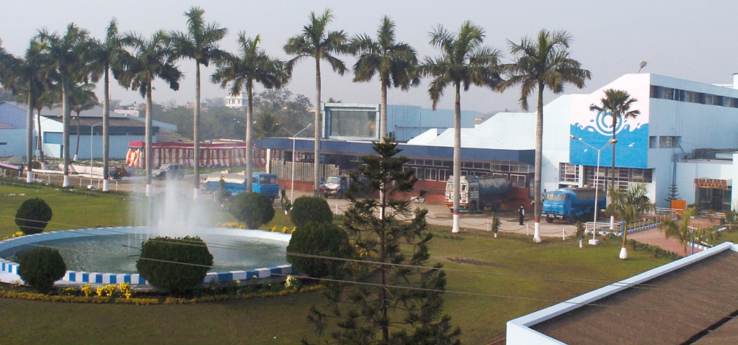

**A PROJECT REPORT SUBMITTED BY**

**MAMTA KUMARI (31)**

**KAJAL KUMARI (55)**

**KUMARI ANJALI (56)**

** *PATNA WOMEN’S COLLEGE***

**(AUTONOMOUS)**

***PATNA UNIVERSITY***

**3 RD Cycle NAAC Accredited at “A” grade with CGPA 3.58/4**

**\*College with potential for excellence*(CPE) status accorded by UGC**



**TITLE OF THE PROJECT**

***“PRODUCT MARKETING MANAGEMENT SYSTEM”***

**BY**

**MAMTA KUMARI (31) KAJAL KUMARI (55) KUMARI ANJALI(56)**

** *PATNA WOMEN’S COLLEGE***

**Patna Women’s College was founded in 1940 by Bishop B.J. Sullivan S.J., Bishop of Patna and Mother M. Josephine A.C. Superior General of the Apostolic Carmel. It was the first institution of higher learning opened to cater to the educational needs of women in Bihar. Bishop Sullivan, the founder, named it Patna Women’s College and presented it as a gift to the Women of Bihar, thereby placing at their disposal an opportunity for higher education. It was Bishop Sullivan’s firm belief that the upliftment of Bihar lay in liberating its womenfolk by providing them with opportunities for higher education, in other words, by empowering them. In the early years the College and the hostel were housed in the Bishop’s own residence at Bankipur, which he vacated for this great work.**

**The College was granted the status of degree college in July 1941. The site for the College building was offered to the then Principal, Mother Theodosia by the Governor of Bihar Lord Rutherford in 1945. The Governor was concerned that the College building should match in beauty the High Court opposite which this site was located. He was not disappointed. Father Gerhard and Father Loesch saw an ‘architect’s dream’ for the new building of Patna Women’s College, a unique synthesis of Hindu, Islamic, Norman and Gothic styles. The College moved into the new building in July 1948. Thousands of motivated and empowered women have passed through the portals of this college and have entered various fields of life, many making a mark in our country and abroad.**

**The College has come a long way from the time the pioneers envisioned and undertook the difficult task of establishing a Women’s College at a time when only a few truly enlightened and far-sighted persons were prepared to support this infant project in a place where higher education for women was frowned upon, if not rejected outright.**

**ABOUT PATNA DAIRY PROJECT**

**“Patna Dairy Project(PDP**)” was started at 1st October,1981 through the National DairyDevelopment Board(NDDB).NDDB handed over the arrangements of Patna Dairy Project(PDP) to Vaishal Patliputra Dugdh Utpadak Sahkari Sangh Ltd.(VPDUSS) with effects from 1st july,1988.The company **is ISO-9001:2000 and HACCP(IS-15000)** certified by Bureau of Indian Standards in march, 2002.

A Corporation known as Bihar State Dairy Corporation was formed in the year 1972 for speedy and effective implementation of the operation Flood programme in the state. The Dairy Corporation was to develop the Dairy Corporatives both at the village level and milk shed level cooperative would take over the entire infrastructure created in due course.

The Corporation positioned a multi disciplinary Procurement & Inputs wing in 1975 after their recruitment and training . A Spread Head Team(SHT) was deputed from National Dairy Development Board(NDDB) from the same year for helping the corporation in organizing and developing the cooperatives. Though the progress in the initial years was encouraging the programme, for obvious reasons could not achieve the goals for which it was established**.**

Subsequently, the State Government felt it worthwhile to request the DAIRY BOARD (NDDB) for taking over the infrastructure created on management basis. The National Dairy Development Board(NDDB) took over the management of the infrastructure with effect from 1st October,1981 under the banner of Patna Dairy Project(PDP).

LOGO



**MISSION & VISION**

**Our mission is to make Sudha Brand a market leader by making Sudha Milk and Milk products a consumers delight ensuring that the esteemed customers get value for money. We have created District Coorporative Society (DCS) in different districts for the better care of cattles. Our main focus is on Clean Milk Production (CMP) and to achieve the desired outcome we work on regional levels. we provide the cattle keepers with doctors for the regular checkup of the cattles.we also make them aware about how to keep cattles healthy and also how the production milk can be increased .**

**We have also created DCS for women in which only women members are involved , through those women’s ,we aware women about how they can also work for themselves rather than being stuck just in household activities .**

**Where we are working out of the organization at different levels ,it is our responsibility to work upon our employees at different level and for that we keep orientation programs ensuring motivation and involvement leading to all round progress of the organization.**



|  |  |
| --- | --- |
|  |  |

**1 Acknowledgement**

**2 Preface**

1. **Introduction**

* About organization
* About my project

**4 Objectives**

**5 Tools & Environment Used**

* About Windows 7
* About JAVA
* About Oracle 11g

**6 System Analysis & Design**

* Problem Definition
* System Investigation
* Information Of Database
* Synthesis
* **E-R Digrams/Class Digrams**
* **Data Flow Diagram(DFD)**
* **Design Part**
* **Database Diagram**

**7 System Codes & Methods (Coding)**

**8 Testing (Simple Run)**

**\*\*\*\*\*\*\*\*\*\*\*\*\*\*\*\*\*\*\*\*\*\*\*\*\*\*\*\*\*\*\*\*\*\*\*\*\*\*\*\*\*\*\*\*\*\*\*\*\*\*\*\*\*\*\*\*\*\*\*\*\*\*\*\*\*\*\*\*\*\*\***

*This is one of the greatest and most pleasant experiences of my life till now. No matter I faced a series of mishap during the period of my project. Apart from all these, with the incessant help of my guide* ***“Suresh sir”****. I have done it by own. From the dawn to end I must make thank to God, which couldn’t be a bit move without the God’s grace. So, an undoubtedly thanks to same who always boosted me up and rejuvenated me by lining up the unprecedented approach to my mind. And, I would like to pay all of my devotion and determination to the almighty god that never laid me astray from the path.*

*I want to express my sincere thanks to* ***Prof. MANISHA PRASAD****, head of department* ***BCA, Patna women’s College,*** *Patna for her kind co-operation and allow permission for completing the project .*

Above all I would like to thank my Family members and friends who stood behind and provide me formidable support .I also acknowledged their ideas in building of this project as an excellent work of this sort ever made before. My parents always stand with me and sail through me all my hard times and I am always grateful of my parents who blessed me when I am in need.

**Preface**

*We are doing* ***BCA*** *from* ***Patna women’s college, Patna*** *we are required to submit a project work for the requirement of the partial fulfillment of the degree course at the end of our course. I wanted a relatively challenging job from where I could complete the project and the working at the Institute as explained by my guide sounded bit luring and I was convinced to take the work to automate the Product Marketing management system at the* ***Patna Dairy Project*.**

**ABOUT MY PROJECT**

We were working on the project to deal the management of Product Marketing and this is my approach to accomplish more and more management of the **PATNA DAIRY PROJECT** which was already running using another software as well as many sections were dealing manually and so I was requested to automate the management of the Institute that’s why we selected the caption **“Product Market Management System“** As a **BCA** Project topics that deal with the Institute Management.

The excellent approach and the available equipments or objects are used to develop this software which meets all the requirements of the Institution.

For maintaining the database the powerful feature of **ORACLE** are used as like **TRIGGER** to reflect the account at instantly which avoid the error prone. As a front end tool the most attractive tool **Java 8** is used to deal the front end window so that one can easily takes the inputs to the tables and show the results in a convenient manner.

Finally we wish our software for the better future use , so that we could be able to requested again in future with the amending the better feature of coming technology.

**DEVELOPER**

**Mamta kumari (31)**

**Kajal kumari (55)**

**Kumari Anjali (56)**

Objectives of the Project

For partial fulfillment of **Bachelor In Computer Application** from **Patna women’s College, Patna** this project was under taken to justify the knowledge gained in this three years course and to prove the ability to develop real life projects in different fields.

The software that we developed is named **“PRODUCT MARKETING MANAGEMENT SYSTEM”** has been prepared depicting the overall functioning of the system and the features provided by the software. After this we referred the various books on SQL, Reports, and ORACLE and with the knowledge.

Again started designing the database and generated codes for the various modules keeping in mind the distinctive and features to be incorporated in the concerned application software, With the experience gained I was able to diversify my knowledge and skills in database technologies, designing user friendly interfaces, incorporating portability features and utilizing features of efficient programming.

The software developed **“PRODUCT MARKETING MANAGEMENT SYSTEM**” computerizes the entire functioning of the Institute **“PATNA DAIRY PROJECT”**. It enables to keep the information of different products available,different zones where product is to be supplied, information of distributors transaction details and invoice generation Facilities.

There are given several facilities, incentive as well. Thus to keep record of their Institute and other information, Institute System needs a software. My software is created to fulfill their requirement.

Here through our software backup is also created which helps the institution to know about the annual profit and loss in easy manner without any manual involvement.

* **Invoice is generated**
* **New products can be added in product list**
* **New zone can be added and removed**
* **Daily backup is created for further use**

**APPLICATION : DATABASE MANAGEMENT SYSTEM**

**(Product Marketing Management System of Patna Dairy Project Pvt.Ltd)**

**OPERATING SYSTEM : WINDOWS 7**

**FRONT END / GUI TOOLS : JAVA**

**RDBMS / BACKEND : ORACLE 11g**

**JDBC D DRIVERS : JDBC 14**

**Reasons for choosing windows 7 as Operating System**

**Windows 7 is personal computer operating system that was produced by Microsoft as part of the windows NT family of operating systems. It was released to manufacturing on july 22, 2009 and became generally available on October 22 , 2009.**

**Some of the features of windows 7 are :-**

* **Shell & user interface**
* **Power management**
* **Mobility enhancement**
* **Boot performance**
* **Security**

**JAVA**

Java is a general-purpose, object-oriented programming language developed by **Sun Microsystems** of USA in 1991.originally called OAK by **James Gosling** who is the inventor of the language ,java was designed for development of software for consumer electronic devices like TVs, VCRs and such other electronic machines. The goal had a strong impact on the development team to make the language simple, portable and highly reliable. the java team which include Patrick naughton discovered that the existing language c and c++ had limitation In terms of both reliability and portability ,their new language java on c and c++ but removed a number of features of c and c++ that were considered as sources of problems and thus made java a really simple ,reliable ,portable and powerful language .

Usually computer language is either compiled or interpreted java combines both these approach, thus making java a two-stage system first ,java compiler translated source code into byte code instruction byte codes are not machine instructions and therefore ,in the second stage java interpreter generates machine code that can be directly executed by the machine that is running the java program so we could say java is both a compile and interpreted language .

* **Java is a platform-independent language, java is a highly secure language on internet**

**Principles**

**James Gosling**, the creator of Java

There were five primary goals in the creation of the Java language:

1. It should be "simple, object-oriented and familiar"

2. It should be "robust and secure"

3. It should be "architecture-neutral and portable"

4. It should execute with "high performance"

5. It should be "interpreted, threaded, and dynamic"

**Versions**

*Major release versions of Java:*

* **JDK 1.0**
* **JDK 1.1**
* **JDK 1.2**
* **JDK 1.3**
* **JDK 1.4**
* **JDK 1.5**
* **JDK 1.7**
* **JDK 1.8**

**About Oracle 11g**

11g is oracle’s grid computing product group including a database management system and an application server. In addition to supporting grid computing features such as resource sharing and automatic load balancing , 10g products automate many database management tasks.

**Features of oracle 11g:-**

* **Application development**
* **Availability**
* **Clustering**
* **Information integration**
* **Security**
* **Windows**

**DATABASESDESIGN**

*The main objective of database designing is to reduce the usage of secondary*

*memory spaces as well as to work proficiently and easily.*

**Distributor master**:- In this table all the details about the distributors is stored.

Zone master :- In this all the zones are stored.

Main product master :- In this all the main products available are stored.

Product master :- In this all the sub products available are stored.

Status :- In this status of every master can be seen

Transaction :-transaction details are shown in this

**Information of the database**

* **Distributor_master**

|  |  |  |  |  |
| --- | --- | --- | --- | --- |
| *Sr.no* | *Column name* | *Data type* | *Size* | *Description* |
| *1.* | *Dist_id* | *Number* | *7* | *It specify distributor Id* |
| *2.* | *Dist_name* | *Varchar* | *30* | *It specify distributor name* |
| *3.* | *Address* | *Varchar* | *50* | *It specify distributor address* |
| *4.* | *Contact_no* | *Varchar* | *12* | *It specify distributor contact no* |
| *5.* | *E_mail* | *Varchar* | *30* | *It specify distributor email id* |
| *6.* | *Addhar_no* | *Varchar* | *12* | *It specify distributor addhar no* |
| *7.* | *Pan_card_no* | *Varchar* | *10* | *It specify distributor pancard no* |
| *8.* | *Zone_id* | *Varchar* | *4* | *It specify the specific zone of distributor* |
| *9.* | *Dob* | *Date* |  | *It specify distributor date of birth* |
| *10.* | *Office_ref* | *Varchar* | *10* | *It specify distributor office reference* |
| *11.* | *Ref_date* | *Date* |  | *It specify distributor reference date* |
| *12.* | *Image* | *Blob* |  | *It specify distributor image* |
| *13.* | *Gender* | *Varchar* | *6* | *It specify distributor gender* |

* ***Zone_master***

|  |  |  |  |  |
| --- | --- | --- | --- | --- |
| *Sr no.* | *Column name* | *Data type* | *Size* | *Description* |
| *1.* | *Zone_id* | *Varchar* | *4* | *It specify zone id* |
| *2.* | *Location* | *Varchar* | *50* | *It specify location of specific zone* |

* **Main_product_master**

|  |  |  |  |  |
| --- | --- | --- | --- | --- |
| *Sr no.* | *Column name* | *Data type* | *Size* | *Description* |
| **1.** | Main_prod_id | Varchar | **3** | *It specify the main product id* |
| **2.** | Main_prod_name | Varchar | **20** | *It specify the main product name* |
| **3.** | taxable | Varchar | **3** | *It specify that product is taxable or not* |
| **4.** | Prod_last_ref | Varchar | **5** | *It specify the product last reference* |
| **5.** | Prod_image | Blob |  | *It specify the image of the product* |

* **Product_master**

|  |  |  |  |  |
| --- | --- | --- | --- | --- |
| *Sr no.* | *Column name* | *Data type* | *Size* | *Description* |
| *1.* | *Prod_id* | *Varchar* | *5* | *It specify the product id* |
| *2.* | *Prod_name* | *Varchar* | *60* | *It specify the product name* |
| *3.* | *Prod_unit* | *Varchar* | *10* | *It specify product unit* |
| *4.* | *Basic_price* | *Number* | *8,2* | *It specify basic price of product* |
| *5.* | *Taxable* | *Varchar* | *3* | *It specify that product is taxable or not* |
| *6.* | *Cgst* | *Number* | *5,2* | *It specify central gst on product* |
| *7.* | *Sgst* | *Number* | *5,2* | *It specify state gst on product* |
| *8.* | *Dist_commision* | *Number* | *5,2* | *It specify distributor commission* |
| *9.* | *Retailer_commision* | *Number* | *5,2* | *It specify retailer commision* |
| *10.* | *Mrp* | *Number* | *8,2* | *It specify the mrp of the product* |

* **Transaction**

|  |  |  |  |  |
| --- | --- | --- | --- | --- |
| *Sr no.* | *Column name* | *Data type* | *Size* | *Description* |
| *1.* | *Invoice_no* | *Number* | *5* | *It specify the invoice number* |
| *2.* | *Invoice_date* | *Date* |  | *It specify the invoice date* |
| *3.* | *Amount_received* | *Number* | *8,2* | *It specify the amount received by distributor* |
| *4.* | *Balance_amount* | *Number* | *8,2* | *It specify the amount left* |
| *5.* | *Dist_id* | *Number* | *7* | *It specify the distributor id* |
| *6.* | *Terms_of_payment* | *Varchar* | *40* | *It specify the mode of payment* |
| *7.* | *Amount_chargeable* | *Number* | *10* | *It specify the chargeable amount* |

* **Sign_in**

|  |  |  |  |  |
| --- | --- | --- | --- | --- |
| *Sr no.* | *Column name* | *Data type* | *Size* | *Description* |
| *1.* | *User_id* | *Varchar* | *12* | *It specify user id* |
| *2.* | *User_name* | *Varchar* | *30* | *It specify user name* |
| *3.* | *Pwd* | *Varchar* | *10* | *It specify user password* |
| *4.* | *Gender* | *Varchar* | *6* | *It specify user gender* |
| *5.* | *Security_question* | *Varchar* | *50* | *It specify security question for password change* |
| *6.* | *Address* | *Varchar* | *50* | *It specify user address* |
| *7.* | *Contact_no* | *Varchar* | *12* | *It specify user contact number* |
| *8.* | *Addhar_no* | *Varchar* | *12* | *It specify user addhar number* |
| *9.* | *Email* | *Varchar* | *30* | *It specify user email id* |

**ER-DIAGRAM**

**The diagram which show the relationship between the entities of the system is know as the entity relationship diagram.**

**ERD deals with the structural aspects of the system and database represents the structure of the system.**

**Any real object is called entity.These objects constitute the system to developed to developed a software.**

**THREE IMPORTANT FEATURE OF THE ENTITY RELATIONSHIP DIAGRAM**

**1. Entity:- It can be person, place, events to the organization and about which data are captured, stored or processed.**

**2. Attribute:- various type of data element that describe an entity are know as attribute.**

**3. Relationship:- An association of the several entities in an er-model is called relationship.**

**NOTATION / SYMBOL USED IN ERD**

**NAME SYMBOL MEANING**

**Rectangle Represents entity**

**OVAL Represents attribute**

**Diamond Represents relationship**

**Line Link the attribute**

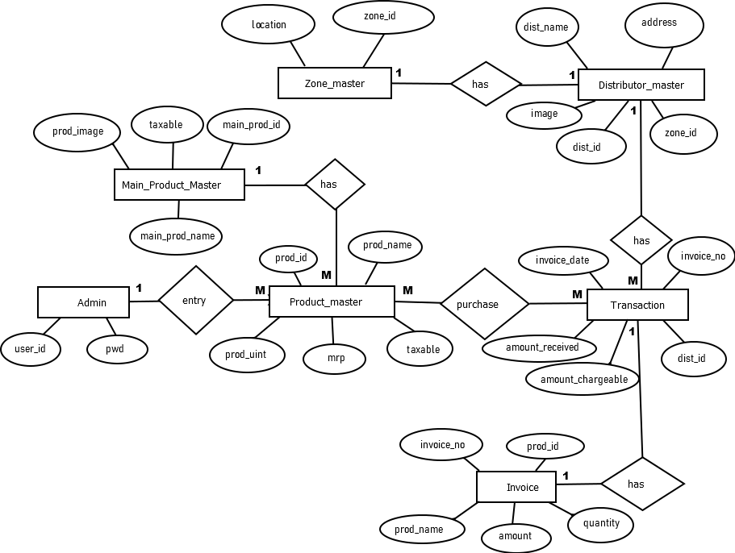

Data Flow Diagram (DFD) :-

**After Study of Information requirement and processing requirement and finalization of module and study of data flow in system.**

**A data flow diagram is a graphical representation of the “flow” of data through an information system,modeling its process aspects. A DFD is often used as a preliminary step to create an overview of the the system without going into details,which can later be elaborated.**

*SYMBOL USED IN DATA FLOW DIAGRAM*

*NAME SYMBOL DESCRIPTION*

**External entity denotes entity**

**Process bubble process definition**

**data carrier shows data flow**

**Data repository data storage**

**Admin**

Product entry

User creation request

**User**

respond

Zone entry invoice generation

Distributor entry

database

DATA FLOW DIAGRAM

**DESIGNING PART**

**SPLASH SCREEN**

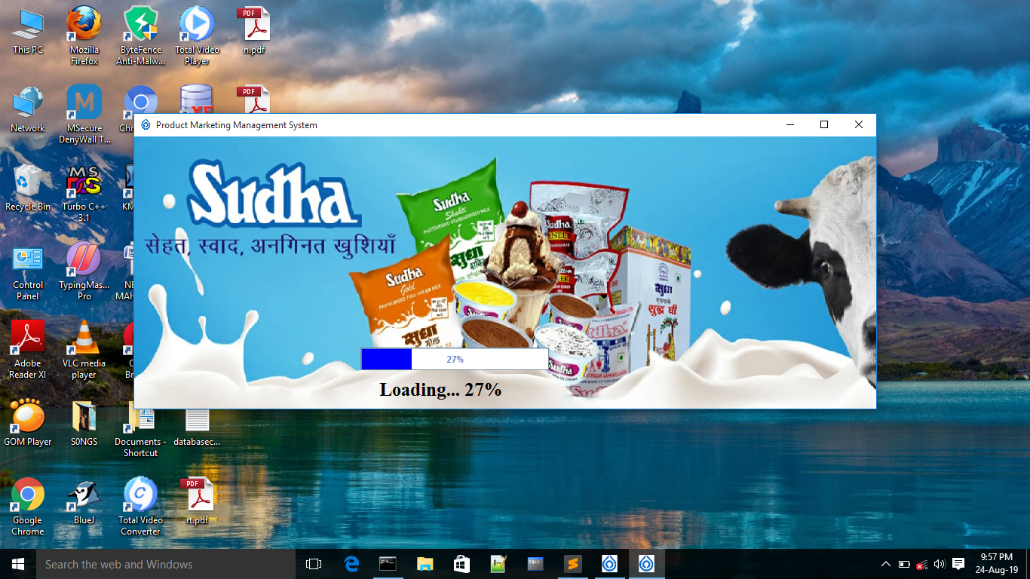import java.awt.*;

import javax.swing.*;

import java.io.File;

import java.sql.*;

import javax.media.*;

import javax.sound.sampled.*;

import java.awt.event.*;

public class FirstForm extends JFrame implements Runnable

{ Connection con;

PreparedStatement pst;

JProgressBar progress=new JProgressBar();

JLabel prg = new JLabel();

public void run()

{

for(int i=1;i<100;i++)

{

progress.setValue(i);

prg.setText("Loading... "+i+"%");

try{Thread.sleep(70);}catch(Exception e){}

}

dispose();

new LoginForm();

}

{

try

{

Class.forName("oracle.jdbc.driver.OracleDriver");//ClassNotFoundException

con=DriverManager.getConnection("jdbc:oracle:thin:@localhost:1521:XE","sudha","sudha123");//SQLException

}

catch(SQLException e)

{

System.out.println(e);

}

catch(ClassNotFoundException e)

{}

}

Thread th;

int opt;

Toolkit toolkit=Toolkit.getDefaultToolkit();

Dimension dimension=toolkit.getScreenSize();

ButtonGroup bg=new ButtonGroup();

int w;

int h;

{

w=(int)dimension.getWidth();

h=(int)dimension.getHeight();

}

JPanel panel=new JPanel()

{

public void paintComponent(Graphics g)

{

super.paintComponent(g);

g.drawImage(new ImageIcon("IMG-20190731-WA0008.jpg").getImage(), 0 , 0 , 1000 , 400 , null);

}

};

public FirstForm()

{

progress.setBackground(Color.white);

progress.setForeground(Color.blue);

progress.setStringPainted(true);

th=new Thread(this);

th.start();

add(panel);

panel.setLayout(null);

setIconImage(new ImageIcon("icon.jpg").getImage());

panel.add(prg);prg.setBounds(325,310,200,50);prg.setFont(new Font("Times New Roman", Font.BOLD,25));prg.setForeground(Color.BLACK);

progress.setBounds(300,280,250,30);

panel.add(progress);

setTitle("Product Marketing Management System");

setBounds(170 , 150 , 1000 , 400);

setVisible(true);

try

{

AudioInputStream aud = AudioSystem.getAudioInputStream(new File("o95.wav"));

Clip clip = AudioSystem.getClip();

clip.open(aud);

//clip.play();

//clip.loop(Clip.LOOP_CONTINUOUSLY);

clip.start();

}

catch(Exception e){System.out.println(e);}

}

public static void main(String[]args)

{

new FirstForm();

}

}

**LOGIN WINDOW**

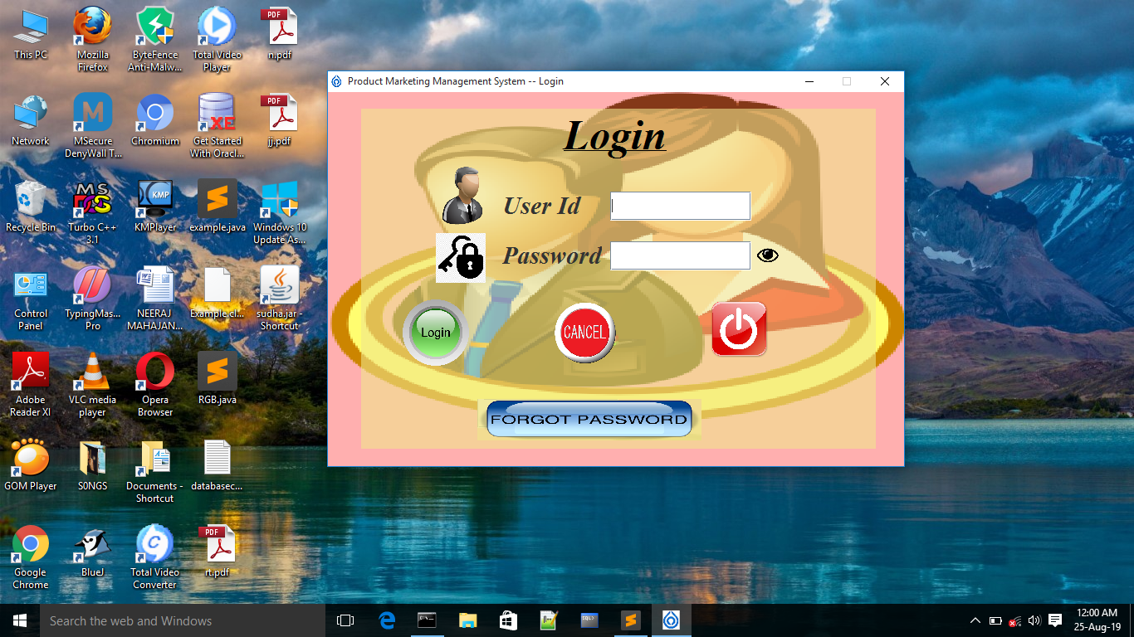

import javax.swing.*;

import java.awt.*;

import java.awt.event.*;

import java.text.*;

import java.sql.*;

public class LoginForm extends JFrame implements ActionListener

{

static boolean show = true;

Connection con;

ResultSet rst;

PreparedStatement pst;

String admin = "admin";

String password = "sudha123";

public static String admin_login , pwd_login;

{

try

{

Class.forName("oracle.jdbc.driver.OracleDriver");//class not found exception

con=DriverManager.getConnection("jdbc:oracle:thin:@localhost:1521:XE","sudha","sudha123");//sqlexcpetion

}

catch(SQLException e)

{

System.out.println(e);

}

catch(ClassNotFoundException e){}

}

JLabel lbl=new JLabel("<html><u>Login</u></html>");

JLabel name=new JLabel("User Id");

JButton pwdvisible=new JButton()

{

public void paintComponent(Graphics g)

{

super.paintComponent(g);

g.drawImage(new ImageIcon("anti-click-fraud.png").getImage(),0 , 0 ,30,30 , null);

}

};

JLabel uicon=new JLabel()

{

public void paintComponent(Graphics g)

{

super.paintComponent(g);

g.drawImage(new ImageIcon("Boss-icon.png").getImage(),0 , 0 ,70,70 , null);

}

};

JTextField tname=new JTextField();

JLabel pwd=new JLabel("Password");

JLabel error=new JLabel();

JLabel picon=new JLabel()

{

public void paintComponent(Graphics g)

{

super.paintComponent(g);

g.drawImage(new ImageIcon("key.png").getImage(),0 , 0 ,60,60 , null);

}

};

JPasswordField txtpwd=new JPasswordField('*');

JButton login=new JButton()

{

public void paintComponent(Graphics g)

{

super.paintComponent(g);

g.drawImage(new ImageIcon("login-button-hi.png").getImage(),0 , 0 ,80,80 , null);

}

};

JButton fpwd=new JButton()

{

public void paintComponent(Graphics g)

{

super.paintComponent(g);

g.drawImage(new ImageIcon("forgot-password-button-png-hi.png").getImage(),0 , 0 ,270,50 , null);

}

};

JButton cancel=new JButton()

{

public void paintComponent(Graphics g)

{

super.paintComponent(g);

g.drawImage(new ImageIcon("button_clear.png").getImage(),0 , 0 ,80,80 , null);

}

};

JButton exit=new JButton()

{

public void paintComponent(Graphics g)

{

super.paintComponent(g);

g.drawImage(new ImageIcon("1024px-Crystal_Clear_action_exit.svg.png").getImage(),0 , 0 ,70,70 , null);

}

};

JPanel pmaster=new JPanel()

{

public void paintComponent(Graphics g)

{

super.paintComponent(g);

g.drawImage(new ImageIcon("men.png").getImage(),0 , 0 ,700,400 , null);

}

};

JPanel pchild=new JPanel();

LoginForm()

{

setTitle("Product Marketing Management System -- Login");

setResizable(false);

add(pmaster);

pmaster.setBackground(Color.PINK);

pmaster.setLayout(null);

pmaster.setBounds(0 , 0 , 700 , 480);

pchild.setBounds(40,20,620,410);

pmaster.add(pchild);

pchild.setBackground(new Color(240,230,140,150));

pchild.setLayout(null);

lbl.setBounds(230,0,150,60);

pchild.add(lbl);

pchild.add(lbl);

lbl.setHorizontalAlignment(JLabel.CENTER);

lbl.setVerticalAlignment(JLabel.CENTER);

lbl.setFont(new Font("Times New Roman",Font.ITALIC+Font.BOLD,50));

lbl.setForeground(Color.BLACK);

uicon.setBounds(90,70,70,70);pchild.add(uicon);

name.setBounds(170,100,120,35);pchild.add(name);

name.setFont(new Font("Times New Roman",Font.ITALIC+Font.BOLD,30));

tname.setBounds(300,100,170,35);pchild.add(tname);

pwd.setBounds(170,160,120,35);pchild.add(pwd);

picon.setBounds(90,150,60,60);pchild.add(picon);

pwd.setFont(new Font("Times New Roman",Font.ITALIC+Font.BOLD,30));

txtpwd.setBounds(300,160,170,35);pchild.add(txtpwd);

txtpwd.setFont(new Font( "Arial",Font.PLAIN ,30));

login.setBounds(50,230,80,80);pchild.add(login);

login.setContentAreaFilled(false);

login.setBorderPainted(false);

fpwd.setBounds(140,350,270,50);pchild.add(fpwd);

fpwd.setFont(new Font("Times New Roman",Font.ITALIC+Font.BOLD,30));

fpwd.setOpaque(false);

fpwd.setContentAreaFilled(false);

fpwd.setBorderPainted(false);

setIconImage(new ImageIcon("icon.jpg").getImage());

cancel.setBounds(230,230,80,80);pchild.add(cancel);

cancel.setContentAreaFilled(false);

cancel.setBorderPainted(false);

exit.setBounds(420,230,70,70);pchild.add(exit);

exit.setContentAreaFilled(false);

exit.setBorderPainted(false);

pchild.add(pwdvisible);pwdvisible.setBounds(475, 162 , 30 , 30);

pwdvisible.setContentAreaFilled(false);

pwdvisible.setBorderPainted(false);

setBounds(250 , 100 , 700 , 480);

setVisible(true);

login.addActionListener(this);

fpwd.addActionListener(this);

cancel.addActionListener(this);

exit.addActionListener(this);

pwdvisible.addActionListener(this);

}

public void actionPerformed(ActionEvent evt)

{

boolean temp=false;

if(evt.getSource()==exit)

{

int opt= JOptionPane.showConfirmDialog(this,"Do You Want To Exit...");

if(opt==JOptionPane.YES_OPTION)

{

System.exit(0);

}

}

if(evt.getSource()==pwdvisible)

{

repaint();

if(show == true)

{

txtpwd.setEchoChar((char)0);

show = false;

}

else if(show == false)

{

txtpwd.setEchoChar('*');

show = true;

}

}

if(evt.getSource()==login)

{

repaint();

String a , b , c;

a = tname.getText();

c = txtpwd.getText();

b = "";

if(a.equals(admin) && c.equals(password))

{

dispose();

Menu mnu = new Menu();

admin_login = a;

pwd_login = c;

}

else

{

try

{

pst =con.prepareStatement("select * from sign_in where user_id=?");

pst.setString(1,a);

rst=pst.executeQuery();

if(rst.next())

{

a = rst.getString("user_id");

b = rst.getString("pwd");

if(b.equals(c))

{

dispose();

Menu mnu = new Menu();

admin_login = a;

pwd_login = c;

}

else

{

JOptionPane.showMessageDialog(this,"invalid user id or password!!..","Error Message",JOptionPane.ERROR_MESSAGE);

}

}

else

{

JOptionPane.showMessageDialog(this,"invalid user id or password!!..","Error Mesaage",JOptionPane.ERROR_MESSAGE);

}

}

catch(Exception ex)

{

JOptionPane.showMessageDialog(this,"invalid user id or password!!..","Error Mesaage",JOptionPane.ERROR_MESSAGE);

}

}

}

if(evt.getSource()==fpwd)

{

repaint();

String a , b, c;

a = tname.getText();

b = "";

c =JOptionPane.showInputDialog(this,"What is your favourite book?..");

try

{

pst =con.prepareStatement("select * from sign_in where user_id=?");

pst.setString(1,a);

rst=pst.executeQuery();

if(rst.next())

{

a = rst.getString("user_id");

b = rst.getString("security_question");

if(b.equals(c))

{

String pwdc =JOptionPane.showInputDialog(this,"Enter new password..");

if(!ValidationPassword.checkPassword(pwdc))

{

JOptionPane.showMessageDialog(this,"Enter 10 Characters");

temp=true;

}

else

{

String cpwdc = JOptionPane.showInputDialog(this,"Enter new password to confirm..");

if(pwdc.equals(cpwdc))

{

pst=con.prepareStatement("update sign_in set pwd=? where user_id=?");

pst.setString(1,pwdc);

pst.setString(2,a);

if(pst.executeUpdate()>0)

{

JOptionPane.showMessageDialog(this,"Password Changed...","Confirm Message",JOptionPane.INFORMATION_MESSAGE);

}

else

{

JOptionPane.showMessageDialog(this,"Password Not Changed...","Error Message",JOptionPane.ERROR_MESSAGE);

}

}

else

{

JOptionPane.showMessageDialog(this,"Passwords don't match!!..Try Again!!..");

}

}

}

else

{

JOptionPane.showMessageDialog(this,"Try Again");

}

}

else

{

JOptionPane.showMessageDialog(this,"Invalid User!!..");

}

}

catch(Exception et){JOptionPane.showMessageDialog(this,"Password Not Changed...","Error Message",JOptionPane.ERROR_MESSAGE);}

}

if(evt.getSource()==cancel){

repaint();

cancel();}

}

public void cancel()

{

repaint();

tname.setText("");

txtpwd.setText("");

}

public static void main(String...args)

{

new LoginForm();

}

}

**MENU WINDOW**

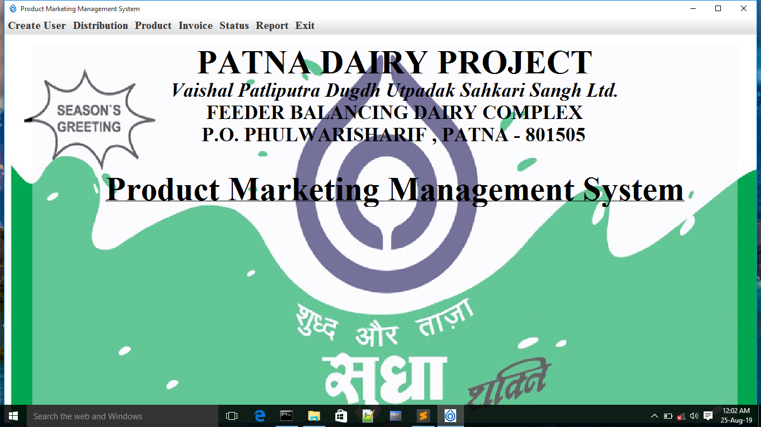

import java.io.*;

import java.util.*;

import javax.swing.*;

import java.awt.*;

import java.awt.event.*;

public class Menu extends JFrame implements ActionListener

{

int w , h ;

Toolkit toolkit = Toolkit.getDefaultToolkit();

Dimension dimension = toolkit.getScreenSize();

{

w = (int)dimension.getWidth();

h = (int)dimension.getHeight();

}

Image img;

JPanel p = new JPanel()

{

{

img = Toolkit.getDefaultToolkit().createImage("F:\\GUI\\s1.gif");

}

public void paintComponent(Graphics g)

{

super.paintComponent(g);

if(img != null)

{

g.drawImage(img ,0 ,0 , w , h , this);

}

}

};

JPanel p1 = new JPanel();

JLabel lbl1 = new JLabel("PATNA DAIRY PROJECT");

JLabel lbl2 = new JLabel("Vaishal Patliputra Dugdh Utpadak Sahkari Sangh Ltd.");

JLabel lbl3 = new JLabel("FEEDER BALANCING DAIRY COMPLEX");

JLabel lbl4 = new JLabel("P.O. PHULWARISHARIF , PATNA - 801505");

JLabel lbl5 = new JLabel("<html><u>Product Marketing Management System</u></html>");

JMenuBar menuBar=new JMenuBar();

JMenu m1=new JMenu("Create User");

JMenu m2=new JMenu("Distribution");

JMenu m3=new JMenu("Product");

JMenu m4=new JMenu("Invoice");

JMenu m5=new JMenu("Status");

JMenu m6=new JMenu("Report");

JMenu m7 = new JMenu("Exit");

JMenuItem mi1=new JMenuItem("Sign Up");

JMenuItem mi21=new JMenuItem("Zone");

JMenuItem mi22=new JMenuItem("Distributor");

JMenuItem mi31=new JMenuItem("Main Product");

JMenuItem mi32=new JMenuItem("Product");

JMenuItem mi4=new JMenuItem("Invoice");

JMenuItem mi5=new JMenuItem("Status");

JMenuItem mi6=new JMenuItem("Report");

JMenuItem mi7=new JMenuItem("Exit");

JPanel panel=null;

Menu()

{

setTitle("Product Marketing Management System");

setIconImage(new ImageIcon("icon.jpg").getImage());

setBounds(0 , 0 , w , h);

setVisible(true);

add(p);p.setLayout(null);

p.add(p1);p1.setBounds(50 , 20 , w-100 ,h-50);p1.setBackground(new Color(248 , 248 , 255 , 100));p1.setLayout(null);

p1.add(lbl1);lbl1.setBounds(250 , 0 , 800 , 60);

lbl1.setHorizontalAlignment(JLabel.CENTER);

lbl1.setVerticalAlignment(JLabel.CENTER);

lbl1.setFont(new Font("Times New Roman",Font.BOLD,60));

lbl1.setForeground(Color.BLACK);

p1.add(lbl2);lbl2.setBounds(150 , 60 , 1000 , 40);

lbl2.setHorizontalAlignment(JLabel.CENTER);

lbl2.setVerticalAlignment(JLabel.CENTER);

lbl2.setFont(new Font("Times New Roman",Font.ITALIC+Font.BOLD,35));

lbl2.setForeground(Color.BLACK);

p1.add(lbl3);lbl3.setBounds(150 , 100 , 1000 , 40);

lbl3.setHorizontalAlignment(JLabel.CENTER);

lbl3.setVerticalAlignment(JLabel.CENTER);

lbl3.setFont(new Font("Times New Roman",Font.BOLD,35));

lbl3.setForeground(Color.BLACK);

p1.add(lbl4);lbl4.setBounds(248 , 140 , 800 , 40);

lbl4.setHorizontalAlignment(JLabel.CENTER);

lbl4.setVerticalAlignment(JLabel.CENTER);

lbl4.setFont(new Font("Times New Roman",Font.BOLD,35));

lbl4.setForeground(Color.BLACK);

p1.add(lbl5);lbl5.setBounds(100 , 220 , 1100 , 70);

lbl5.setHorizontalAlignment(JLabel.CENTER);

lbl5.setVerticalAlignment(JLabel.CENTER);

lbl5.setFont(new Font("Times New Roman",Font.BOLD,60));

lbl5.setForeground(Color.BLACK);

setJMenuBar(menuBar);//menuBar.setFont(new Font("Times New Roman",Font.BOLD,70));

menuBar.add(m1);m1.setMnemonic('F');m1.add(mi1);m1.setFont(new Font("Times New Roman",Font.BOLD,20));

menuBar.add(m2);m2.setMnemonic('E');

m2.add(mi21);m2.setFont(new Font("Times New Roman",Font.BOLD,20));

m2.addSeparator();m3.setFont(new Font("Times New Roman",Font.BOLD,20));

m2.add(mi22);

menuBar.add(m3);m3.setMnemonic('G');

m3.add(mi31);

m3.addSeparator();

m3.add(mi32);

menuBar.add(m4);m4.setMnemonic('H');m4.add(mi4);m4.setFont(new Font("Times New Roman",Font.BOLD,20));

menuBar.add(m5);m5.setMnemonic('I');m5.add(mi5);m5.setFont(new Font("Times New Roman",Font.BOLD,20));

menuBar.add(m6);m6.setMnemonic('J');m6.add(mi6);m6.setFont(new Font("Times New Roman",Font.BOLD,20));

menuBar.add(m7);m7.setMnemonic('K');m7.add(mi7);m7.setFont(new Font("Times New Roman",Font.BOLD,20));

mi1.addActionListener(this);

mi21.addActionListener(this);

mi22.addActionListener(this);

mi31.addActionListener(this);

mi32.addActionListener(this);

mi4.addActionListener(this);

mi5.addActionListener(this);

mi6.addActionListener(this);

mi7.addActionListener(this);

}

public void actionPerformed(ActionEvent evt)

{

if(evt.getSource()==mi1)

{ if(LoginForm.admin_login.equals("admin") && LoginForm.pwd_login.equals("sudha123"))

{

SignUpForm sgf = new SignUpForm();

sgf.setVisible(true);

}

}

if(evt.getSource()==mi21)

{

zonemaster zm = new zonemaster();

zm.setVisible(true);

}

if(evt.getSource()==mi22)

{

distributermaster dm = new distributermaster();

dm.setVisible(true);

}

if(evt.getSource()==mi31)

{

MainProductMaster mpm = new MainProductMaster();

mpm.setVisible(true);

}

if(evt.getSource()==mi32)

{

ProductMaster pm = new ProductMaster();

pm.setVisible(true);

}

if(evt.getSource()==mi4)

{

Transaction t = new Transaction();

t.setVisible(true);

}

if(evt.getSource()==mi5)

{

Status s = new Status();

s.setVisible(true);

}

if(evt.getSource()==mi6)

{

Report r = new Report();

r.setVisible(true);

}

if(evt.getSource()==mi7)

{

int opt= JOptionPane.showConfirmDialog(this,"Do You Want To Quit...");

if(opt==JOptionPane.YES_OPTION)

{

dispose();

}

}

}

public static void main(String[]args)

{

new Menu();

}

}

**SIGN IN**

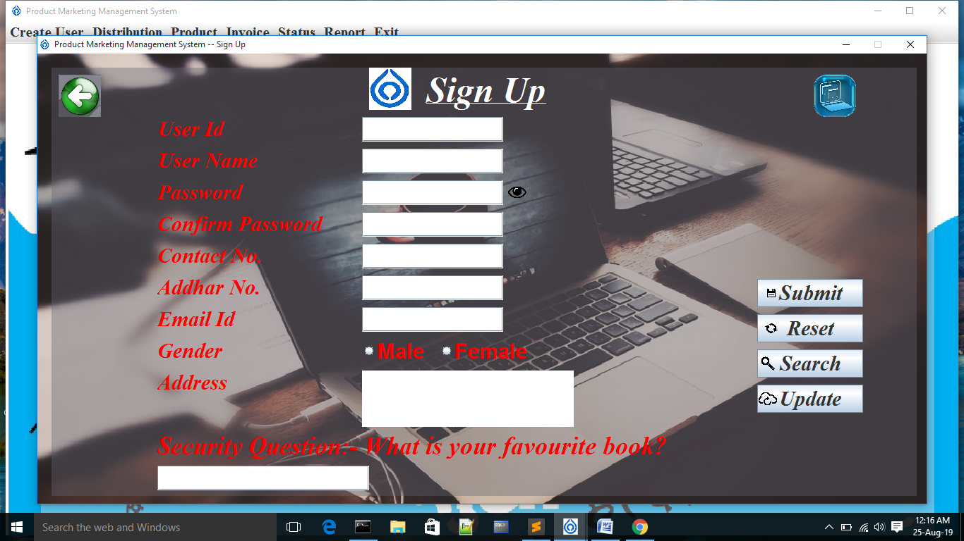

import javax.swing.*;

import java.awt.*;

import java.awt.event.*;

import java.text.*;

import java.sql.*;

public class SignUpForm extends JFrame implements ActionListener

{

static boolean show = true;

Connection con;

ResultSet rst;

PreparedStatement pst;

{

try

{

Class.forName("oracle.jdbc.driver.OracleDriver");

con=DriverManager.getConnection("jdbc:oracle:thin:@localhost:1521:XE","sudha","sudha123");

}

catch(SQLException e)

{

System.out.println(e);

}

catch(ClassNotFoundException e)

{System.out.println(e);}

}

String opt;

JLabel head=new JLabel("<html><u>Sign Up</u></html>");

JLabel uname=new JLabel("User Name");

JLabel unameerror=new JLabel();

JLabel pwd=new JLabel("Password");

JLabel cpwderror=new JLabel();

JLabel cpwd=new JLabel("Confirm Password");

JLabel gen=new JLabel("Gender");

ButtonGroup bg=new ButtonGroup();

JRadioButton rm=new JRadioButton("Male");

JRadioButton rf=new JRadioButton("Female");

JLabel sq=new JLabel("Security Question:- What is your favourite book?");

JTextField tuname=new JTextField();

JPasswordField tpwd=new JPasswordField();

JPasswordField tcpwd=new JPasswordField();

JTextField tsq=new JTextField();

JLabel address=new JLabel("Address");

JTextArea taddress=new JTextArea();

JLabel contact=new JLabel("Contact No.");

JLabel contacterror=new JLabel();

JTextField tcontact=new JTextField();

JLabel addhar=new JLabel("Addhar No.");

JLabel addharerror=new JLabel();

JTextField taddhar=new JTextField();

JLabel id=new JLabel("User Id");

JLabel iderror=new JLabel();

JTextField tid=new JTextField();

JLabel email=new JLabel("Email Id");

JLabel emailerror=new JLabel();

JTextField temail=new JTextField();

JLabel sicon=new JLabel()

{

public void paintComponent(Graphics g)

{

super.paintComponent(g);

g.drawImage(new ImageIcon("icon.jpg").getImage(),0 , 0 ,60,60 , null);

}

};

JButton submit=new JButton("Submit")

{

public void paintComponent(Graphics g)

{

super.paintComponent(g);

g.drawImage(new ImageIcon("insert.png").getImage(),0 , 0 ,40,40 , null);

}

};

JButton update=new JButton("Update")

{

public void paintComponent(Graphics g)

{

super.paintComponent(g);

g.drawImage(new ImageIcon("update.png").getImage(),0 , 5 ,30,30 , null);

}

};

JButton search = new JButton("Search")

{

public void paintComponent(Graphics g)

{

super.paintComponent(g);

g.drawImage(new ImageIcon("search.png").getImage(),5 , 10 ,20,20 , null);

}

};

JButton cancel=new JButton("Reset")

{

public void paintComponent(Graphics g)

{

super.paintComponent(g);

g.drawImage(new ImageIcon("reset.png").getImage(),0 , 0 ,40,40 , null);

}

};

JButton back = new JButton()

{

public void paintComponent(Graphics g)

{

super.paintComponent(g);

g.drawImage(new ImageIcon("back1.png").getImage(),0 , 0 ,60,60 , null);

}

};

JButton backup = new JButton()

{

public void paintComponent(Graphics g)

{

super.paintComponent(g);

g.drawImage(new ImageIcon("backup.png").getImage(),0 , 0 , 60,60 , null);

}

};

JPanel pmaster=new JPanel()

{

public void paintComponent(Graphics g)

{

super.paintComponent(g);

g.drawImage(new ImageIcon("user.jpg").getImage(),0 , 0 ,w,h , null);

}

};

JPanel pchild=new JPanel();

Toolkit toolkit=Toolkit.getDefaultToolkit();

Dimension dimension=toolkit.getScreenSize();

int w,h;

{

w=(int)dimension.getWidth();

h=(int)dimension.getHeight();

}

JButton pwdvisible=new JButton()

{

public void paintComponent(Graphics g)

{

super.paintComponent(g);

g.drawImage(new ImageIcon("anti-click-fraud.png").getImage(),0 , 0 ,30,30 , null);

}

};

SignUpForm()

{

setTitle("Product Marketing Management System -- Sign Up");

setResizable(false);

add(pmaster);

pmaster.setBounds(50 , 50 , w-100 , h-100);

pmaster.setLayout(null);

pchild.setBounds(20,20,w-140,h-160);

pmaster.add(pchild);

pchild.setBackground(new Color(100,100,111,100));

pchild.setLayout(null);

pchild.add(sicon);sicon.setBounds(450 , 0 , 60 , 60);

setIconImage(new ImageIcon("icon.jpg").getImage());

head.setBounds(490,0,250,60);

pchild.add(head);

head.setHorizontalAlignment(JLabel.CENTER);

head.setVerticalAlignment(JLabel.CENTER);

head.setFont(new Font("Times New Roman",Font.ITALIC+Font.BOLD,50));

head.setForeground(Color.WHITE);

id.setBounds(150,70,280,35);pchild.add(id);

id.setFont(new Font("Times New Roman",Font.ITALIC+Font.BOLD,30));

id.setForeground(Color.RED);

iderror.setBounds(650,70,50,35);pchild.add(iderror);

tid.setBounds(440,70,200,35);pchild.add(tid);

uname.setBounds(150,115,280,35);pchild.add(uname);

unameerror.setBounds(650,115,150,35);pchild.add(unameerror);

unameerror.setForeground(Color.RED);

unameerror.setFont(new Font("Times New Roman",Font.ITALIC+Font.BOLD,20));

uname.setForeground(Color.RED);

uname.setFont(new Font("Times New Roman",Font.ITALIC+Font.BOLD,30));

tuname.setBounds(440,115,200,35);pchild.add(tuname);

pwd.setBounds(150,160,250,35);pchild.add(pwd);

pwd.setForeground(Color.RED);

pwd.setFont(new Font("Times New Roman",Font.ITALIC+Font.BOLD,30));

tpwd.setBounds(440,160,200,35);pchild.add(tpwd);

tpwd.setFont(new Font("Times New Roman",Font.ITALIC+Font.BOLD,30));

cpwd.setBounds(150,205,250,35);pchild.add(cpwd);

cpwderror.setBounds(650,205,300,35);pchild.add(cpwderror);

cpwd.setForeground(Color.RED);

cpwd.setFont(new Font("Times New Roman",Font.ITALIC+Font.BOLD,30));

tcpwd.setBounds(440,205,200,35);pchild.add(tcpwd);

tcpwd.setFont(new Font("Times New Roman",Font.ITALIC+Font.BOLD,30));

contact.setBounds(150,250,250,35);pchild.add(contact);

contacterror.setBounds(650,250,150,35);pchild.add(contacterror);

contacterror.setForeground(Color.RED);

contacterror.setFont(new Font("Times New Roman",Font.ITALIC+Font.BOLD,30));

contact.setForeground(Color.RED);

contact.setFont(new Font("Times New Roman",Font.ITALIC+Font.BOLD,30));

tcontact.setBounds(440,250,200,35);pchild.add(tcontact);

addhar.setBounds(150,295,250,35);pchild.add(addhar);

addharerror.setBounds(650,295,150,35);pchild.add(addharerror);

addharerror.setForeground(Color.RED);

addharerror.setFont(new Font("Times New Roman",Font.ITALIC+Font.BOLD,30));

addhar.setForeground(Color.RED);

addhar.setFont(new Font("Times New Roman",Font.ITALIC+Font.BOLD,30));

taddhar.setBounds(440,295,200,35);pchild.add(taddhar);

email.setBounds(150,340,250,35);pchild.add(email);

emailerror.setBounds(650,340,150,35);pchild.add(emailerror);

emailerror.setForeground(Color.RED);

emailerror.setFont(new Font("Times New Roman",Font.ITALIC+Font.BOLD,30));

email.setForeground(Color.RED);

email.setFont(new Font("Times New Roman",Font.ITALIC+Font.BOLD,30));

temail.setBounds(440,340,200,35);pchild.add(temail);

gen.setBounds(150,385,250,35);pchild.add(gen);

gen.setForeground(Color.RED);

gen.setFont(new Font("Times New Roman",Font.ITALIC+Font.BOLD,30));

rm.setBounds(440,385,100,35); pchild.add(rm);

rm.setFont(new Font( "Arial",Font.BOLD ,30));

rm.setForeground(Color.RED);rm.setOpaque(false);

rf.setBounds(550,385,150,35); pchild.add(rf);

rf.setForeground(Color.RED);rf.setOpaque(false);

rf.setFont(new Font( "Arial",Font.BOLD ,30));

bg.add(rm);

bg.add(rf);

sq.setBounds(150,520,w-50,35);pchild.add(sq);

sq.setForeground(Color.RED);

sq.setFont(new Font("Times New Roman",Font.ITALIC+Font.BOLD,35));

tsq.setBounds(150,565,300,35);pchild.add(tsq);

address.setBounds(150,430,255,35);pchild.add(address);

address.setForeground(Color.RED);

address.setFont(new Font("Times New Roman",Font.ITALIC+Font.BOLD,30));

taddress.setBounds(440,430,300,80);pchild.add(taddress);

submit.setBounds(1000,300,150,40);pchild.add(submit);

submit.setFont(new Font("Times New Roman",Font.ITALIC+Font.BOLD,30));

cancel.setBounds(1000,350,150,40);pchild.add(cancel);

cancel.setFont(new Font("Times New Roman",Font.ITALIC+Font.BOLD,30));

pchild.add(search);search.setBounds(1000,400,150,40);

search.setFont(new Font("Times New Roman",Font.ITALIC+Font.BOLD,30));

pchild.add(update);update.setBounds(1000,450,150,40);

update.setFont(new Font("Times New Roman",Font.ITALIC+Font.BOLD,30));

pchild.add(back);

back.setBounds(10, 10 , 60 , 60);

back.setContentAreaFilled(false);

back.setBorderPainted(false);

backup.setBounds(1080,10,60,60);pchild.add(backup);

backup.setContentAreaFilled(false);

backup.setBorderPainted(false);

pchild.add(pwdvisible);pwdvisible.setBounds(645, 162 , 30 , 30);

pwdvisible.setContentAreaFilled(false);

pwdvisible.setBorderPainted(false);

setBounds(50,50, w-100 , h-100);

setVisible(true);

cpwderror.setOpaque(false);

submit.addActionListener(this);

cancel.addActionListener(this);

back.addActionListener(this);

search.addActionListener(this);

update.addActionListener(this);

backup.addActionListener(this);

pwdvisible.addActionListener(this);

}

public void actionPerformed(ActionEvent evt)

{

if(evt.getSource()==pwdvisible)

{

repaint();

if(show == true)

{

tpwd.setEchoChar((char)0);

tcpwd.setEchoChar((char)0);

show = false;

}

else if(show == false)

{

tpwd.setEchoChar('*');

tcpwd.setEchoChar('*');

show = true;

}

}

if(evt.getSource()==submit)

{

repaint();

String a , b ;

a = tpwd.getText();

b = tcpwd.getText();

boolean temp=false;

if(!validationname.checkname(tuname.getText()))

{

unameerror.setText("Only Alphabets");

temp=true;

}

else

{

unameerror.setText("");

}

if(!Validation.check(tcontact.getText()))

{

contacterror.setText("***");

temp=true;

}

else

{

contacterror.setText("");

}

if(!ValidationEmail.checkEmail(temail.getText()))

{

emailerror.setText("***");

temp=true;

}

else

{

emailerror.setText("");

}

if(!validationaddhar.checkaddhar(taddhar.getText()))

{

addharerror.setText("***");

temp=true;

}

else

{

addharerror.setText("");

}

if(!ValidationPassword.checkPassword(tpwd.getText()))

{

JOptionPane.showMessageDialog(this,"Password must be 8 charcters long , it must contain an upper case alphabet , a lower case alphabet , a digit and a special charcter...","Error Message",JOptionPane.ERROR_MESSAGE);

temp=true;

}

if(temp)

{

JOptionPane.showMessageDialog(this,"Sign Up denied...","Error Message",JOptionPane.ERROR_MESSAGE);

setVisible(false);

setVisible(true);

return;

}

String gender="";

if(rm.isSelected())

{gender="Male";}

else if(rf.isSelected())

{

gender="Female";

}

if(a.equals(b))

{

cpwderror.setOpaque(false);

cpwderror.setText("");

cpwderror.setVisible(false);

try

{

pst=con.prepareStatement("insert into sign_in values(?,?,?,?,?,?,?,?,?)");

pst.setString(1,tid.getText());

pst.setString(2,tuname.getText());

pst.setString(3,tpwd.getText());

pst.setString(4,gender);

pst.setString(5,tsq.getText());

pst.setString(6,taddress.getText());

pst.setString(7,tcontact.getText());

pst.setString(8,taddhar.getText());

pst.setString(9,temail.getText());

if(pst.executeUpdate()>0)

{

JOptionPane.showMessageDialog(this,"Signed Up Successfully...","Confirm Message",JOptionPane.INFORMATION_MESSAGE);

}

else

{

JOptionPane.showMessageDialog(this,"Sign Up Denied...","Error Message",JOptionPane.ERROR_MESSAGE);

}

}

catch(Exception ex)

{

JOptionPane.showMessageDialog(this,ex);

}

}

else

{

cpwderror.setText("The passwords don't match!!..");

cpwderror.setForeground(Color.RED);

cpwderror.setFont(new Font( "Arial",Font.BOLD ,20));

cpwderror.setVisible(true);

}

}

if(evt.getSource() == backup)

{

repaint();

String d = new SimpleDateFormat("dd-MMM-yyyy").format(new java.util.Date());

String fnm = "SudhaUser"+d;

String s = "exp sudha/sudha123 file = D:\\BackupUser\\"+fnm+".dmp";

try

{

Process p = Runtime.getRuntime().exec(s);

JOptionPane.showMessageDialog(this,"BackUp Done...","Confirm Message",JOptionPane.INFORMATION_MESSAGE);

}

catch(Exception e){JOptionPane.showMessageDialog(this,"BackUp Not Done...","Error Message",JOptionPane.ERROR_MESSAGE); }

}

if(evt.getSource() == search)

{

String id=JOptionPane.showInputDialog(this,"Enter your User Id");

opt=id;

reset();

try

{

pst =con.prepareStatement("select * from sign_in where user_id =?");

pst.setString(1,opt);

rst=pst.executeQuery();

if(rst.next())

{tid.setText(rst.getString("user_id"));

tuname.setText(rst.getString("user_name"));

tpwd.setText(rst.getString("pwd"));

String g=rst.getString("gender");

if(g.equalsIgnoreCase("Male"))

rm.setSelected(true);

else if(g.equalsIgnoreCase("Female"))

rf.setSelected(true);

tsq.setText(rst.getString("security_question"));

taddress.setText(rst.getString("address"));

tcontact.setText(rst.getString("contact_no"));

taddhar.setText(rst.getString("addhar_no"));

temail.setText(rst.getString("email"));

rm.setEnabled(false);

rf.setEnabled(false);

tid.setEditable(false);

tuname.setEditable(false);

tpwd.setEditable(false);

tsq.setEditable(false);

taddhar.setEditable(false);

tcpwd.setEditable(false);

}

else

{

JOptionPane.showMessageDialog(this,"Data Not found...","Error Message",JOptionPane.ERROR_MESSAGE);

}

}

catch(Exception ef){JOptionPane.showMessageDialog(this,"Data Not Found...","Error Message",JOptionPane.ERROR_MESSAGE);}

}

if(evt.getSource() == back)

{

int opt= JOptionPane.showConfirmDialog(this,"Do You Want To Exit...");

if(opt==JOptionPane.YES_OPTION)

{

dispose();

}

}

if(evt.getSource() == cancel)

{

repaint();

reset();

}

if(evt.getSource() == update)

{

repaint();

try

{

pst=con.prepareStatement("update sign_in set Address=?,Contact_no=?,addhar_no=?,email=? where user_id=?");

pst.setString(1,taddress.getText());

pst.setString(2,tcontact.getText());

pst.setString(3,taddhar.getText());

pst.setString(4,temail.getText());

pst.setString(5,tid.getText());

if(pst.executeUpdate()>0)

{

JOptionPane.showMessageDialog(this,"Data Updated...","Confirm Message",JOptionPane.INFORMATION_MESSAGE);

}

else

{

JOptionPane.showMessageDialog(this,"Data Not Updtaed...","Error Message",JOptionPane.ERROR_MESSAGE);

}

}

catch(Exception et){JOptionPane.showMessageDialog(this,et.toString());}

}

}

void reset()

{

repaint();

rm.setEnabled(true);

rf.setEnabled(true);

tid.setEditable(true);

tuname.setEditable(true);

tpwd.setEditable(true);

tsq.setEditable(true);

taddhar.setEditable(true);

tcpwd.setEditable(true);

rm.setSelected(false);

rf.setSelected(false);

tid.setText("");

tuname.setText("");

tpwd.setText("");

tcpwd.setText("");

tsq.setText("");

taddhar.setText("");

taddress.setText("");

tcontact.setText("");

temail.setText("");

}

public static void main(String...args)

{

new SignUpForm();

}

}

**Main product entry**

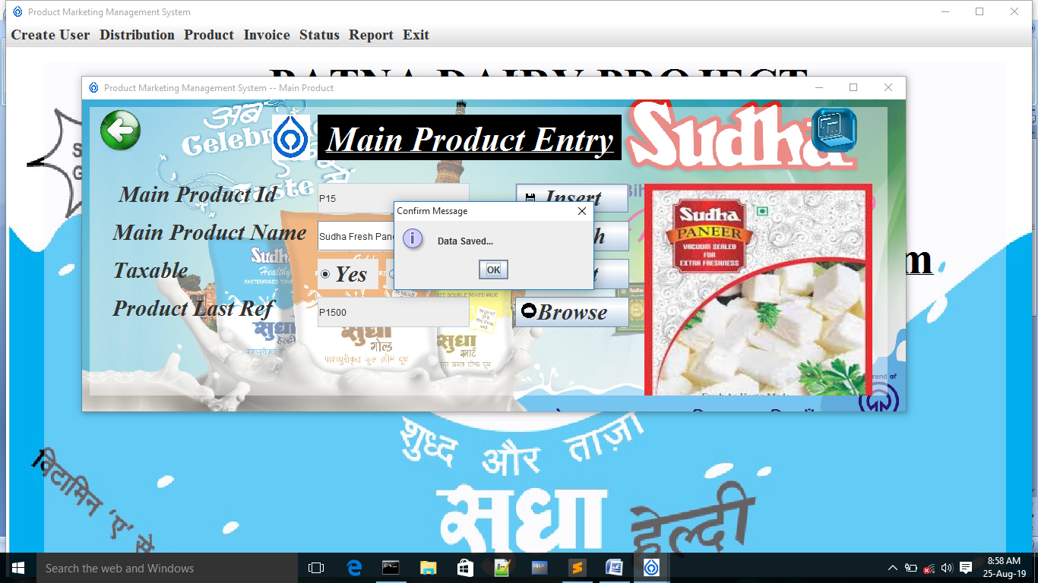

import javax.swing.*;

import java.awt.*;

import java.awt.event.*;

import com.toedter.calendar.*;

import java.io.*;

import java.text.*;

import java.sql.*;

import java.awt.event.ActionListener;

import java.util.regex.*;

public class MainProductMaster extends JFrame implements ActionListener

{

Connection con;

PreparedStatement pst;

File f;

ResultSet rst;

int opt;

{

try

{

Class.forName("oracle.jdbc.driver.OracleDriver");

con=DriverManager.getConnection("jdbc:oracle:thin:@localhost:1521:XE","sudha","sudha123");

}

catch(SQLException e)

{

System.out.println(e);

}

catch(ClassNotFoundException e)

{System.out.println(e);}

}

JLabel lbl=new JLabel("<html><u> Main Product Entry</u></html>");

JLabel lbl1=new JLabel(" Main Product Id");

JLabel lbl2=new JLabel("Main Product Name");

JLabel lbl2E=new JLabel();

JLabel lbl3=new JLabel("Taxable");

JLabel lbl4=new JLabel("Product Last Ref");

JLabel lbl5=new JLabel();

JTextField txt1=new JTextField();

JTextField txt2=new JTextField();

JTextField txt4=new JTextField();

JRadioButton r1 = new JRadioButton("Yes");

JRadioButton r2 = new JRadioButton("No");

ButtonGroup bg = new ButtonGroup();

JLabel sicon=new JLabel()

{

public void paintComponent(Graphics g)

{

super.paintComponent(g);

g.drawImage(new ImageIcon("icon.jpg").getImage(),0 , 0 ,50,60 , null);

}

};

JButton btn=new JButton("Browse")

{

public void paintComponent(Graphics g)

{

super.paintComponent(g);

g.drawImage(new ImageIcon("browse.png").getImage(),8 , 8 ,20,20 , null);

}

};

JButton btn1=new JButton("Insert")

{

public void paintComponent(Graphics g)

{

super.paintComponent(g);

g.drawImage(new ImageIcon("insert.png").getImage(),0 , 0 ,40,40 , null);

}

};

JButton btn2=new JButton("Search")

{

public void paintComponent(Graphics g)

{

super.paintComponent(g);

g.drawImage(new ImageIcon("search.png").getImage(),5 , 10 ,20,20 , null);

}

};

JButton btn3=new JButton("Reset")

{

public void paintComponent(Graphics g)

{

super.paintComponent(g);

g.drawImage(new ImageIcon("reset.png").getImage(),0 , 0 ,40,40 , null);

}

};

JButton btn4=new JButton("Exit")

{

public void paintComponent(Graphics g)

{

super.paintComponent(g);

g.drawImage(new ImageIcon("back1.png").getImage(),0 , 0 ,60,60 , null);

}

};

JButton backup = new JButton()

{

public void paintComponent(Graphics g)

{

super.paintComponent(g);

g.drawImage(new ImageIcon("backup.png").getImage(),0 , 0 ,60,60 , null);

}

};

JPanel p1=new JPanel()

{

public void paintComponent(Graphics g)

{

super.paintComponent(g);

g.drawImage(new ImageIcon("pro1.jpg").getImage(),0,0,1100,450,null);

}

};

JPanel p2=new JPanel();

Toolkit toolkit=Toolkit.getDefaultToolkit();

Dimension dimension=toolkit.getScreenSize();

int w;

int h;

{

w=(int)dimension.getWidth();

h=(int)dimension.getHeight();

}

MainProductMaster()

{

setTitle("Product Marketing Management System -- Main Product");

if(LoginForm.admin_login.equals("admin") && LoginForm.pwd_login.equals("sudha123"))

{

btn.setVisible(true);

btn1.setVisible(true);

btn2.setVisible(true);

btn3.setVisible(true);

btn4.setVisible(true);

try

{

pst=con.prepareStatement("Select max(to_number(substr(main_prod_id,2))) from main_product_master order by (to_number(substr(main_prod_id,2))) desc");

int id=1;

ResultSet rst=pst.executeQuery();

if(rst.next())

{

id=rst.getInt(id)+1;

}

if(id<10)

{

txt1.setText("P"+"0"+String.valueOf(id));

}

else if(id>=10 && id<100)

{

txt1.setText("P"+String.valueOf(id));

}

else

{

txt1.setText("Out of Bounds");

}

}

catch(Exception ee){System.out.println(ee);}

}

else

{

btn1.setVisible(false);

btn.setVisible(true);

btn2.setVisible(true);

btn3.setVisible(true);

btn4.setVisible(true);

}

add(p1);

p1.setBounds(100, 100 , 1100 , 450);

p1.setBackground(Color.PINK);

p1.setLayout(null);

p2.setBounds(10,10,1050,380);

p1.add(p2);

p2.setBackground(new Color(255,255,255,120));

p2.setLayout(null);

lbl.setBounds(300 , 10 , 400 ,60);

p2.add(lbl);p2.add(lbl);

lbl.setHorizontalAlignment(JLabel.CENTER);

lbl.setVerticalAlignment(JLabel.CENTER);

lbl.setFont(new Font("Times New Roman",Font.ITALIC+Font.BOLD,45));

lbl.setForeground(Color.WHITE);lbl.setOpaque(true);

lbl.setBackground(Color.BLACK);

p2.add(sicon);sicon.setBounds(240 , 10 , 50 , 60);

setIconImage(new ImageIcon("icon.jpg").getImage());

lbl1.setBounds(30,90,250,50);p2.add(lbl1);

lbl1.setFont(new Font("Times New Roman",Font.ITALIC+Font.BOLD,30));

lbl2.setBounds(30,140,260,50);p2.add(lbl2);

lbl2.setFont(new Font("Times New Roman",Font.ITALIC+Font.BOLD,30));

lbl2E.setBounds(460,140,50,50); p2.add(lbl2E);

lbl2E.setFont(new Font( "Arial",Font.PLAIN ,20));

lbl2E.setForeground(Color.RED);

lbl3.setBounds(30,190,250,50);p2.add(lbl3);

lbl3.setFont(new Font("Times New Roman",Font.ITALIC+Font.BOLD,30));

lbl4.setBounds(30,240,250,50);p2.add(lbl4);

lbl4.setFont(new Font("Times New Roman",Font.ITALIC+Font.BOLD,30));

lbl5.setBounds(730,100,300,300);p2.add(lbl5);

lbl5.setFont(new Font("Times New Roman",Font.ITALIC+Font.BOLD,30));

txt1.setBounds(300,100,200,40);

p2.add(txt1);txt1.setEditable(false);

txt2.setBounds(300,150,200,40);

p2.add(txt2);

r1.setBounds(300,200,80,40);r2.setBounds(390,200,80,40);

r1.setFont(new Font("Times New Roman",Font.ITALIC+Font.BOLD,30));

r2.setFont(new Font("Times New Roman",Font.ITALIC+Font.BOLD,30));

bg.add(r1);r1.setSelected(false);

bg.add(r2);r2.setSelected(false);

p2.add(r1);p2.add(r2);

txt4.setBounds(300,250,200,40);txt4.setEditable(false);

p2.add(txt4);

p2.add(btn1);

btn1.setBounds(560,100,150,40);

btn1.setFont(new Font("Times New Roman",Font.ITALIC+Font.BOLD,30));

p2.add(btn2);

btn2.setFont(new Font("Times New Roman",Font.ITALIC+Font.BOLD,30));

btn2.setBounds(560,150,150,40);

p2.add(btn3);

btn3.setFont(new Font("Times New Roman",Font.ITALIC+Font.BOLD,30));

btn3.setBounds(560,200,150,40);

p2.add(btn4);

btn4.setBounds(10,0,60,60);

btn4.setContentAreaFilled(false);

btn4.setBorderPainted(false);

p2.add(btn);

btn.setFont(new Font("Times New Roman",Font.ITALIC+Font.BOLD,30));

btn.setBounds(560,250,150,40);

p2.add(backup);backup.setBounds(950,0,60,60);

backup.setContentAreaFilled(false);

backup.setBorderPainted(false);

setBounds(100 , 100 , 1100 , 450);

setVisible(true);

btn.addActionListener(this);

btn1.addActionListener(this);

btn2.addActionListener(this);

btn3.addActionListener(this);

btn4.addActionListener(this);

backup.addActionListener(this);

}

public void actionPerformed(ActionEvent evt)

{

if(evt.getSource()==btn)

{

repaint();

JFileChooser fchooser=new JFileChooser();

int opt=fchooser.showOpenDialog(this);

if(opt==JFileChooser.OPEN_DIALOG)

{

f=fchooser.getSelectedFile();

String path=f.getAbsolutePath();

Image img=Toolkit.getDefaultToolkit().getImage(path);

Image img1=img.getScaledInstance(300,300,Image.SCALE_SMOOTH);

lbl5.setIcon(new ImageIcon(img1));

}

}

if(evt.getSource()==btn1)

{

repaint();

boolean temp=false;

if(!validationname.checkname(txt2.getText()))

{

JOptionPane.showMessageDialog(this,"Main Product Name Should Contain Only Alphabets...","Error Message",JOptionPane.ERROR_MESSAGE);

temp=true;

}

else

{

temp=false;

}

if(temp){

JOptionPane.showMessageDialog(this,"Recheck your details...","Error Message",JOptionPane.ERROR_MESSAGE);

return;

}

String taxable="";

if(r1.isSelected())

taxable="Yes";

else if(r2.isSelected())

taxable="No";

try

{

txt4.setText(txt1.getText()+"00");

pst=con.prepareStatement("insert into Main_Product_Master values(?,?,?,?,?)");

pst.setString(1,txt1.getText());

pst.setString(2,txt2.getText());

pst.setString(3,taxable);

pst.setString(4,txt4.getText());

pst.setBinaryStream(5,new FileInputStream(f),(int)f.length());

if(pst.executeUpdate()>0)

{

JOptionPane.showMessageDialog(this,"Data Saved...","Confirm Message",JOptionPane.INFORMATION_MESSAGE);

}

else

{

JOptionPane.showMessageDialog(this,"Data Not Saved...","Eror Message",JOptionPane.ERROR_MESSAGE);

}

}

catch(Exception e)

{

JOptionPane.showMessageDialog(this,"Data Not Saved","Eror Message",JOptionPane.ERROR_MESSAGE);

}

}

else if(evt.getSource()==btn3){

repaint();

reset();}

else if(evt.getSource()==btn4)

{

repaint();

int opt= JOptionPane.showConfirmDialog(this,"Do You Want To Exit...");

if(opt==JOptionPane.YES_OPTION)

{

dispose();

}

}

else if(evt.getSource()==btn2)

{

repaint();

String id=JOptionPane.showInputDialog(this,"Enter Your Main Product Id");

try

{

pst =con.prepareStatement("Select * from main_product_master where main_prod_id=?");

pst.setString(1,id);

rst=pst.executeQuery();

if(rst.next())

{

txt1.setText(rst.getString("main_prod_id"));

txt2.setText(rst.getString("main_prod_name"));

String g=rst.getString("taxable");

if(g.equalsIgnoreCase("yes"))

r1.setSelected(true);

else if(g.equalsIgnoreCase("no"))

r2.setSelected(true);

txt4.setText(rst.getString("prod_last_ref"));

byte b[]=rst.getBytes("Prod_image");

Image img=Toolkit.getDefaultToolkit().createImage(b);

img=img.getScaledInstance(300,300,Image.SCALE_SMOOTH);

lbl5.setIcon(new ImageIcon(img));

}

else

{

lbl5.setIcon(null);

JOptionPane.showMessageDialog(this,"Data Not Found","Error Message",JOptionPane.ERROR_MESSAGE);

}

}

catch(Exception e){JOptionPane.showMessageDialog(this,"Data Not Found","Error Message",JOptionPane.ERROR_MESSAGE);}

}

if(evt.getSource() == backup)

{ repaint();

String d = new SimpleDateFormat("dd-MMM-yyyy").format(new java.util.Date());

String fnm = "SudhaMainProduct"+d;

String s = "exp sudha/sudha123 file = D:\\BackupMainProduct\\"+fnm+".dmp";

try

{

Process p = Runtime.getRuntime().exec(s);

JOptionPane.showMessageDialog(this,"BackUp Done...","Confirm Message",JOptionPane.INFORMATION_MESSAGE);

}

catch(Exception e){JOptionPane.showMessageDialog(this,"BackUp Not Done...","Error Message",JOptionPane.ERROR_MESSAGE); }

}

}

public void reset()

{

repaint();

try

{

pst=con.prepareStatement("Select max(to_number(substr(main_prod_id,2))) from main_product_master order by (to_number(substr(main_prod_id,2))) desc");

int id=1;

ResultSet rst=pst.executeQuery();

if(rst.next())

{

id=rst.getInt(id)+1;

}

if(id<10)

{

txt1.setText("P"+"0"+String.valueOf(id));

}

else if(id>=10 && id<100)

{

txt1.setText("P"+String.valueOf(id));

}

else

{

txt1.setText("Out of Bounds");

}

}

catch(Exception ee){System.out.println(ee);}

txt2.setText("");

txt4.setText("");

bg.clearSelection();

lbl5.setIcon(new ImageIcon(""));

}

public static void main(String[]args)

{

new MainProductMaster();

}

}

**PRODUCT MASTER ENTRY**

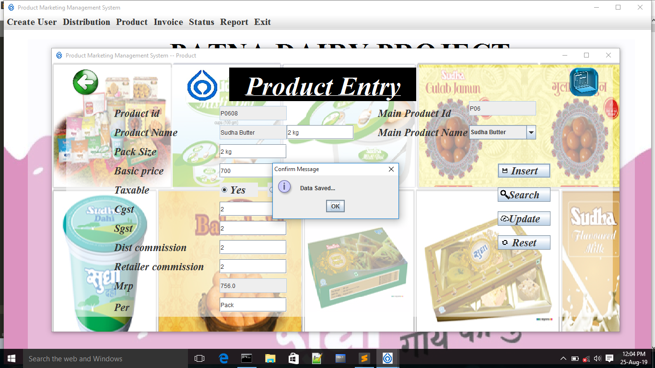

import javax.swing.*;

import java.awt.*;

import java.awt.event.*;

import com.toedter.calendar.*;

import java.io.*;

import java.text.*;

import java.sql.*;

import java.awt.event.ActionListener;

import java.util.regex.*;

public class ProductMaster extends JFrame implements ActionListener , FocusListener

{

Connection con;

PreparedStatement pst;

File f;

ResultSet rst;

int opt;

JLabel lbl=new JLabel("<html><u>Product Entry</u></html>");

JLabel lbl1=new JLabel("Product id");

JLabel lbl2=new JLabel("Product Name");

JLabel lbl3=new JLabel("Pack Size");

JLabel lbl3E=new JLabel();

JLabel lbl4=new JLabel("Basic price");

JLabel lbl4E=new JLabel();

JLabel lbl5=new JLabel("Taxable");

JLabel lbl6=new JLabel("Cgst");

JLabel lbl6E=new JLabel();

JLabel lbl7=new JLabel("Sgst");

JLabel lbl7E=new JLabel();

JLabel lbl8=new JLabel("Dist commission");

JLabel lbl8E=new JLabel();

JLabel lbl9=new JLabel("Retailer commission");

JLabel lbl9E=new JLabel();

JLabel lbl10=new JLabel("Mrp");

JLabel lbl10E=new JLabel();

JLabel lbl11=new JLabel("Main Product Id");

JLabel lbl12=new JLabel("Main Product Name");

JLabel lbl13=new JLabel("Per");

JTextField txt1=new JTextField();

JTextField txt21=new JTextField();JTextField txt22=new JTextField();

JTextField txt3=new JTextField();

JTextField txt4=new JTextField();

JRadioButton r1 = new JRadioButton("Yes");

JRadioButton r2 = new JRadioButton("No");

JTextField txt6=new JTextField();

JTextField txt7=new JTextField();

JTextField txt8=new JTextField();

JTextField txt9=new JTextField();

JTextField txt10=new JTextField();

JTextField txt11=new JTextField();

JTextField txt12=new JTextField();

JComboBox cmb1=new JComboBox();

ButtonGroup bg = new ButtonGroup();

JButton btn1=new JButton("Insert")

{

public void paintComponent(Graphics g)

{

super.paintComponent(g);

g.drawImage(new ImageIcon("insert.png").getImage(),0 , 0 ,30,30 , null);

}

};

JButton btn2=new JButton("Search")

{

public void paintComponent(Graphics g)

{

super.paintComponent(g);

g.drawImage(new ImageIcon("search.png").getImage(),5 , 5 ,20,20 , null);

}

};

JButton btn3=new JButton("Update")

{

public void paintComponent(Graphics g)

{

super.paintComponent(g);

g.drawImage(new ImageIcon("update.png").getImage(),5 , 5 ,20,20 , null);

}

};

JButton btn4=new JButton("Reset")

{

public void paintComponent(Graphics g)

{

super.paintComponent(g);

g.drawImage(new ImageIcon("reset.png").getImage(),0 , 0 ,30,30 , null);

}

};

JButton btn5=new JButton()

{

public void paintComponent(Graphics g)

{

super.paintComponent(g);

g.drawImage(new ImageIcon("back1.png").getImage(),0 , 0 ,60,60 , null);

}

};

JLabel sicon=new JLabel()

{

public void paintComponent(Graphics g)

{

super.paintComponent(g);

g.drawImage(new ImageIcon("icon.jpg").getImage(),0 , 0 ,70,70 , null);

}

};

JButton backup = new JButton()

{

public void paintComponent(Graphics g)

{

super.paintComponent(g);

g.drawImage(new ImageIcon("backup.png").getImage(),0 , 0 ,60,60 , null);

}

};

{

try

{

Class.forName("oracle.jdbc.driver.OracleDriver");

con=DriverManager.getConnection("jdbc:oracle:thin:@localhost:1521:XE","sudha","sudha123");

pst=con.prepareStatement("Select Main_prod_name from main_product_master");

rst=pst.executeQuery();

while(rst.next())

{

cmb1.addItem(rst.getString(1));

}

pst=con.prepareStatement("Select prod_name from product_master");

ResultSet rst=pst.executeQuery();

}

catch(SQLException e)

{

System.out.println(e);

}

catch(ClassNotFoundException e)

{System.out.println(e);}

}

JPanel p1=new JPanel()

{

public void paintComponent(Graphics g)

{

super.paintComponent(g);

g.drawImage(new ImageIcon("pro.jpg").getImage(),0,0,1200,600,null);

}

};

JPanel p2=new JPanel();

Toolkit toolkit=Toolkit.getDefaultToolkit();

Dimension dimension=toolkit.getScreenSize();

int w;

int h;

{

w=(int)dimension.getWidth();

h=(int)dimension.getHeight();

}

ProductMaster()

{

setTitle("Product Marketing Management System -- Product");

if(LoginForm.admin_login.equals("admin") && LoginForm.pwd_login.equals("sudha123"))

{

btn1.setVisible(true);

btn2.setVisible(true);

btn3.setVisible(true);

btn4.setVisible(true);

btn5.setVisible(true);

}

else

{

btn1.setVisible(false);

btn2.setVisible(true);

btn3.setVisible(true);

btn4.setVisible(true);

btn5.setVisible(true);

}

add(p1);

p1.setBackground(Color.ORANGE);

p1.setLayout(null);

p2.setBounds(30,10,1140,520);

p1.add(p2);

p2.setBackground(new Color(255,255,255,140));

setIconImage(new ImageIcon("icon.jpg").getImage());

p2.setLayout(null);

lbl.setBounds(340,0,390,70);

p2.add(lbl);

p2.add(lbl);

p2.add(sicon);sicon.setBounds(250 , 3 , 70 , 70);

lbl.setHorizontalAlignment(JLabel.CENTER);

lbl.setVerticalAlignment(JLabel.CENTER);

lbl.setFont(new Font("Times New Roman",Font.ITALIC+Font.BOLD,55));

lbl.setForeground(Color.WHITE);lbl.setOpaque(true);

lbl.setBackground(Color.BLACK);

lbl1.setBounds(100,70,150,50);p2.add(lbl1);

lbl1.setFont(new Font("Times New Roman",Font.ITALIC+Font.BOLD,22));

lbl2.setBounds(100,110,150,50);p2.add(lbl2);

lbl2.setFont(new Font("Times New Roman",Font.ITALIC+Font.BOLD,22));

lbl3.setBounds(100,150,150,50);p2.add(lbl3);

lbl3.setFont(new Font("Times New Roman",Font.ITALIC+Font.BOLD,22));

lbl3E.setBounds(520,150,250,50); p2.add(lbl3E);

lbl3E.setFont(new Font( "Arial",Font.PLAIN ,22));

lbl3E.setForeground(Color.RED);

lbl4.setBounds(100,190,150,50);p2.add(lbl4);

lbl4.setFont(new Font("Times New Roman",Font.ITALIC+Font.BOLD,22));

lbl4E.setBounds(520,190,250,50); p2.add(lbl4E);

lbl4E.setFont(new Font( "Arial",Font.PLAIN ,22));

lbl4E.setForeground(Color.RED);

lbl5.setBounds(100,230,150,50);p2.add(lbl5);

lbl5.setFont(new Font("Times New Roman",Font.ITALIC+Font.BOLD,22));

lbl6.setBounds(100,270,150,50);p2.add(lbl6);

lbl6.setFont(new Font("Times New Roman",Font.ITALIC+Font.BOLD,22));

lbl6E.setBounds(520,270,250,50); p2.add(lbl6E);

lbl6E.setFont(new Font( "Arial",Font.PLAIN ,22));

lbl6E.setForeground(Color.RED);

lbl7.setBounds(100,310,150,50);p2.add(lbl7);

lbl7.setFont(new Font("Times New Roman",Font.ITALIC+Font.BOLD,22));

lbl7E.setBounds(520,310,250,50); p2.add(lbl7E);

lbl7E.setFont(new Font( "Arial",Font.PLAIN ,22));

lbl7E.setForeground(Color.RED);

lbl8.setBounds(100,350,170,50);p2.add(lbl8);

lbl8.setFont(new Font("Times New Roman",Font.ITALIC+Font.BOLD,22));

lbl8E.setBounds(520,350,250,50); p2.add(lbl8E);

lbl8E.setFont(new Font( "Arial",Font.PLAIN ,22));

lbl8E.setForeground(Color.RED);

lbl9.setBounds(100,390,200,50);p2.add(lbl9);

lbl9.setFont(new Font("Times New Roman",Font.ITALIC+Font.BOLD,22));

lbl9E.setBounds(520,390,250,50); p2.add(lbl9E);

lbl9E.setFont(new Font( "Arial",Font.PLAIN ,22));

lbl9E.setForeground(Color.RED);

lbl10.setBounds(100,430,150,50);p2.add(lbl10);

lbl10.setFont(new Font("Times New Roman",Font.ITALIC+Font.BOLD,22));

lbl13.setBounds(100,475,150,50);p2.add(lbl13);

lbl13.setFont(new Font("Times New Roman",Font.ITALIC+Font.BOLD,22));

lbl10E.setBounds(520,430,250,50); p2.add(lbl10E);

lbl10E.setFont(new Font( "Arial",Font.PLAIN ,22));

lbl10E.setForeground(Color.RED);

lbl11.setBounds(650,70,190,50);p2.add(lbl11);

lbl11.setFont(new Font("Times New Roman",Font.ITALIC+Font.BOLD,22));

lbl12.setBounds(650,110,190,50);p2.add(lbl12);

lbl12.setFont(new Font("Times New Roman",Font.ITALIC+Font.BOLD,22));

txt1.setBounds(320,80,140,30);

p2.add(txt1);txt1.setEditable(false);

txt21.setBounds(320,120,140,30);

p2.add(txt21);txt21.setEditable(false);

txt22.setBounds(460,120,140,30);

p2.add(txt22);

txt3.setBounds(320,160,140,30);

p2.add(txt3);

txt4.setBounds(320,200,140,30);

p2.add(txt4);

r1.setBounds(320,240,80,30);r2.setBounds(420,240,80,30);

r1.setFont(new Font("Times New Roman",Font.ITALIC+Font.BOLD,23));

r2.setFont(new Font("Times New Roman",Font.ITALIC+Font.BOLD,23));

bg.add(r1);bg.add(r2);

p2.add(r1);p2.add(r2);

txt6.setBounds(320,280,140,30);

p2.add(txt6);

txt7.setBounds(320,320,140,30);

p2.add(txt7);

txt8.setBounds(320,360,140,30);

p2.add(txt8);

txt9.setBounds(320,400,140,30);

p2.add(txt9);

txt10.setBounds(320,440,140,30);txt10.setEditable(false);

p2.add(txt10);

txt11.setBounds(840,70,140,30);

p2.add(txt11);txt11.setEditable(false);

txt12.setBounds(320,480,140,30);

p2.add(txt12);

cmb1.setBounds(840,120,140,30);p2.add(cmb1);

cmb1.addItem("Sudha Balushahi");

cmb1.addItem("Sudha Dahi");

cmb1.addItem("Sudha Rassogulla");

cmb1.addItem("sudha Raskadam");

cmb1.addItem("Sudha Gulab-jamun");

cmb1.addItem("Sudha Butter");

cmb1.addItem("Sudha Kalakand");

cmb1.addItem("Sudha Paneer");

cmb1.addItem("Sudha Peda");

cmb1.addItem("Sudha Ghee");

cmb1.addItem("Sudha Lassi");

p2.add(btn1);

btn1.setFont(new Font("Times New Roman",Font.ITALIC+Font.BOLD,22));

btn1.setBounds(900,200,110,30);

p2.add(btn2);

btn2.setFont(new Font("Times New Roman",Font.ITALIC+Font.BOLD,22));

btn2.setBounds(900,250,110,30);

p2.add(btn3);

btn3.setFont(new Font("Times New Roman",Font.ITALIC+Font.BOLD,22));

btn3.setBounds(900,300,110,30);

p2.add(btn4);

btn4.setFont(new Font("Times New Roman",Font.ITALIC+Font.BOLD,22));

btn4.setBounds(900,350,110,30);

p2.add(btn5);

btn5.setBounds(10,0,60,60);

btn5.setContentAreaFilled(false);

btn5.setBorderPainted(false);

p2.add(backup);backup.setBounds(1050,0,60,60);

backup.setContentAreaFilled(false);

backup.setBorderPainted(false);

setBounds(100 , 100 , 1200,600);

setVisible(true);

btn1.addActionListener(this);

btn2.addActionListener(this);

btn3.addActionListener(this);

btn4.addActionListener(this);

btn5.addActionListener(this);

backup.addActionListener(this);

cmb1.addActionListener(this);

txt10.addFocusListener(this);

//txt2.addActionListener(this);

}

public void focusGained(FocusEvent evtt)

{

if(evtt.getSource()==txt10)

{

repaint();

float a = Float.parseFloat(txt4.getText());

float b = Float.parseFloat(txt6.getText());

float c = Float.parseFloat(txt7.getText());

float d = Float.parseFloat(txt8.getText());

float e = Float.parseFloat(txt9.getText());

float u = 0.0f;

u = a+((b/100)*a)+((c/100)*a)+((d/100)*a)+((e/100)*a);

txt10.setText(String.valueOf(u));

}

}

public void focusLost(FocusEvent evtt)

{

repaint();

}

public void actionPerformed(ActionEvent evt)

{

String taxable="";

if(r1.isSelected())

taxable="Yes";

else if(r2.isSelected())

taxable="No";

if(evt.getSource()==cmb1)

{

repaint();

try

{

pst=con.prepareStatement("Select Main_prod_id from main_product_master where main_prod_name=?");

pst.setString(1,cmb1.getSelectedItem().toString());

ResultSet rst=pst.executeQuery();

if(rst.next())

{

txt11.setText(rst.getString(1));

try

{

pst=con.prepareStatement("Select to_number(substr(prod_last_ref,4)) from main_product_master where main_prod_id = ?");

int id=1;

pst.setString(1,txt11.getText());

rst=pst.executeQuery();

if(rst.next())

{

id=rst.getInt(id)+1;

}

if(id<10)

{

txt1.setText(txt11.getText()+"0"+String.valueOf(id));

}

else if(id>=10 && id<100)

{

txt1.setText(txt11.getText()+String.valueOf(id));

}

else

{

txt1.setText("Out of Bounds");

}

txt21.setText(cmb1.getSelectedItem().toString());

}

catch(Exception ee){System.out.println(ee);}

}

}

catch(SQLException e)

{

System.out.println(e);

}

}

if(evt.getSource()==btn1)

{

repaint();

boolean temp=false;

if(!validationnumeric.checknumeric(txt3.getText()))

{

lbl3E.setText("***");

temp=true;

}

else

{

lbl3E.setText("");

temp = false;

}

if(!validationnumeric1.checknumeric1(txt4.getText()))

{

lbl4E.setText("***");

temp=true;

}

else

{

lbl4E.setText("");

temp=false;

}

if(!validationnumeric1.checknumeric1(txt6.getText()))

{

lbl6E.setText("***");

temp=true;

}

else

{

lbl6E.setText("");

temp=false;

}

if(!validationnumeric1.checknumeric1(txt7.getText()))

{

lbl7E.setText("***");

temp=true;

}

else

{

lbl7E.setText("");

temp=false;

}

if(!validationnumeric1.checknumeric1(txt8.getText()))

{

lbl8E.setText("***");

temp=true;

}

else

{

lbl8E.setText("");

temp=false;

}

if(!validationnumeric1.checknumeric1(txt9.getText()))

{

lbl9E.setText("***");

temp=true;

}

else

{

lbl9E.setText("");

temp=false;

}

if(!validationnumeric1.checknumeric1(txt10.getText()))

{

lbl10E.setText("***");

temp=true;

}

else

{

lbl10E.setText("");

temp=false;

}

String prd_nm = txt21.getText() + txt22.getText();

if(temp){return;}

try

{

pst=con.prepareStatement("insert into Product_Master values(?,?,?,?,?,?,?,?,?,?,?)");

pst.setString(1,txt1.getText());

pst.setString(2,prd_nm);

pst.setString(3,txt3.getText());

pst.setString(4,txt4.getText());

pst.setString(5,taxable);

pst.setString(6,txt6.getText());

pst.setString(7,txt7.getText());

pst.setString(8,txt8.getText());

pst.setString(9,txt9.getText());

pst.setString(10,txt10.getText());

pst.setString(11,txt12.getText());

if(pst.executeUpdate()>0)

{

String plf = "";

PreparedStatement pst1=con.prepareStatement("Select to_number(substr(prod_last_ref,4)) from main_product_master where main_prod_id = ?");

int id=1;

pst1.setString(1,txt11.getText());

rst=pst1.executeQuery();

if(rst.next())

{

id=rst.getInt(id)+1;

System.out.println(id);

}

if(id<10)

{

plf = txt11.getText()+"0"+String.valueOf(id);

}

else if(id>=10 && id<100)

{

plf = txt11.getText()+String.valueOf(id);

}

pst1=con.prepareStatement("update main_product_master set prod_last_ref =? where main_prod_id=?");

pst1.setString(1,plf);

pst1.setString(2,txt11.getText());

if(pst1.executeUpdate()>0)

{

System.out.println("Done");

}

JOptionPane.showMessageDialog(this,"Data Saved...","Confirm Message",JOptionPane.INFORMATION_MESSAGE);

}

else

{

JOptionPane.showMessageDialog(this,"Data Not Saved...","Eror Message",JOptionPane.ERROR_MESSAGE);

}

}

catch(Exception e)

{

JOptionPane.showMessageDialog(this,"Data Not Saved...","Eror Message",JOptionPane.ERROR_MESSAGE);

}

}

if(evt.getSource()==btn3)

{

repaint();

try

{ pst=con.prepareStatement("update product_master set basic_Price=?,taxable=?,cgst=?,sgst=?,dist_commission=?,retailer_commission=?,mrp=? where prod_id=?");

pst.setInt(1,Integer.parseInt(txt4.getText()));

pst.setString(2,taxable);

pst.setInt(3,Integer.parseInt(txt6.getText()));

pst.setInt(4,Integer.parseInt(txt7.getText()));

pst.setInt(5,Integer.parseInt(txt8.getText()));

pst.setInt(6,Integer.parseInt(txt9.getText()));

pst.setInt(7,Integer.parseInt(txt10.getText()));

pst.setString(8,txt1.getText());

if(pst.executeUpdate()>0)

{

JOptionPane.showMessageDialog(this,"Data Updated...","Confirm Message",JOptionPane.INFORMATION_MESSAGE);

}

else

{

JOptionPane.showMessageDialog(this,"Data Not Updated...","Eror Message",JOptionPane.ERROR_MESSAGE);

}

}

catch(SQLException e)

{

JOptionPane.showMessageDialog(this,"Data Not Updated...","Eror Message",JOptionPane.ERROR_MESSAGE);

}

}

else if(evt.getSource()==btn4){

repaint();

reset();}

else if(evt.getSource()==btn5)

{

int opt= JOptionPane.showConfirmDialog(this,"Do You Want To Exit...");

if(opt==JOptionPane.YES_OPTION)

{

dispose();

}

}

else if(evt.getSource()==btn2)

{

repaint();

String id=JOptionPane.showInputDialog(this,"Enter Your Product Id");

cmb1.setEnabled(false);

try

{

pst =con.prepareStatement("Select * from product_master where prod_id=?");

pst.setString(1,id);

rst=pst.executeQuery();

if(rst.next())

{

txt1.setText(rst.getString("prod_id"));txt1.setEditable(false);

txt21.setText(rst.getString("prod_name"));txt21.setEditable(false);

txt22.setEditable(false);

txt3.setText(rst.getString("prod_unit"));txt3.setEditable(false);

txt4.setText(rst.getString("Basic_Price"));

String g=rst.getString("taxable");

if(g.equalsIgnoreCase("yes"))

r1.setSelected(true);

else if(g.equalsIgnoreCase("no"))

r2.setSelected(true);

txt6.setText(rst.getString("cgst"));

txt7.setText(rst.getString("sgst"));

txt8.setText(rst.getString("DIST_COMMISSION"));

txt9.setText(rst.getString("retailer_commission"));

txt10.setText(rst.getString("mrp"));

txt12.setText(rst.getString("per"));

}

else

{

lbl5.setIcon(null);

JOptionPane.showMessageDialog(this,"Data Not Found");

}

pst =con.prepareStatement("Select * from main_product_master where main_prod_id=substr(?,1,3)");

pst.setString(1,id);

rst=pst.executeQuery();

if(rst.next())

{

txt11.setText(rst.getString("main_prod_id"));

cmb1.setSelectedItem(rst.getString("main_prod_name"));

}

}

catch(Exception e){JOptionPane.showMessageDialog(this,"Data Not Found...","Eror Message",JOptionPane.ERROR_MESSAGE);}

}

if(evt.getSource() == backup)

{

repaint();

String d = new SimpleDateFormat("dd-MMM-yyyy").format(new java.util.Date());

String fnm = "SudhaProduct"+d;

String s = "exp sudha/sudha123 file = D:\\BackupProduct\\"+fnm+".dmp";

try

{

Process p = Runtime.getRuntime().exec(s);

JOptionPane.showMessageDialog(this,"BackUp Done...","Confirm Message",JOptionPane.INFORMATION_MESSAGE);

}

catch(Exception e){JOptionPane.showMessageDialog(this,"BackUp Not Done...","Error Message",JOptionPane.ERROR_MESSAGE); }

}

}

public void reset()

{

repaint();

txt1.setText("");txt1.setEditable(true);

txt21.setText("");

txt22.setText("");txt22.setEditable(true);

txt3.setText("");txt3.setEditable(true);

txt4.setText("");

r1.setEnabled(true);

r2.setEnabled(true);

r1.setSelected(false);

r2.setSelected(false);

txt6.setText("");

txt7.setText("");

txt8.setText("");

txt9.setText("");

txt10.setText("");

txt11.setText("");

txt12.setText("");

cmb1.setEnabled(true);

}

public static void main(String[]args)

{

new ProductMaster();

}

}

**ZONE MASTER**

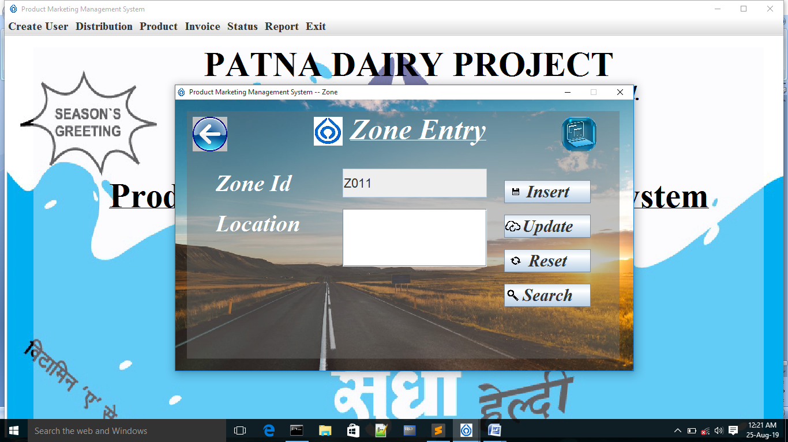

import javax.swing.*;

import java.awt.*;

import java.awt.event.*;

import java.text.*;

import java.sql.*;

public class zonemaster extends JFrame implements ActionListener

{

Connection con;

PreparedStatement pst;

ResultSet rst;

int opt;

{

try

{

Class.forName("oracle.jdbc.driver.OracleDriver");//class not found exception

con=DriverManager.getConnection("jdbc:oracle:thin:@localhost:1521:XE","sudha","sudha123");//sqlexcpetion

}

catch(SQLException e)

{

System.out.println(e);

}

catch(ClassNotFoundException e){}

}

JLabel lbl=new JLabel("<html><u>Zone Entry</u></html>");

JLabel zone=new JLabel("Zone Id");

JTextField tzone=new JTextField();

JLabel loc=new JLabel("Location");

JTextArea tloc=new JTextArea();

JScrollPane jsp=new JScrollPane(tloc);

JButton insert=new JButton("Insert")

{

public void paintComponent(Graphics g)

{

super.paintComponent(g);

g.drawImage(new ImageIcon("insert.png").getImage(),0 , 0 ,40,40 , null);

}

};

JLabel sicon=new JLabel()

{

public void paintComponent(Graphics g)

{

super.paintComponent(g);

g.drawImage(new ImageIcon("icon.jpg").getImage(),0 , 0 ,50,50 , null);

}

};

JButton update=new JButton("Update")

{

public void paintComponent(Graphics g)

{

super.paintComponent(g);

g.drawImage(new ImageIcon("update.png").getImage(),0 , 5 ,30,30 , null);

}

};

JButton search=new JButton("Search")

{

public void paintComponent(Graphics g)

{

super.paintComponent(g);

g.drawImage(new ImageIcon("search.png").getImage(),5 , 10 ,20,20 , null);

}

};

JButton reset=new JButton("Reset")

{

public void paintComponent(Graphics g)

{

super.paintComponent(g);

g.drawImage(new ImageIcon("reset.png").getImage(),0 , 0 ,40,40 , null);

}

};

JButton exit=new JButton()

{

public void paintComponent(Graphics g)

{

super.paintComponent(g);

g.drawImage(new ImageIcon("back1 (2).png").getImage(),0 , 0 ,60,60 , null);

}

};

JButton backup = new JButton()

{

public void paintComponent(Graphics g)

{

super.paintComponent(g);

g.drawImage(new ImageIcon("backup.png").getImage(),0 , 0 , 60,60 , null);

}

};

JPanel pmaster=new JPanel()

{

public void paintComponent(Graphics g)

{

super.paintComponent(g);

g.drawImage(new ImageIcon("Travel.jpg").getImage(),0,0,800,500,null);

}

};

JPanel pchild=new JPanel();

Toolkit toolkit=Toolkit.getDefaultToolkit();

Dimension dimension=toolkit.getScreenSize();

int w,h;

{

w=(int)dimension.getWidth();

h=(int)dimension.getHeight();

}

zonemaster()

{

setTitle("Product Marketing Management System -- Zone");

if(LoginForm.admin_login.equals("admin") && LoginForm.pwd_login.equals("sudha123"))

{

insert.setVisible(true);

update.setVisible(true);

reset.setVisible(true);

search.setVisible(true);

exit.setVisible(true);

try

{

pst=con.prepareStatement("Select max(to_number(substr(zone_id,2))) from zone_master order by (to_number(substr(zone_id,2))) desc");

int id=1;

ResultSet rst=pst.executeQuery();

if(rst.next())

{

id=rst.getInt(id)+1;

System.out.println(id);

}

if(id<10)

{

tzone.setText("Z"+"00"+String.valueOf(id));

}

else if(id>=10 && id<100)

{

tzone.setText("Z"+"0"+String.valueOf(id));

}

else if(id>=100 && id<1000)

{

tzone.setText("Z"+String.valueOf(id));

}

else

{

tzone.setText("Out of Bounds");

}

}

catch(Exception ee){System.out.println(ee);}

}

else

{

insert.setVisible(false);

update.setVisible(true);

reset.setVisible(true);

search.setVisible(true);

exit.setVisible(true);

}

setResizable(false);

add(pmaster);

pmaster.setBackground(Color.WHITE);pmaster.setLayout(null);

pchild.setBounds(20,20,750,430);

pmaster.add(pchild);

pchild.setBackground(new Color(112,112,112,110));

pchild.setLayout(null);

lbl.setBounds(250,0,300,60);

pchild.add(lbl);

pchild.add(lbl);

lbl.setHorizontalAlignment(JLabel.CENTER);

lbl.setVerticalAlignment(JLabel.CENTER);

lbl.setFont(new Font("Times New Roman",Font.ITALIC+Font.BOLD,50));

pchild.add(sicon);sicon.setBounds(220 , 10 , 50 , 50);

setIconImage(new ImageIcon("icon.jpg").getImage());

//lbl.setBackground(Color.BLACK);lbl.setOpaque(true);

lbl.setForeground(Color.WHITE);

zone.setBounds(50,100,200,50);pchild.add(zone);

zone.setFont(new Font("Times New Roman",Font.ITALIC+Font.BOLD,40));zone.setForeground(Color.WHITE);

tzone.setBounds(270,100,250,50);pchild.add(tzone);tzone.setEditable(false);

tzone.setFont(new Font( "Arial",Font.PLAIN ,22));

loc.setBounds(50,170,200,50);pchild.add(loc);

loc.setFont(new Font("Times New Roman",Font.ITALIC+Font.BOLD,40));loc.setForeground(Color.WHITE);

jsp.setBounds(270,170,250,100);pchild.add(jsp);

tloc.setFont(new Font( "Arial",Font.PLAIN ,22));

insert.setBounds(550,120,150,40);pchild.add(insert);

insert.setFont(new Font("Times New Roman",Font.ITALIC+Font.BOLD,30));

update.setBounds(550,180,150,40);pchild.add(update);

update.setFont(new Font("Times New Roman",Font.ITALIC+Font.BOLD,30));

reset.setBounds(550,240,150,40);pchild.add(reset);

reset.setFont(new Font("Times New Roman",Font.ITALIC+Font.BOLD,30));

search.setBounds(550,300,150,40);pchild.add(search);

search.setFont(new Font("Times New Roman",Font.ITALIC+Font.BOLD,30));

pchild.add(exit);exit.setBounds(10, 10 , 60 , 60);

exit.setContentAreaFilled(false);

exit.setBorderPainted(false);

backup.setBounds(650,10,60,60);pchild.add(backup);

backup.setContentAreaFilled(false);

backup.setBorderPainted(false);

setBounds(80,80,800,500);

setVisible(true);

insert.addActionListener(this);

update.addActionListener(this);

reset.addActionListener(this);

search.addActionListener(this);

exit.addActionListener(this);

backup.addActionListener(this);

}

public void actionPerformed(ActionEvent evt)

{

if(evt.getSource()==exit)

{

int opt= JOptionPane.showConfirmDialog(this,"Do You Want To Exit...");

if(opt==JOptionPane.YES_OPTION)

{

dispose();

}

}

if(evt.getSource()==insert)

{

repaint();

try

{

pst=con.prepareStatement("insert into zone_master values(?,?)");

pst.setString(1,tzone.getText());

pst.setString(2,tloc.getText());

if(pst.executeUpdate()>0)

{

JOptionPane.showMessageDialog(this,"Data Saved...","Confirm Message",JOptionPane.INFORMATION_MESSAGE);

}

else

{

JOptionPane.showMessageDialog(this,"Data Not Saved...","Error Message",JOptionPane.ERROR_MESSAGE);

}

}

catch(Exception ex)

{

JOptionPane.showMessageDialog(this,"Data Not Saved...","Error Message",JOptionPane.ERROR_MESSAGE);

}

}

if(evt.getSource()==update)

{

repaint();

try

{

pst=con.prepareStatement("update zone_master set location=? where zone_id=?");

pst.setString(1,tloc.getText());

pst.setString(2,tzone.getText());

if(pst.executeUpdate()>0)

{

JOptionPane.showMessageDialog(this,"Data Updated...","Confirm Message",JOptionPane.INFORMATION_MESSAGE);

}

else

{JOptionPane.showMessageDialog(this,"Data Not Updtaed...","Error Message",JOptionPane.ERROR_MESSAGE);

}

}

catch(Exception et){JOptionPane.showMessageDialog(this,"Data Not Updated...","Error Message",JOptionPane.ERROR_MESSAGE);}

}

if(evt.getSource()==reset){

repaint();

reset();}

if(evt.getSource()==search)

{

repaint();

String id=JOptionPane.showInputDialog(this,"Enter Zone Id");

reset();

try

{

pst =con.prepareStatement("select * from zone_master where zone_id=?");

pst.setString(1,id);

rst=pst.executeQuery();

if(rst.next())

{

tzone.setText(rst.getString("zone_id"));

tloc.setText(rst.getString("location"));

tzone.setEditable(false);

tloc.setEditable(false);

}

else

{

JOptionPane.showMessageDialog(this,"Data Not Found","Error Message",JOptionPane.ERROR_MESSAGE);

}

}

catch(Exception ef){JOptionPane.showMessageDialog(this,"Data Not Found...","Error Message",JOptionPane.ERROR_MESSAGE);}

}

if(evt.getSource() == backup)

{

repaint();

String d = new SimpleDateFormat("dd-MMM-yyyy").format(new java.util.Date());

String fnm = "SudhaZone"+d;

String s = "exp sudha/sudha123 file = D:\\BackupZone\\"+fnm+".dmp";

try

{

Process p = Runtime.getRuntime().exec(s);

JOptionPane.showMessageDialog(this,"BackUp Done...","Confirm Message",JOptionPane.INFORMATION_MESSAGE);

}

catch(Exception e){JOptionPane.showMessageDialog(this,"BackUp Not Done...","Error Message",JOptionPane.ERROR_MESSAGE); }

}

}

public void reset()

{

repaint();

try

{

pst=con.prepareStatement("Select max(to_number(substr(zone_id,2))) from zone_master order by (to_number(substr(zone_id,2))) desc");

int id=1;

ResultSet rst=pst.executeQuery();

if(rst.next())

{

id=rst.getInt(id)+1;

System.out.println(id);

}

if(id<10)

{

tzone.setText("Z"+"00"+String.valueOf(id));

}

else if(id>=10 && id<100)

{

tzone.setText("Z"+"0"+String.valueOf(id));

}

else if(id>=100 && id<1000)

{

tzone.setText("Z"+String.valueOf(id));

}

else

{

tzone.setText("Out of Bounds");

}

}

catch(Exception ee){System.out.println(ee);}

tloc.setText("");

tzone.setEditable(true);

tloc.setEditable(true);

}

public static void main(String...args)

{

new zonemaster();

}

}

**DISTRIBUTOR MASTER ENTRY**

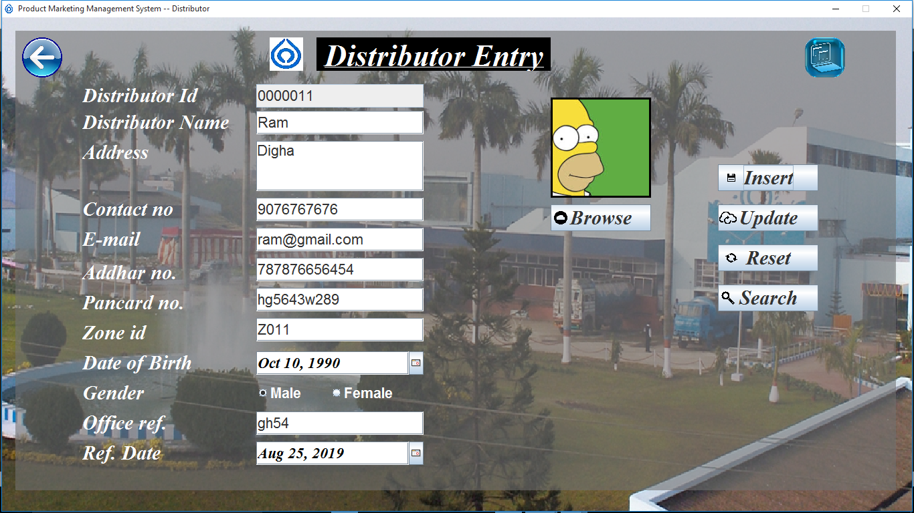

import javax.swing.*;

import java.awt.*;

import java.awt.event.*;

import com.toedter.calendar.*;

import java.io.*;

import java.text.*;

import java.sql.*;

public class distributermaster extends JFrame implements ActionListener

{

PreparedStatement pst;

Connection con;

ResultSet rst;

File f;

{

try

{

Class.forName("oracle.jdbc.driver.OracleDriver");//class not found exception

con=DriverManager.getConnection("jdbc:oracle:thin:@localhost:1521:XE","sudha","sudha123");//sqlexcpetion

}

catch(SQLException e)

{

System.out.println(e);

}

catch(ClassNotFoundException e){}

}

int opt;

JLabel lbL=new JLabel("<html><u>Distributor Entry</u></html>");

JLabel lbl=new JLabel("Distributor Id");

JLabel lbl1=new JLabel("Distributor Name");

JLabel lbl1E=new JLabel();

JLabel lbl2=new JLabel("Address");

JLabel lbl3=new JLabel("Contact no");

JLabel lbl3E=new JLabel();

JLabel lbl4=new JLabel("E-mail");

JLabel lbl4E=new JLabel("");

JLabel lbl5=new JLabel("Addhar no.");

JLabel lbl5E=new JLabel();

JLabel lbl6=new JLabel("Pancard no.");

JLabel lbl6E=new JLabel();

JLabel lbl7=new JLabel("Zone id");

JLabel lbl8=new JLabel("Date of Birth");

JLabel lbl9=new JLabel("Select Image");

JLabel lbl10=new JLabel("Office ref.");

JLabel lbl11=new JLabel("Ref. Date");

JTextField txt8=new JTextField();

JTextField txt=new JTextField();

JTextField txt1=new JTextField();

JTextArea txt2=new JTextArea();

JScrollPane jsp = new JScrollPane(txt2);

JTextField txt3=new JTextField();

JTextField txt4=new JTextField();

JTextField txt5=new JTextField();

JTextField txt6=new JTextField();

JTextField txt7=new JTextField();

JLabel Gen=new JLabel("Gender");

ButtonGroup bg=new ButtonGroup();

JRadioButton rm=new JRadioButton("Male");

JRadioButton rf=new JRadioButton("Female");

JLabel sicon=new JLabel()

{

public void paintComponent(Graphics g)

{

super.paintComponent(g);

g.drawImage(new ImageIcon("icon.jpg").getImage(),0 , 0 ,50,50 , null);

}

};

JButton insert=new JButton("Insert")

{

public void paintComponent(Graphics g)

{

super.paintComponent(g);

g.drawImage(new ImageIcon("insert.png").getImage(),0 , 0 ,40,40 , null);

}

};

JButton update=new JButton("Update")

{

public void paintComponent(Graphics g)

{

super.paintComponent(g);

g.drawImage(new ImageIcon("update.png").getImage(),0 , 5 ,30,30 , null);

}

};

JButton reset=new JButton("Reset")

{

public void paintComponent(Graphics g)

{

super.paintComponent(g);

g.drawImage(new ImageIcon("reset.png").getImage(),0 , 0 ,40,40 , null);

}

};

JButton search=new JButton("Search")

{

public void paintComponent(Graphics g)

{

super.paintComponent(g);

g.drawImage(new ImageIcon("search.png").getImage(),5 , 10 ,20,20 , null);

}

};

JButton exit=new JButton()

{

public void paintComponent(Graphics g)

{

super.paintComponent(g);

g.drawImage(new ImageIcon("back1 (2).png").getImage(),0 , 0 ,60,60 , null);

}

};

JButton browse=new JButton("Browse")

{

public void paintComponent(Graphics g)

{

super.paintComponent(g);

g.drawImage(new ImageIcon("browse.png").getImage(),5 , 10 ,20,20 , null);

}

};

JButton backup = new JButton()

{

public void paintComponent(Graphics g)

{

super.paintComponent(g);

g.drawImage(new ImageIcon("backup.png").getImage(),0 , 0 ,60,60 , null);

}

};

JPanel p1=new JPanel()

{

public void paintComponent(Graphics g)

{

super.paintComponent(g);

g.drawImage(new ImageIcon("23__RAJ0089.jpg").getImage(),0 , 0 ,w,h , null);

}

};

JPanel p2=new JPanel();

JDateChooser calendar=new JDateChooser(new java.util.Date());

JDateChooser calendar1=new JDateChooser(new java.util.Date());

Toolkit toolkit=Toolkit.getDefaultToolkit();

Dimension dimension=toolkit.getScreenSize();

int w,h;

{

w=(int)dimension.getWidth();

h=(int)dimension.getHeight();

}

distributermaster()

{

setTitle("Product Marketing Management System -- Distributor");

if(LoginForm.admin_login.equals("admin") && LoginForm.pwd_login.equals("sudha123"))

{

insert.setVisible(true);

update.setVisible(true);

reset.setVisible(true);

browse.setVisible(true);

search.setVisible(true);

exit.setVisible(true);

try

{

pst=con.prepareStatement("Select max(dist_id) from distributor_master");

int id=1;

ResultSet rst=pst.executeQuery();

if(rst.next())

{

id=rst.getInt(id)+1;

}

if(id<10)

{

txt.setText("000000"+String.valueOf(id));

}

else if(id>=10 && id<100 )

{

txt.setText("00000"+String.valueOf(id));

}

else if(id>=100 && id<1000 )

{

txt.setText("0000"+String.valueOf(id));

}

else if(id>=1000 && id<10000 )

{

txt.setText("000"+String.valueOf(id));

}

else if(id>=10000 && id<100000 )

{

txt.setText("00"+String.valueOf(id));

}

else if(id>=100000 && id<1000000 )

{

txt.setText("0"+String.valueOf(id));

}

else if(id>=1000000 && id<10000000)

{

txt.setText(String.valueOf(id));

}

else

{

txt.setText("Out of Bounds");

}

}

catch(Exception ee){System.out.println(ee);}

}

else

{

insert.setVisible(false);

update.setVisible(true);

reset.setVisible(true);

browse.setVisible(true);

search.setVisible(true);

exit.setVisible(true);

}

setResizable(false);

add(p1);

p1.setBackground(Color.PINK);

p1.setLayout(null);

p2.setBounds(20,20,w-50,h-80);

p1.add(p2);

p2.setBackground(new Color(112,112,113,150));

p2.setLayout(null);

p2.add(calendar);

lbL.setBounds(450 , 10 , 350 ,50);

p2.add(lbL);p2.add(lbL);

lbL.setHorizontalAlignment(JLabel.CENTER);

lbL.setVerticalAlignment(JLabel.CENTER);

lbL.setFont(new Font("Times New Roman",Font.ITALIC+Font.BOLD,45));

lbL.setForeground(Color.WHITE);lbL.setBackground(Color.BLACK);lbL.setOpaque(true);

p2.add(exit);exit.setBounds(10, 10 , 60 , 60);

exit.setContentAreaFilled(false);

exit.setBorderPainted(false);

p2.add(sicon);sicon.setBounds(380 , 10 , 50 , 50);

setIconImage(new ImageIcon("icon.jpg").getImage());

lbl.setBounds(100,80,250,35);p2.add(lbl);lbl.setForeground(Color.WHITE);

lbl.setFont(new Font("Times New Roman",Font.ITALIC+Font.BOLD,30));

lbl1.setBounds(100,120,250,35);p2.add(lbl1);lbl1.setForeground(Color.WHITE);

lbl1.setFont(new Font("Times New Roman",Font.ITALIC+Font.BOLD,30));

lbl1E.setBounds(620,120,250,50); p2.add(lbl1E);

lbl1E.setFont(new Font( "Arial",Font.PLAIN ,22));

lbl1E.setForeground(Color.RED);

lbl2.setBounds(100,165,250,35);p2.add(lbl2);lbl2.setForeground(Color.WHITE); lbl2.setFont(new Font("Times New Roman",Font.ITALIC+Font.BOLD,30));

Gen.setBounds(100,525,250,35);p2.add(Gen);Gen.setForeground(Color.WHITE);

Gen.setFont(new Font("Times New Roman",Font.ITALIC+Font.BOLD,30));

rm.setBounds(360,525,100,35); p2.add(rm);rm.setOpaque(false);

rm.setFont(new Font( "Arial",Font.BOLD ,22));rm.setForeground(Color.WHITE);

rf.setBounds(470,525,100,35); p2.add(rf);rf.setOpaque(false);

rf.setFont(new Font( "Arial",Font.BOLD ,22));rf.setForeground(Color.WHITE);

bg.add(rm);rm.setSelected(false);

rf.setSelected(false);

bg.add(rf);

lbl3.setBounds(100,250,250,35); p2.add(lbl3);lbl3.setForeground(Color.WHITE);

lbl3E.setBounds(620,250,250,50); p2.add(lbl3E);

lbl3E.setFont(new Font( "Arial",Font.PLAIN ,32));

lbl3E.setForeground(Color.RED);

lbl3.setFont(new Font("Times New Roman",Font.ITALIC+Font.BOLD,30));

lbl4.setBounds(100,295,250,35);p2.add(lbl4);lbl4.setForeground(Color.WHITE);

lbl4E.setBounds(620,295,250,50);p2.add(lbl4E);

lbl4E.setFont(new Font( "Arial",Font.PLAIN ,32));

lbl4E.setForeground(Color.RED);

lbl4.setFont(new Font("Times New Roman",Font.ITALIC+Font.BOLD,30));

lbl5.setBounds(100,345,250,35); p2.add(lbl5);lbl5.setForeground(Color.WHITE);

lbl5.setFont(new Font("Times New Roman",Font.ITALIC+Font.BOLD,30));

lbl5E.setBounds(620,345,250,50); p2.add(lbl5E);

lbl5E.setFont(new Font( "Arial",Font.PLAIN ,32));

lbl5E.setForeground(Color.RED);

lbl6.setBounds(100,390,250,35); p2.add(lbl6);lbl6.setForeground(Color.WHITE);

lbl6.setFont(new Font("Times New Roman",Font.ITALIC+Font.BOLD,30));

lbl6E.setBounds(620,390,250,50); p2.add(lbl6E);

lbl6E.setFont(new Font( "Arial",Font.PLAIN ,32));

lbl6E.setForeground(Color.RED);

lbl7.setBounds(100,435,250,35); p2.add(lbl7);lbl7.setForeground(Color.WHITE);

lbl7.setFont(new Font("Times New Roman",Font.ITALIC+Font.BOLD,30));

lbl8.setBounds(100,480,250,35); p2.add(lbl8);lbl8.setForeground(Color.WHITE);

lbl8.setFont(new Font("Times New Roman",Font.ITALIC+Font.BOLD,30));

lbl9.setBounds(800,100,150,150);p2.add(lbl9);

lbl9.setFont(new Font("Times New Roman",Font.ITALIC+Font.BOLD,25));

lbl9.setOpaque(true);lbl9.setBackground(Color.WHITE);

lbl9.setHorizontalAlignment(JLabel.CENTER);

lbl9.setBorder(BorderFactory.createLineBorder(Color.BLACK,3));

txt.setBounds(360,80,250,35);

p2.add(txt);

txt.setFont(new Font( "Arial",Font.PLAIN ,22));txt.setEditable(false);

txt1.setBounds(360,120,250,35);

p2.add(txt1);

txt1.setFont(new Font( "Arial",Font.PLAIN ,22));

jsp.setBounds(360,165,250,75);

p2.add(jsp);

txt2.setFont(new Font( "Arial",Font.PLAIN ,22));

txt3.setBounds(360,250,250,35);

p2.add(txt3);

txt3.setFont(new Font( "Arial",Font.PLAIN ,22));

txt4.setBounds(360,295,250,35);

p2.add(txt4);

txt4.setFont(new Font( "Arial",Font.PLAIN ,22));

txt5.setBounds(360,340,250,35);

p2.add(txt5);

txt5.setFont(new Font( "Arial",Font.PLAIN ,22));

txt6.setBounds(360,385,250,35);

p2.add(txt6);

txt6.setFont(new Font( "Arial",Font.PLAIN ,22));

txt7.setBounds(360,430,250,35);

p2.add(txt7);

txt7.setFont(new Font( "Arial",Font.PLAIN ,22));lbl10.setBounds(100,570,250,35);p2.add(lbl10);

lbl10.setFont(new Font("Times New Roman",Font.ITALIC+Font.BOLD,30));lbl10.setForeground(Color.WHITE);

txt8.setBounds(360,570,250,35);p2.add(txt8);

txt8.setFont(new Font( "Arial",Font.PLAIN ,22));

lbl11.setBounds(100,615,250,35);p2.add(lbl11);lbl11.setForeground(Color.WHITE);

lbl11.setFont(new Font("Times New Roman",Font.ITALIC+Font.BOLD,30));

calendar1.setBounds(360,615,250,35);p2.add(calendar1);

calendar1.setFont(new Font("Times New Roman",Font.ITALIC+Font.BOLD,23));

calendar1.setForeground(Color.BLACK);

calendar.setBounds(360,480,250,35);

calendar.setFont(new Font("Times New Roman",Font.ITALIC+Font.BOLD,23));

calendar.setForeground(Color.BLACK);

insert.setBounds(1050,200,150,40);

insert.setFont(new Font("Times New Roman",Font.ITALIC+Font.BOLD,30));

p2.add(insert);

update.setBounds(1050,260,150,40);

update.setFont(new Font("Times New Roman",Font.ITALIC+Font.BOLD,30));

p2.add(update);

reset.setBounds(1050,320,150,40);

reset.setFont(new Font("Times New Roman",Font.ITALIC+Font.BOLD,30));

p2.add(reset);

search.setBounds(1050,380,150,40);

search.setFont(new Font("Times New Roman",Font.ITALIC+Font.BOLD,30));

p2.add(search);

browse.setBounds(800,260,150,40);p2.add(browse);

browse.setFont(new Font("Times New Roman",Font.ITALIC+Font.BOLD,30));

backup.setBounds(1180,10,60,60);p2.add(backup);

backup.setContentAreaFilled(false);

backup.setBorderPainted(false);

setSize(w,h);

setVisible(true);

insert.addActionListener(this);

update.addActionListener(this);

reset.addActionListener(this);

search.addActionListener(this);

exit.addActionListener(this);

browse.addActionListener(this);

backup.addActionListener(this);

}

public void actionPerformed(ActionEvent evt)

{

if(evt.getSource()==exit)

{

int opt= JOptionPane.showConfirmDialog(this,"Do You Want To Exit...");

if(opt==JOptionPane.YES_OPTION)

{

dispose();

}

}

if(evt.getSource()==insert)

{

repaint();

boolean temp=false;

if(!validationname.checkname(txt1.getText()))

{

lbl1E.setText("Only Alphabets");

temp=true;

}

else

{

lbl1E.setText("");

}

if(!Validation.check(txt3.getText()))

{

lbl3E.setText("***");

temp=true;

}

else

{

lbl3E.setText("");

}

if(!ValidationEmail.checkEmail(txt4.getText()))

{

lbl4E.setText("***");

temp=true;

}

else

{

lbl4E.setText("");

}

if(!validationaddhar.checkaddhar(txt5.getText()))

{

lbl5E.setText("**");

temp=true;

}

else

{

lbl5E.setText("");

}

if(!validationpan.checkpan(txt6.getText()))

{

lbl6E.setText("**");

temp=true;

}

else

{

lbl6E.setText("");

}

if(temp){

JOptionPane.showMessageDialog(this,"Recheck your details...","Error Message",JOptionPane.ERROR_MESSAGE);

return;

}

String gender="";

if(rm.isSelected())

{gender="Male";}

else if(rf.isSelected())

{

gender="Female";

}

try

{

SimpleDateFormat sf = new SimpleDateFormat("dd-MMM-YYYY");

String str = sf.format(calendar.getDate());

String str1 = sf.format(new java.util.Date());

SimpleDateFormat sd = new SimpleDateFormat("dd-MMM-YYYY");

java.util.Date cur_date = sd.parse(str1);

java.util.Date date_of_birth = sd.parse(str);

long diff=cur_date.getTime()-date_of_birth.getTime();

long no_of_days = (int)(diff/(60*60*1000*24));

long no_of_year = (no_of_days/30)/12;

JOptionPane.showMessageDialog(this,"Age="+no_of_year);

if(no_of_year<18)

{

JOptionPane.showMessageDialog(this,"You Are Not Eligible...");

return;

}

if(no_of_year>18)

{

SimpleDateFormat sdf1=new SimpleDateFormat("dd-MMM-yyyy");

String st1=sdf1.format(calendar.getDate());

SimpleDateFormat sdf=new SimpleDateFormat("dd-MMM-yyyy");

String st=sdf.format(calendar1.getDate());

pst=con.prepareStatement("insert into distributor_master values(?,?,?,?,?,?,?,?,?,?,?,?,?)");

pst.setString(2,txt1.getText());

pst.setInt(1,Integer.parseInt(txt.getText()));

pst.setString(3,txt2.getText());

pst.setString(4,txt3.getText());

pst.setString(5,txt4.getText());

pst.setString(6,txt5.getText());

pst.setString(7,txt6.getText());

pst.setString(8,txt7.getText());

pst.setString(10,txt8.getText());

pst.setBinaryStream(12,new FileInputStream(f),(int)f.length());

pst.setString(9,st1);

pst.setString(11,st);

pst.setString(13,gender);

if(pst.executeUpdate()>0)

{

JOptionPane.showMessageDialog(this,"Data Saved...","Confirm Message",JOptionPane.INFORMATION_MESSAGE);

}

else

{

JOptionPane.showMessageDialog(this,"Data Not Saved...","Error Message",JOptionPane.ERROR_MESSAGE);

}

}

}

catch(Exception ex)

{

JOptionPane.showMessageDialog(this,"Data Not Saved...","Error Message",JOptionPane.ERROR_MESSAGE);

}

}

if(evt.getSource()==update)

{

repaint();

try

{

pst=con.prepareStatement("update distributor_master set Address=?,Contact_no=?,e_mail=? where dist_id=?");

pst.setString(1,txt2.getText());

pst.setString(2,txt3.getText());

pst.setString(3,txt4.getText());

pst.setInt(4,opt);

if(pst.executeUpdate()>0)

{

JOptionPane.showMessageDialog(this,"Data Updated...","Confirm Message",JOptionPane.INFORMATION_MESSAGE);

}

else

{

JOptionPane.showMessageDialog(this,"Data Not Updtaed...","Error Message",JOptionPane.ERROR_MESSAGE);

}

}

catch(Exception et){JOptionPane.showMessageDialog(this,"Data Not Updated...","Error Message",JOptionPane.ERROR_MESSAGE);}

}

if(evt.getSource()==browse)

{

repaint();

JFileChooser fchooser=new JFileChooser();

int opt=fchooser.showOpenDialog(this);

if(opt==JFileChooser.OPEN_DIALOG)

{

f=fchooser.getSelectedFile();

String path=f.getAbsolutePath();

Image img=Toolkit.getDefaultToolkit().getImage(path);

Image img1=img.getScaledInstance(200,200,Image.SCALE_SMOOTH);

lbl9.setIcon(new ImageIcon(img1));

}

}

if(evt.getSource()==reset){

repaint();

reset();}

if(evt.getSource()==search)

{

repaint();

String id=JOptionPane.showInputDialog(this,"Enter your distributor Id");

opt=Integer.parseInt(id);

reset();

try

{

pst =con.prepareStatement("select * from distributor_master where dist_id=?");

pst.setInt(1,opt);

rst=pst.executeQuery();

if(rst.next())

{txt.setText(rst.getString("dist_id"));

txt1.setText(rst.getString("dist_name"));

txt2.setText(rst.getString("address"));

txt3.setText(rst.getString("Contact_no"));

txt4.setText(rst.getString("e_mail"));

txt5.setText(rst.getString("aadhaar_no"));

txt6.setText(rst.getString("pan_card_no"));

txt7.setText(rst.getString("zone_id"));

txt8.setText(rst.getString("office_ref"));

calendar.setDate(rst.getDate("DOB"));

calendar1.setDate(rst.getDate("ref_date"));

String g=rst.getString("gender");

if(g.equalsIgnoreCase("Male"))

rm.setSelected(true);

else if(g.equalsIgnoreCase("Female"))

rf.setSelected(true);

byte b[]=rst.getBytes("image");

Image img=Toolkit.getDefaultToolkit().createImage(b);

img=img.getScaledInstance(200,200,Image.SCALE_SMOOTH);

lbl9.setIcon(new ImageIcon(img));

rm.setEnabled(false);

rf.setEnabled(false);

txt.setEditable(false);

txt1.setEditable(false);

txt5.setEditable(false);

txt6.setEditable(false);

txt7.setEditable(false);

txt8.setEditable(false);

calendar.setEnabled(false);

calendar1.setEnabled(false);

}

else

{

lbl9.setIcon(null);

JOptionPane.showMessageDialog(this,"Data Not Found...","Error Message",JOptionPane.ERROR_MESSAGE);

}

}

catch(Exception ef){JOptionPane.showMessageDialog(this,"Data Not Found...","Error Message",JOptionPane.ERROR_MESSAGE);}

}

if(evt.getSource() == backup)

{

repaint();

String d = new SimpleDateFormat("dd-MMM-yyyy").format(new java.util.Date());

String fnm = "SudhaDistributor"+d;

String s = "exp sudha/sudha123 file = D:\\BackupDistributor\\"+fnm+".dmp";

try

{

Process p = Runtime.getRuntime().exec(s);

JOptionPane.showMessageDialog(this,"BackUp Done...","Confirm Message",JOptionPane.INFORMATION_MESSAGE);

}

catch(Exception e){JOptionPane.showMessageDialog(this,"BackUp Not Done...","Error Message",JOptionPane.ERROR_MESSAGE); }

}

}

public void reset()

{

repaint();

try

{

pst=con.prepareStatement("Select max(dist_id) from distributor_master");

int id=1;

ResultSet rst=pst.executeQuery();

if(rst.next())

{

id=rst.getInt(id)+1;

}

if(id<10)

{

txt.setText("000000"+String.valueOf(id));

}

else if(id>=10 && id<100 )

{

txt.setText("00000"+String.valueOf(id));

}

else if(id>=100 && id<1000 )

{

txt.setText("0000"+String.valueOf(id));

}

else if(id>=1000 && id<10000 )

{

txt.setText("000"+String.valueOf(id));

}

else if(id>=10000 && id<100000 )

{

txt.setText("00"+String.valueOf(id));

}

else if(id>=100000 && id<1000000 )

{

txt.setText("0"+String.valueOf(id));

}

else if(id>=1000000 && id<10000000)

{

txt.setText(String.valueOf(id));

}

else

{

txt.setText("Out of Bounds");

}

}

catch(Exception ee){System.out.println(ee);}

txt1.setText("");

txt2.setText("");

txt3.setText("");

txt4.setText("");

txt5.setText("");

txt6.setText("");

txt7.setText("");

txt8.setText("");

lbl1E.setText("");

lbl3E.setText("");

lbl4E.setText("");

lbl5E.setText("");

lbl6E.setText("");

lbl9.setIcon(new ImageIcon(""));

calendar.setDate(null);

calendar1.setDate(null);

txt5.setEditable(true);

txt6.setEditable(true);

txt7.setEditable(true);

txt8.setEditable(true);

txt.setEditable(true);

bg.clearSelection();

txt1.setEditable(true);

calendar.setEnabled(true);

calendar1.setEnabled(true);

}

public static void main(String[]args)

{

new distributermaster();

}

}

**TRANSACTION**

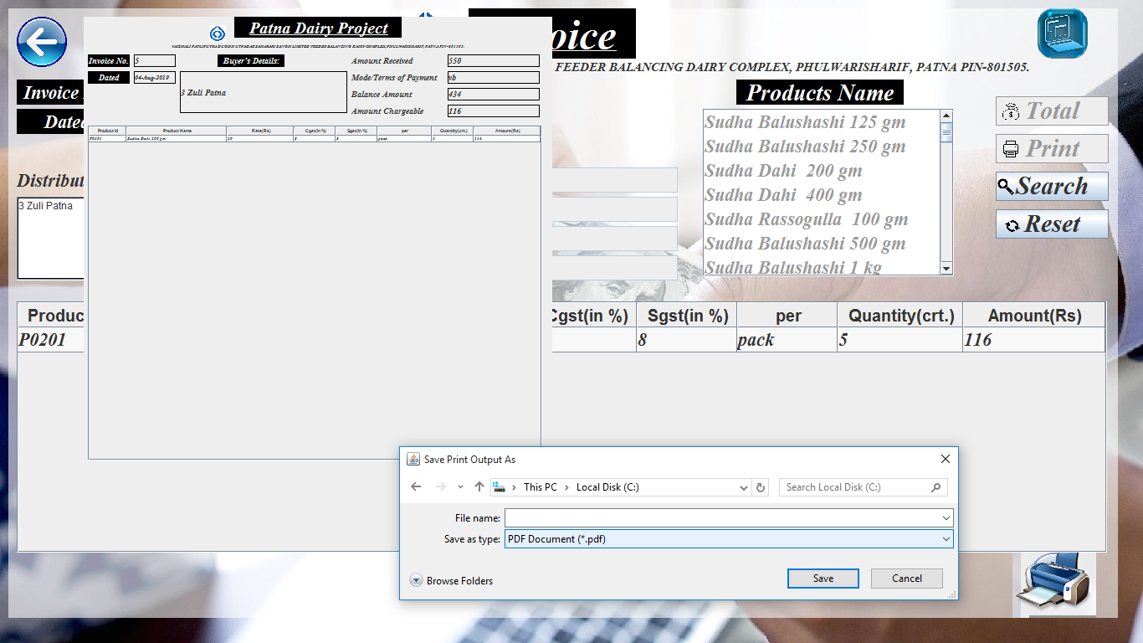

import javax.swing.*;

import javax.swing.event.*;

import javax.swing.table.*;

import java.awt.*;

import java.awt.event.*;

import com.toedter.calendar.*;

import java.text.*;

import java.io.*;

import java.sql.*;

import java.util.*;

import java.awt.print.PageFormat;

import java.awt.print.Printable;

import java.awt.print.PrinterException;

import java.awt.print.PrinterJob;

public class Transaction extends JFrame implements ListSelectionListener , ActionListener

{

public static boolean entry_status = false;

public static boolean print_status = true;

public static boolean data_save = false;

Connection con;

PreparedStatement pst;

ResultSet rst;

File f;

DefaultListModel dlm=new DefaultListModel();

JList lst=new JList(dlm);

JScrollPane jsp=new JScrollPane(lst);

DefaultListModel dlm1=new DefaultListModel();

JList lst1=new JList(dlm1);

JScrollPane jsp1=new JScrollPane(lst1);

{

try

{

Class.forName("oracle.jdbc.driver.OracleDriver");

con=DriverManager.getConnection("jdbc:oracle:thin:@localhost:1521:XE","sudha","sudha123");

pst=con.prepareStatement("Select * from distributor_master");

rst=pst.executeQuery();

while(rst.next())

{

dlm.addElement(rst.getString("dist_id"));

}

pst=con.prepareStatement("Select * from product_master");

rst=pst.executeQuery();

while(rst.next())

{

dlm1.addElement(rst.getString("prod_name"));

}

}

catch(SQLException e)

{

System.out.println(e);

}

catch(ClassNotFoundException e)

{}

}

int w , h ;

Toolkit toolkit = Toolkit.getDefaultToolkit();

Dimension dimension = toolkit.getScreenSize();

{

w = (int)dimension.getWidth();

h = (int)dimension.getHeight();

}

JPanel pan = new JPanel()

{

public void paintComponent(Graphics g)

{

super.paintComponent(g);

g.drawImage(new ImageIcon("F:\\GUI\\102165051-money-transaction.1910x1000.jpg").getImage(), 0 , 0 , w , h , null);

}

};

int opt;

JPanel p1 = new JPanel();

JLabel lbl = new JLabel("<html><u>Invoice</u></html>");

JLabel l1 = new JLabel("VAISHALI PATLIPUTRA DUGDH UTPADAK SAHAKARI SANGH LIMITED FEEDER BALANCING DAIRY COMPLEX, PHULWARISHARIF, PATNA PIN-801505.");

JLabel l2 = new JLabel("Invoice No.");

JLabel l3 = new JLabel("Dated");

JLabel l4 = new JLabel("Buyer's Details:");

JLabel l5 = new JLabel("Distributor's Id");

JLabel l6 = new JLabel("Amount Received");

JLabel l7 = new JLabel("Mode/Terms of Payment");

JLabel l8 = new JLabel("Balance Amount");

JLabel l9 = new JLabel("Amount Chargeable");

JLabel l10 = new JLabel("Products Name");

JTextField t1 = new JTextField();

JTextArea t2 = new JTextArea();

JScrollPane jspt = new JScrollPane(t2);

JTextField t3 = new JTextField();

JTextField t4 = new JTextField();

JTextField t5 = new JTextField();

JTextField t6 = new JTextField();

JLabel sicon=new JLabel()

{

public void paintComponent(Graphics g)

{

super.paintComponent(g);

g.drawImage(new ImageIcon("icon.jpg").getImage(),0 , 0 ,60,60 , null);

}

};

JButton print = new JButton("Print")

{

public void paintComponent(Graphics g)

{

super.paintComponent(g);

g.drawImage(new ImageIcon("print.png").getImage(),8 , 8 ,20,20 , null);

}

};

JButton reset = new JButton("Reset")

{

public void paintComponent(Graphics g)

{

super.paintComponent(g);

g.drawImage(new ImageIcon("reset.png").getImage(),0 , 0 ,40,40 , null);

}

};

JButton exit=new JButton()

{

public void paintComponent(Graphics g)

{

super.paintComponent(g);

g.drawImage(new ImageIcon("back1 (2).png").getImage(),0 , 0 ,60,60 , null);

}

};

JButton total = new JButton("Total")

{

public void paintComponent(Graphics g)

{

super.paintComponent(g);

g.drawImage(new ImageIcon("total.png").getImage(),8 , 8 ,20,20 , null);

}

};

JButton search = new JButton("Search")

{

public void paintComponent(Graphics g)

{

super.paintComponent(g);

g.drawImage(new ImageIcon("search.png").getImage(),2 , 8 ,20,20 , null);

}

};

JButton delete=new JButton("Remove Entry")

{

public void paintComponent(Graphics g)

{

super.paintComponent(g);

g.drawImage(new ImageIcon("delete.png").getImage(),8 , 5 ,20,20 , null);

}

};

JButton print1 = new JButton()

{

public void paintComponent(Graphics g)

{

super.paintComponent(g);

g.drawImage(new ImageIcon("print-image.png").getImage(),0 , 0 ,100,100 , null);

}

};

JButton backup = new JButton()

{

public void paintComponent(Graphics g)

{

super.paintComponent(g);

g.drawImage(new ImageIcon("backup.png").getImage(),0 , 0 ,60,60 , null);

}

};

JDateChooser calendar=new JDateChooser(new java.util.Date());

JLabel lblE1=new JLabel();

String data[][];

String heading[]={"Product Id","Product Name","Rate(Rs)","Cgst(in %)","Sgst(in %)","per","Quantity(crt.)","Amount(Rs)"};

String rows[][]=new String[0][0];

DefaultTableModel dtm=new DefaultTableModel(rows,heading)

{

public boolean isCellEditable(int row,int column)

{

return column==6?true:false;

}

};

JTable tab=new JTable(dtm);

JScrollPane jsp2=new JScrollPane(tab);

int inv_id = PrintInvoice.id;

Transaction()

{

setUndecorated(true);

prn();

setTitle("Product Marketing Management System -- Transaction");

calendar.setEnabled(false);

JTableHeader eheader=tab.getTableHeader();tab.setBackground(new Color(255 , 255 , 255 , 150));

eheader.setFont(new Font("Times Roman",Font.BOLD,20));

tab.setAutoResizeMode(JTable.AUTO_RESIZE_OFF);

tab.setRowHeight(30);

javax.swing.table.TableColumn tableColumn =tab.getColumnModel().getColumn(0);

tableColumn.setPreferredWidth(120);

tableColumn =tab.getColumnModel().getColumn(1);

tableColumn.setPreferredWidth(380);

tableColumn =tab.getColumnModel().getColumn(2);

tableColumn.setPreferredWidth(120);

tableColumn =tab.getColumnModel().getColumn(3);

tableColumn.setPreferredWidth(120);

tableColumn =tab.getColumnModel().getColumn(4);

tableColumn.setPreferredWidth(120);

tableColumn =tab.getColumnModel().getColumn(5);

tableColumn.setPreferredWidth(120);

tableColumn =tab.getColumnModel().getColumn(6);

tableColumn.setPreferredWidth(150);

tableColumn =tab.getColumnModel().getColumn(7);

tableColumn.setPreferredWidth(170);

add(pan);pan.setBounds(0, 0 , w , h);pan.setLayout(null);

p1.add(sicon);sicon.setBounds(470 , 3 , 60 , 60);

setIconImage(new ImageIcon("icon.jpg").getImage());

pan.add(p1);p1.setBounds(10 , 10 , w-40 ,h-40);p1.setBackground(new Color(255 , 255 , 255 , 150));p1.setLayout(null);

p1.add(lbl);lbl.setBounds(550 , 0 , 200 , 60);

lbl.setHorizontalAlignment(JLabel.CENTER);

lbl.setVerticalAlignment(JLabel.CENTER);

lbl.setFont(new Font("Times New Roman",Font.ITALIC+Font.BOLD,50));

lbl.setForeground(new Color(255,255,255,150));

lbl.setBackground(Color.BLACK);

lbl.setOpaque(true);

p1.add(l1);l1.setBounds(10 , 60 , w-20 , 20);l1.setFont(new Font("Times New Roman", Font.ITALIC+Font.BOLD,15));

l1.setHorizontalAlignment(JLabel.CENTER);

l1.setVerticalAlignment(JLabel.CENTER);

p1.add(l2);l2.setBounds(10 , 85 , 120 , 30);l2.setFont(new Font("Times New Roman", Font.ITALIC+Font.BOLD,22));

l2.setForeground(Color.WHITE);

l2.setBackground(Color.BLACK);l2.setOpaque(true);

l2.setHorizontalAlignment(JLabel.CENTER);

l2.setVerticalAlignment(JLabel.CENTER);

p1.add(l3);l3.setBounds(10 , 120 , 120 , 30);l3.setFont(new Font("Times New Roman", Font.ITALIC+Font.BOLD,22));

l3.setForeground(Color.WHITE);

l3.setBackground(Color.BLACK);l3.setOpaque(true);

l3.setHorizontalAlignment(JLabel.CENTER);

l3.setVerticalAlignment(JLabel.CENTER);

p1.add(l4);l4.setBounds(300 , 155 , 200 , 30);l4.setFont(new Font("Times New Roman", Font.ITALIC+Font.BOLD,28));

l4.setForeground(Color.WHITE);l4.setOpaque(true);

l4.setBackground(Color.BLACK);

l4.setHorizontalAlignment(JLabel.CENTER);

l4.setVerticalAlignment(JLabel.CENTER);

p1.add(l5);l5.setBounds(10 , 190 , 150 , 30);l5.setFont(new Font("Times New Roman", Font.ITALIC+Font.BOLD,22));

p1.add(l6);l6.setBounds(350 , 190 , 240 , 30);l6.setFont(new Font("Times New Roman", Font.ITALIC+Font.BOLD,22));

p1.add(l7);l7.setBounds(350 , 225 , 240 , 30);l7.setFont(new Font("Times New Roman", Font.ITALIC+Font.BOLD,22));

p1.add(l8);l8.setBounds(350 , 260 , 240 , 30);l8.setFont(new Font("Times New Roman", Font.ITALIC+Font.BOLD,22));

p1.add(l9);l9.setBounds(350 , 295 , 240 , 30);l9.setFont(new Font("Times New Roman", Font.ITALIC+Font.BOLD,22));

p1.add(l10);l10.setBounds(870 , 85 , 200 , 30);l10.setFont(new Font("Times New Roman", Font.ITALIC+Font.BOLD,28));

l10.setForeground(Color.WHITE);

l10.setBackground(Color.BLACK);l10.setOpaque(true);

l10.setHorizontalAlignment(JLabel.CENTER);

l10.setVerticalAlignment(JLabel.CENTER);

p1.add(t1);t1.setBounds(160 , 85 , 150 , 30);t1.setEditable(false);

p1.add(calendar);calendar.setForeground(Color.black);calendar.setBounds(160 , 120 , 150 , 30);

p1.add(jsp);jsp.setBounds(160 , 190 , 150 , 30);lst.setFont(new Font("Times New Roman", Font.ITALIC+Font.BOLD,22));

p1.add(jspt);jspt.setBounds(10 , 225 , 300 , 100);t2.setBorder(BorderFactory.createLineBorder(Color.BLACK,1));t2.setEditable(false);

p1.add(t3);t3.setBounds(600 , 190 , 200 , 30);lblE1.setBounds(800 , 190 , 20 , 25);p1.add(lblE1);lblE1.setForeground(Color.RED);lblE1.setFont(new Font("Times New Roman", Font.ITALIC+Font.BOLD,20));

p1.add(t4);t4.setBounds(600 , 225 , 200 , 30);

p1.add(t5);t5.setBounds(600 , 260 , 200 , 30);t5.setEditable(false);t5.setText("0");

p1.add(t6);t6.setBounds(600 , 295 , 200 , 30);t6.setEditable(false);t6.setText("0");

p1.add(jsp1);jsp1.setBounds(830 , 120 , 300 , 200);lst1.setFont(new Font("Times New Roman", Font.ITALIC+Font.BOLD,22));

jsp2.setBounds(10,350,1303,300);

p1.add(jsp2);tab.setFont(new Font("Times New Roman", Font.ITALIC+Font.BOLD,22));

p1.add(total);total.setBounds(1180 , 105 , 135 , 35);total.setFont(new Font("Times New Roman", Font.ITALIC+Font.BOLD,30));

p1.add(print);print.setBounds(1180 , 150 , 135 , 35);print.setFont(new Font("Times New Roman", Font.ITALIC+Font.BOLD,30));

p1.add(search);search.setBounds(1180 , 195 , 135 , 35);search.setFont(new Font("Times New Roman", Font.ITALIC+Font.BOLD,30));

p1.add(reset);reset.setBounds(1180 , 240 , 135 , 35);reset.setFont(new Font("Times New Roman", Font.ITALIC+Font.BOLD,30));

p1.add(exit);exit.setBounds(10, 10 , 60 , 60);

exit.setContentAreaFilled(false);

exit.setBorderPainted(false);

p1.add(delete);delete.setBounds(500 , 655 , 250 , 30);delete.setFont(new Font("Times New Roman", Font.ITALIC+Font.BOLD,25));

p1.add(print1);print1.setBounds(1200 , 630 , 100 , 100);

print1.setContentAreaFilled(false);

print1.setBorderPainted(false);

print1.setVisible(false);

p1.add(backup);backup.setBounds(1230,0,60,60);

backup.setContentAreaFilled(false);

backup.setBorderPainted(false);

setBounds(0 , 0 , w , h);

setVisible(true);

lst.addListSelectionListener(this);

lst1.addListSelectionListener(this);

search.addActionListener(this);

print.addActionListener(this);

reset.addActionListener(this);

exit.addActionListener(this);

total.addActionListener(this);

delete.addActionListener(this);

print1.addActionListener(this);

backup.addActionListener(this);

tab.addMouseListener(new MouseAdapter()

{

public void mousePressed(MouseEvent evt)

{

int row=tab.getSelectedRow();

float rate=Float.parseFloat(tab.getValueAt(row,2).toString());

float sgst=Float.parseFloat(tab.getValueAt(row,4).toString());

float cgst=Float.parseFloat(tab.getValueAt(row,3).toString());

int qnty=Integer.parseInt(tab.getValueAt(row,6).toString());

tab.setValueAt(((qnty*rate*(sgst+cgst)/100)+(qnty*rate))+"",row,7);

}

});

}

int t=0;

public void valueChanged(ListSelectionEvent evt)

{

if(evt.getSource() == lst)

{

try

{

repaint();

pst=con.prepareStatement("Select * from distributor_master where dist_id=?");

pst.setString(1,lst.getSelectedValue().toString());

rst=pst.executeQuery();

if(rst.next())

{

t2.setText(rst.getString("dist_id")+" "+rst.getString("dist_name")+" "+rst.getString("address"));

}

}

catch(Exception e){}

}

if(evt.getSource() == lst1)

{

repaint();

if(t!=0){t=0;return;}

t=1;

try

{ int row = tab.getRowCount();

float amt = 0.0f;

String amnt;

float a , b , c;

a = Float.parseFloat(t3.getText());

b = Float.parseFloat(t5.getText());

c = Float.parseFloat(t6.getText());

if(a>c)

{

pst=con.prepareStatement("Select * from product_master where prod_name=?");

pst.setString(1,lst1.getSelectedValue().toString());

rst=pst.executeQuery();

if(rst.next())

{

String s[]={rst.getString("prod_id"),rst.getString("prod_name"),rst.getString("basic_price"),rst.getString("cgst"),rst.getString("sgst"),"0","0","0"};

dtm.addRow(s);

}

}

else

{

JOptionPane.showMessageDialog(this ,"Not Enough Balance..." , "Confirm Message" , JOptionPane.INFORMATION_MESSAGE);

}

for(int i = 0 ; i<row ; i++)

{

float s =Float.parseFloat(tab.getValueAt(i,7).toString());

amt = amt + s;

}

amnt = String.valueOf(amt);

t6.setText(amnt);

b = a - amt ;

t5.setText(String.valueOf(b));

}

catch(Exception ef){JOptionPane.showMessageDialog(this,"Error Occured","Error Message",JOptionPane.ERROR_MESSAGE);}

}

}

public void actionPerformed(ActionEvent evt)

{

if(evt.getSource()==exit)

{

int opt= JOptionPane.showConfirmDialog(this,"Do You Want To Exit...");

if(opt==JOptionPane.YES_OPTION)

{

dispose();

}

}

if(evt.getSource() == print1)

{

repaint();

int opt= JOptionPane.showConfirmDialog(this,"Do You Want To Print Invoice...");

if(opt==JOptionPane.YES_OPTION)

{

SimpleDateFormat sdf=new SimpleDateFormat("dd-MMM-yyyy");

String st=sdf.format(calendar.getDate());

PrintInvoice pi = new PrintInvoice();

pi.invoice_no1.setText(t1.getText());

pi.dated1.setText(st);

pi.buyer_det1.setText(t2.getText());

pi.amount_received1.setText(t3.getText());

pi.t_o_p1.setText(t4.getText());

pi.balance_amount1.setText(t5.getText());

pi.amount_chargeable1.setText(t6.getText());

opt=Integer.parseInt(t1.getText());

try

{

pst=con.prepareStatement("Select count(*) from invoice");

rst=pst.executeQuery();

int row1=0;

if(rst.next())

{

row1=rst.getInt(1);

}

data=new String[row1][8];

pst=con.prepareStatement("Select * from invoice where invoice_no = ?");

pst.setInt(1,opt);

rst=pst.executeQuery();

int i=0;

while(rst.next())

{

String s[]={rst.getString(2),rst.getString(9),rst.getString(3),rst.getString(4),rst.getString(5),rst.getString(6),rst.getString(7),rst.getString(8)};

pi.dtm.addRow(s);

i++;

}

}

catch(Exception e){JOptionPane.showMessageDialog(this,e.toString());}

PrinterJob pj = PrinterJob.getPrinterJob();

pj.setJobName(" Print Component ");

pj.setPrintable (new Printable()

{

public int print(Graphics pg, PageFormat pf, int pageNum)

{

if (pageNum > 0)

{

return Printable.NO_SUCH_PAGE;

}

Graphics2D g2 = (Graphics2D) pg;

g2.translate(pf.getImageableX(), pf.getImageableY());

pi.panel.paint(g2);

return Printable.PAGE_EXISTS;

}

});

if (pj.printDialog() == false)

return;

try

{

pj.print();

JOptionPane.showMessageDialog(this,"Invoice Printed...","Confirm Message",JOptionPane.INFORMATION_MESSAGE);

}

catch (PrinterException ex) {JOptionPane.showMessageDialog(this,"Invoice Not Printed...","Error Message",JOptionPane.ERROR_MESSAGE);

}

reset();

pi.setVisible(false);

prn();

}

else

{

JOptionPane.showMessageDialog(this,"Invoice Not Printed...","Error Message",JOptionPane.ERROR_MESSAGE);

}

}

if(evt.getSource()==print)

{

repaint();

int opt= JOptionPane.showConfirmDialog(this,"Do You Want To Grenerate Invoice...");

if(opt==JOptionPane.YES_OPTION)

{

print_status = false;

entry_status = true;

boolean temp=false;

if(!validationamountreceived.checkamountreceived(t3.getText()))

{

lblE1.setText("***");

temp=true;

}

else

{

lblE1.setText("");

}

if(temp){

JOptionPane.showMessageDialog(this,"Recheck your details...","Error Message",JOptionPane.ERROR_MESSAGE);

return;

}

int row = tab.getRowCount();

float amt = 0.0f;

String amnt;

for(int i = 0 ; i<row ; i++)

{

float s =Float.parseFloat(tab.getValueAt(i,7).toString());

amt = amt + s;

}

amnt = String.valueOf(amt);

t6.setText(amnt);

float a , b , c;

a = Float.parseFloat(t3.getText());

b = Float.parseFloat(t5.getText());

c = Float.parseFloat(t6.getText());

b = a - c;

t5.setText(String.valueOf(b));

if(a>c)

{

try

{

pst = con.prepareStatement("insert into transaction values(?,?,?,?,?,?,?)");

pst.setInt(1 , Integer.parseInt(t1.getText()));

SimpleDateFormat sdf=new SimpleDateFormat("dd-MMM-yyyy");

String st=sdf.format(calendar.getDate());

pst.setString(2,st);

pst.setFloat(3 , Float.parseFloat(t3.getText()));

pst.setFloat(4 , Float.parseFloat(t5.getText()));

String str = lst.getSelectedValue().toString();

pst.setFloat(5 , Float.parseFloat(str));

pst.setString(6 , t4.getText());

pst.setFloat(7 , Float.parseFloat(t6.getText()));

if(pst.executeUpdate()>0)

{

JOptionPane.showMessageDialog(this,"Transaction done...","Confirm Message",JOptionPane.QUESTION_MESSAGE);

exit.setEnabled(false);

}

else

{

JOptionPane.showMessageDialog(this,"Transaction not done...","Eror Message",JOptionPane.ERROR_MESSAGE);

}

int row2 = tab.getRowCount();

String prod_id="";

String prod_nm="";

float rate;

float cgst;

float sgst;

String per="";

int qty;

float amts;

int rec=0;

for(int i = 0 ; i<row2 ; i++)

{

prod_id = tab.getValueAt(i,0).toString();

prod_nm = tab.getValueAt(i,1).toString();

rate=Float.parseFloat(tab.getValueAt(i,2).toString());

cgst=Float.parseFloat(tab.getValueAt(i,3).toString());

sgst=Float.parseFloat(tab.getValueAt(i,4).toString());

per = tab.getValueAt(i,5).toString();

qty=Integer.parseInt(tab.getValueAt(i,6).toString());

amts=Float.parseFloat(tab.getValueAt(i,7).toString());

//System.out.println(prod_id+" "+prod_nm+" "+rate+" "+cgst+" "+sgst+" "+per+" "+qty+" "+amt);

pst = con.prepareStatement("insert into invoice values(?,?,?,?,?,?,?,?,?)");

pst.setInt(1 , Integer.parseInt(t1.getText()));

pst.setString(2 , prod_id);

pst.setFloat(3 , rate );

pst.setFloat(4, cgst);

pst.setFloat(5 , sgst);

pst.setString(6 , per);

pst.setInt(7 , qty);

pst.setFloat(8 , amt);

pst.setString(9 , prod_nm);

if(pst.executeUpdate()>0)

{rec++;}

}

opt=Integer.parseInt(t1.getText());

JOptionPane.showMessageDialog(this ," Invoice generated..." , "Confirm Message" , JOptionPane.INFORMATION_MESSAGE);

SimpleDateFormat sdf1=new SimpleDateFormat("dd-MMM-yyyy");

String st1=sdf1.format(calendar.getDate());

PrintInvoice pi = new PrintInvoice();

pi.invoice_no1.setText(t1.getText());

pi.dated1.setText(st);

pi.buyer_det1.setText(t2.getText());

pi.amount_received1.setText(t3.getText());

pi.t_o_p1.setText(t4.getText());

pi.balance_amount1.setText(t5.getText());

pi.amount_chargeable1.setText(t6.getText());

opt=Integer.parseInt(t1.getText());

try

{

pst=con.prepareStatement("Select count(*) from invoice");

rst=pst.executeQuery();

int row1=0;

if(rst.next())

{

row1=rst.getInt(1);

}

data=new String[row1][8];

pst=con.prepareStatement("Select * from invoice where invoice_no = ?");

pst.setInt(1,opt);

rst=pst.executeQuery();

int i=0;

while(rst.next())

{

String s[]={rst.getString(2),rst.getString(9),rst.getString(3),rst.getString(4),rst.getString(5),rst.getString(6),rst.getString(7),rst.getString(8)};

pi.dtm.addRow(s);

i++;

}

}

catch(Exception e){JOptionPane.showMessageDialog(this,e.toString());}

PrinterJob pj = PrinterJob.getPrinterJob();

pj.setJobName(" Print Component ");

pj.setPrintable (new Printable()

{

public int print(Graphics pg, PageFormat pf, int pageNum)

{

if (pageNum > 0)

{

return Printable.NO_SUCH_PAGE;

}

Graphics2D g2 = (Graphics2D) pg;

g2.translate(pf.getImageableX(), pf.getImageableY());

pi.panel.paint(g2);

return Printable.PAGE_EXISTS;

}

});

if (pj.printDialog() == false)

return;

try

{

pj.print();

JOptionPane.showMessageDialog(this,"Invoice Printed...","Confirm Message",JOptionPane.INFORMATION_MESSAGE);

}

catch (PrinterException ex) {JOptionPane.showMessageDialog(this,"Invoice Not Printed...","Error Message",JOptionPane.ERROR_MESSAGE);

}

exit.setEnabled(true);

reset();

pi.setVisible(false);

print_status = true;

data_save = true;

prn();

}

catch(Exception f)

{

JOptionPane.showMessageDialog(this ,"Invoice Not Printed...","Error Message",JOptionPane.ERROR_MESSAGE);

}

}

else

{

JOptionPane.showMessageDialog(this ,"Not Enough Balance..." , "Confirm Message" , JOptionPane.INFORMATION_MESSAGE);

}

}

else

{

JOptionPane.showMessageDialog(this,"Invoice Not Generated...","Error Message",JOptionPane.ERROR_MESSAGE);

}

}

if(evt.getSource()==reset)

{

repaint();

reset();

}

if(evt.getSource()==total)

{

repaint();

int row = tab.getRowCount();

float amt = 0.0f;

String amnt;

for(int i = 0 ; i<row ; i++)

{

float s =Float.parseFloat(tab.getValueAt(i,7).toString());

amt = amt + s;

}

amnt = String.valueOf(amt);

t6.setText(amnt);

float a = Float.parseFloat(t3.getText());

float b = Float.parseFloat(t5.getText());

float c = Float.parseFloat(t6.getText());

b = a - c;

t5.setText(String.valueOf(b));

if(a<c)

{

JOptionPane.showMessageDialog(this ,"Not Enough Balance..." , "Confirm Message" , JOptionPane.INFORMATION_MESSAGE);

}

}

if(evt.getSource()==search)

{

repaint();

String id=JOptionPane.showInputDialog(this,"Enter Invoice number:");

opt=Integer.parseInt(id);

try

{

reset();

t3.setEditable(false);

t4.setEditable(false);

delete.setEnabled(false);

total.setEnabled(false);

lst.setEnabled(false);

lst1.setEnabled(false);

print.setEnabled(false);

print1.setVisible(true);

tab.setEnabled(false);

pst =con.prepareStatement("Select * from transaction where invoice_no=?");

pst.setInt(1,opt);

ResultSet rst=pst.executeQuery();

if(rst.next())

{

t1.setText(rst.getString("invoice_no"));

java.util.Date dt=rst.getDate("invoice_date");

calendar.setDate(dt);

String did = rst.getString("dist_id");

Object obj = did;

lst.setSelectedValue(obj , true);

t3.setText(rst.getString("amount_received"));

t4.setText(rst.getString("terms_of_payment"));

t5.setText(rst.getString("balance_amount"));

t6.setText(rst.getString("amount_chargeable"));

try

{

pst=con.prepareStatement("Select * from distributor_master where dist_id=did");

pst.setString(1,lst.getSelectedValue().toString());

rst=pst.executeQuery();

if(rst.next())

{

t2.setText(rst.getString("dist_id")+" "+rst.getString("dist_name")+" "+rst.getString("address"));

}

}

catch(Exception e){}

}

else

{

JOptionPane.showMessageDialog(this,"Data Not Found");

}

pst=con.prepareStatement("Select count(*) from invoice");

rst=pst.executeQuery();

int row1=0;

if(rst.next())

{

row1=rst.getInt(1);

}

data=new String[row1][8];

pst=con.prepareStatement("Select * from invoice where invoice_no = ?");

pst.setInt(1,opt);

rst=pst.executeQuery();

int i=0;

while(rst.next())

{

String s[]={rst.getString(2),rst.getString(9),rst.getString(3),rst.getString(4),rst.getString(5),rst.getString(6),rst.getString(7),rst.getString(8)};

dtm.addRow(s);

i++;

}

}

catch(Exception e){JOptionPane.showMessageDialog(this,"Data Not Found","Error Message",JOptionPane.ERROR_MESSAGE);}

}

if(evt.getSource()==delete)

{

repaint();

int selectedRow = tab.getSelectedRow();

dtm.removeRow(selectedRow);

}

if(evt.getSource() == backup)

{

String d = new SimpleDateFormat("dd-MMM-yyyy").format(new java.util.Date());

String fnm = "SudhaInvoice"+d;

String s = "exp sudha/sudha123 file = D:\\BackupTransaction\\"+fnm+".dmp";

try

{

Process p = Runtime.getRuntime().exec(s);

JOptionPane.showMessageDialog(this,"BackUp Done...","Confirm Message",JOptionPane.QUESTION_MESSAGE);

}

catch(Exception e){JOptionPane.showMessageDialog(this,"BackUp Not Done...","Error Message",JOptionPane.ERROR_MESSAGE); }

}

}

public void prn()

{ if(print_status == true)

{

try

{

repaint();

pst=con.prepareStatement("Select max(invoice_no) from transaction");

int id=1;

ResultSet rst=pst.executeQuery();

if(rst.next())

{

id=rst.getInt(id)+1;

}

t1.setText(String.valueOf(id));

}

catch(Exception ee){System.out.println(ee);}

}

}

void reset()

{

t=0;

repaint();

t2.setText("");

t3.setText("0");t3.setEditable(true);

t4.setText("");t4.setEditable(true);

t5.setText("0");

t6.setText("0");

calendar.setDate( new java.util.Date());

dtm.setRowCount(0);

tab.setEnabled(true);

delete.setEnabled(true);

total.setEnabled(true);

print.setEnabled(true);

lst.setEnabled(true);

lst1.setEnabled(true);

print1.setVisible(false);

prn();

}

public static void main(String[]args)

{

new Transaction();

}

}

import javax.swing.*;

import javax.swing.event.*;

import javax.swing.table.*;

import java.awt.*;

import com.toedter.calendar.*;

import java.text.*;

import java.io.*;

import java.sql.*;

import java.util.*;

public class PrintInvoice extends JFrame

{ public static boolean print_status = false;

public static int id;

Connection con;

PreparedStatement pst;

ResultSet rst;

File f;

{

try

{

Class.forName("oracle.jdbc.driver.OracleDriver");//ClassNotFoundException

con=DriverManager.getConnection("jdbc:oracle:thin:@localhost:1521:XE","sudha","sudha123");//SQLException

}

catch(SQLException e)

{

System.out.println(e);

}

catch(ClassNotFoundException e)

{}

}

JPanel panel = new JPanel();

JLabel head = new JLabel("<html><u>Patna Dairy Project</u></html>");

JLabel detail = new JLabel("VAISHALI PATLIPUTRA DUGDH UTPADAK SAHAKARI SANGH LIMITED FEEDER BALANCING DAIRY COMPLEX, PHULWARISHARIF, PATNA PIN-801505.");

JLabel invoice_no = new JLabel("Invoice No.");JLabel invoice_no1 = new JLabel();

JLabel dated = new JLabel("Dated");JLabel dated1 = new JLabel();

JLabel buyer_det = new JLabel("Buyer's Details:");JLabel buyer_det1 = new JLabel();

JLabel amount_received = new JLabel("Amount Received");JLabel amount_received1 = new JLabel();

JLabel t_o_p = new JLabel("Mode/Terms of Payment");JLabel t_o_p1 = new JLabel();

JLabel balance_amount = new JLabel("Balance Amount");JLabel balance_amount1 = new JLabel();

JLabel amount_chargeable = new JLabel("Amount Chargeable");JLabel amount_chargeable1 = new JLabel();

JLabel prod_name = new JLabel("Products Name");JLabel prod_name1 = new JLabel();

String data[][];

String heading[]={"Product Id","Product Name","Rate(Rs)","Cgst(in %)","Sgst(in %)","per","Quantity(crt.)","Amount(Rs)"};

String rows[][]=new String[0][0];

DefaultTableModel dtm=new DefaultTableModel(rows,heading);

JTable tab=new JTable(dtm);

JScrollPane jsp2=new JScrollPane(tab);

JLabel sicon=new JLabel()

{

public void paintComponent(Graphics g)

{

super.paintComponent(g);

g.drawImage(new ImageIcon("icon.jpg").getImage(),0 , 0 ,20,20 , null);

}

};

PrintInvoice()

{

setUndecorated(true);

JTableHeader eheader=tab.getTableHeader();

tab.setEnabled(false);

eheader.setFont(new Font("Times Roman",Font.BOLD,5));

tab.setAutoResizeMode(JTable.AUTO_RESIZE_OFF);

tab.setRowHeight(8);

tab.setFont(new Font("Times Roman",Font.BOLD,5));

javax.swing.table.TableColumn tableColumn =tab.getColumnModel().getColumn(0);

tableColumn.setPreferredWidth(45);

tableColumn =tab.getColumnModel().getColumn(1);

tableColumn.setPreferredWidth(120);

tableColumn =tab.getColumnModel().getColumn(2);

tableColumn.setPreferredWidth(80);

tableColumn =tab.getColumnModel().getColumn(3);

tableColumn.setPreferredWidth(50);

tableColumn =tab.getColumnModel().getColumn(4);

tableColumn.setPreferredWidth(50);

tableColumn =tab.getColumnModel().getColumn(5);

tableColumn.setPreferredWidth(65);

tableColumn =tab.getColumnModel().getColumn(6);

tableColumn.setPreferredWidth(50);

tableColumn =tab.getColumnModel().getColumn(7);

tableColumn.setPreferredWidth(80);

add(panel);panel.setBounds(100 , 20 , 560 , 560);panel.setLayout(null);

panel.add(sicon);sicon.setBounds(150 , 10 , 20 , 20);

panel.add(head);head.setBounds(180 , 0 , 200 , 25);

head.setHorizontalAlignment(JLabel.CENTER);

head.setVerticalAlignment(JLabel.CENTER);

head.setFont(new Font("Times New Roman",Font.ITALIC+Font.BOLD,20));

head.setForeground(Color.WHITE);

head.setBackground(Color.BLACK);

head.setOpaque(true);

panel.add(detail);detail.setBounds(10 , 30 , 540 , 10);detail.setFont(new Font("Times New Roman", Font.ITALIC+Font.BOLD,5));

detail.setHorizontalAlignment(JLabel.CENTER);

detail.setVerticalAlignment(JLabel.CENTER);

panel.add(invoice_no);invoice_no.setBounds(5 , 45 , 50 , 15);invoice_no.setFont(new Font("Times New Roman", Font.ITALIC+Font.BOLD,10));

invoice_no.setForeground(Color.WHITE);

invoice_no.setBackground(Color.BLACK);invoice_no.setOpaque(true);

invoice_no.setHorizontalAlignment(JLabel.CENTER);

invoice_no.setVerticalAlignment(JLabel.CENTER);

panel.add(invoice_no1);invoice_no1.setBounds(60 , 45 , 50 , 15);invoice_no1.setBorder(BorderFactory.createLineBorder(Color.BLACK,1));

invoice_no1.setFont(new Font("Times New Roman", Font.ITALIC+Font.BOLD,10));

panel.add(dated);dated.setBounds(5 , 65 , 50 , 15);dated.setFont(new Font("Times New Roman", Font.ITALIC+Font.BOLD,10));

dated.setForeground(Color.WHITE);

dated.setBackground(Color.BLACK);dated.setOpaque(true);

dated.setHorizontalAlignment(JLabel.CENTER);

dated.setVerticalAlignment(JLabel.CENTER);

panel.add(dated1);dated1.setBounds(60 , 65 ,50 , 15);dated1.setBorder(BorderFactory.createLineBorder(Color.BLACK,1));

dated1.setFont(new Font("Times New Roman", Font.ITALIC+Font.BOLD,7));

panel.add(buyer_det);buyer_det.setBounds(160 , 45 , 80 , 15);buyer_det.setFont(new Font("Times New Roman", Font.ITALIC+Font.BOLD,10));

buyer_det.setForeground(Color.WHITE);buyer_det.setOpaque(true);

buyer_det.setBackground(Color.BLACK);

buyer_det.setHorizontalAlignment(JLabel.CENTER);

buyer_det.setVerticalAlignment(JLabel.CENTER);

panel.add(buyer_det1);buyer_det1.setBounds(115 ,65 , 200 , 50);buyer_det1.setBorder(BorderFactory.createLineBorder(Color.BLACK,1));

buyer_det1.setFont(new Font("Times New Roman", Font.ITALIC+Font.BOLD,10));

panel.add(amount_received);amount_received.setBounds(320 , 45 , 110 , 15);amount_received.setFont(new Font("Times New Roman", Font.ITALIC+Font.BOLD,10));

panel.add(t_o_p);t_o_p.setBounds(320 , 65 , 110 , 15);t_o_p.setFont(new Font("Times New Roman", Font.ITALIC+Font.BOLD,10));

panel.add(balance_amount);balance_amount.setBounds(320 , 85 , 110 , 15);balance_amount.setFont(new Font("Times New Roman", Font.ITALIC+Font.BOLD,10));

panel.add(amount_chargeable);amount_chargeable.setBounds(320 , 105 , 110 , 15);amount_chargeable.setFont(new Font("Times New Roman", Font.ITALIC+Font.BOLD,10));

panel.add(amount_received1);amount_received1.setBounds(435 , 45 , 110 , 15);amount_received1.setBorder(BorderFactory.createLineBorder(Color.BLACK,1));

amount_received1.setFont(new Font("Times New Roman", Font.ITALIC+Font.BOLD,10));

panel.add(t_o_p1);t_o_p1.setBounds(435 , 65 , 110 , 15);t_o_p1.setBorder(BorderFactory.createLineBorder(Color.BLACK,1));

t_o_p1.setFont(new Font("Times New Roman", Font.ITALIC+Font.BOLD,10));

panel.add(balance_amount1);balance_amount1.setBounds(435 , 85 , 110 , 15);balance_amount1.setBorder(BorderFactory.createLineBorder(Color.BLACK,1));

balance_amount1.setFont(new Font("Times New Roman", Font.ITALIC+Font.BOLD,10));

panel.add(amount_chargeable1);amount_chargeable1.setBounds(435 , 105 , 110 , 15);amount_chargeable1.setBorder(BorderFactory.createLineBorder(Color.BLACK,1));

amount_chargeable1.setFont(new Font("Times New Roman", Font.ITALIC+Font.BOLD,10));

jsp2.setBounds(5,130,543,400);tab.setFont(new Font("Times New Roman", Font.ITALIC+Font.BOLD,5));

panel.add(jsp2);

setBounds(100 , 20 , 560 , 560);

setVisible(true);

setResizable(false);

}

public static void main(String[]args)

{

new PrintInvoice();

}

}

**STATUS**

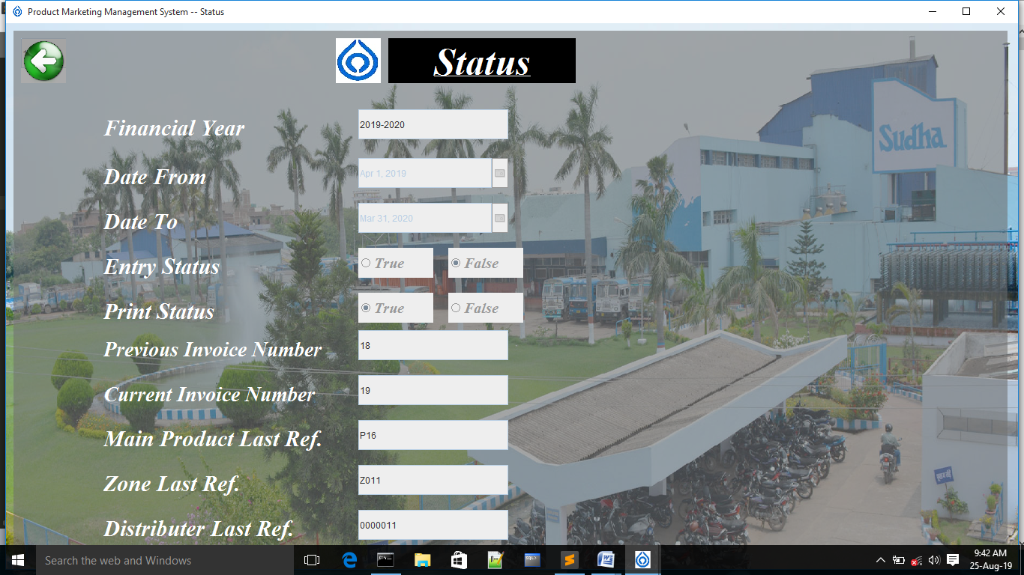

import javax.swing.*;

import java.awt.*;

import java.awt.event.*;

import com.toedter.calendar.*;

import java.text.*;

import java.io.*;

import java.sql.*;

public class Status extends JFrame implements ActionListener

{

Connection con;

PreparedStatement pst;

ResultSet rst;

File f;

{ try

{

Class.forName("oracle.jdbc.driver.OracleDriver");//ClassNotFoundException

con=DriverManager.getConnection("jdbc:oracle:thin:@localhost:1521:XE","sudha","sudha123");//SQLException

//JOptionPane.showMessageDialog(this,"Connected....");

}

catch(SQLException e)

{

System.out.println(e);

}

catch(ClassNotFoundException e)

{}

}

int w , h ;

Toolkit toolkit = Toolkit.getDefaultToolkit();

Dimension dimension = toolkit.getScreenSize();

{

w = (int)dimension.getWidth();

h = (int)dimension.getHeight();

}

JPanel p = new JPanel()

{

public void paintComponent(Graphics g)

{

super.paintComponent(g);

g.drawImage(new ImageIcon("F:\\GUI\\sudha-slider1.jpg").getImage(), 0 , 0 , w , h , null);

}

};

JPanel p1 = new JPanel();

JLabel lbl = new JLabel("<html><u>Status</u></html>");

JLabel l1 = new JLabel("Financial Year");

JLabel l2 = new JLabel("Date From");

JLabel l3 = new JLabel("Date To");

JLabel l4 = new JLabel("Entry Status");

JLabel l5 = new JLabel("Print Status");

JLabel l6 = new JLabel("Previous Invoice Number");

JLabel l7 = new JLabel("Current Invoice Number");

JLabel l8 = new JLabel("Main Product Last Ref.");

JLabel l9 = new JLabel("Zone Last Ref.");

JLabel l10 = new JLabel("Distributer Last Ref.");

JTextField t1 = new JTextField();

JDateChooser calendar2=new JDateChooser(new java.util.Date());

JDateChooser calendar3=new JDateChooser(new java.util.Date());

JTextField t6 = new JTextField();

JTextField t7 = new JTextField();

JTextField t8 = new JTextField();

JTextField t9 = new JTextField();

JTextField t10 = new JTextField();

JRadioButton t4 = new JRadioButton("True");

JRadioButton f4 = new JRadioButton("False");

ButtonGroup bg4 = new ButtonGroup();

JRadioButton t5 = new JRadioButton("True");

JRadioButton f5 = new JRadioButton("False");

ButtonGroup bg5 = new ButtonGroup();

JLabel sicon=new JLabel()

{

public void paintComponent(Graphics g)

{

super.paintComponent(g);

g.drawImage(new ImageIcon("icon.jpg").getImage(),0 , 0 ,60,60 , null);

}

};

JButton exit=new JButton()

{

public void paintComponent(Graphics g)

{

super.paintComponent(g);

g.drawImage(new ImageIcon("back1.png").getImage(),0 , 0 ,60,60 , null);

}

};

int month = new java.util.Date().getMonth()+1;

String year = new SimpleDateFormat("yyyy").format(new java.util.Date());

public static String financial_yr;

Status()

{

setTitle("Product Marketing Management System -- Status");

try

{

pst=con.prepareStatement("Select max(to_number(substr(zone_id,2))) from zone_master order by (to_number(substr(zone_id,2))) desc");

int id=1;

ResultSet rst=pst.executeQuery();

if(rst.next())

{

id=rst.getInt(id)+1;

System.out.println(id);

}

if(id<10)

{

t9.setText("Z"+"00"+String.valueOf(id));

}

else if(id>=10 && id<100)

{

t9.setText("Z"+"0"+String.valueOf(id));

}

else if(id>=100 && id<1000)

{

t9.setText("Z"+String.valueOf(id));

}

else

{

t9.setText("Out of Bounds");

}

}

catch(Exception ee){System.out.println(ee);}

try

{

pst=con.prepareStatement("Select max(dist_id) from distributor_master");

int id=1;

ResultSet rst=pst.executeQuery();

if(rst.next())

{

id=rst.getInt(id)+1;

}

if(id<10)

{

t10.setText("000000"+String.valueOf(id));

}

else if(id>=10 && id<100 )

{

t10.setText("00000"+String.valueOf(id));

}

else if(id>=100 && id<1000 )

{

t10.setText("0000"+String.valueOf(id));

}

else if(id>=1000 && id<10000 )

{

t10.setText("000"+String.valueOf(id));

}

else if(id>=10000 && id<100000 )

{

t10.setText("00"+String.valueOf(id));

}

else if(id>=100000 && id<1000000 )

{

t10.setText("0"+String.valueOf(id));

}

else if(id>=1000000 && id<10000000)

{

t10.setText(String.valueOf(id));

}

else

{

t10.setText("Out of Bounds");

}

}

catch(Exception ee){}

try

{

repaint();

pst=con.prepareStatement("Select max(invoice_no) from transaction");

int id=1;

ResultSet rst=pst.executeQuery();

if(rst.next())

{

id=rst.getInt(id)+1;

}

t6.setText(String.valueOf(id-1));

t7.setText(String.valueOf(id));

}

catch(Exception ee){System.out.println(ee);}

try

{

pst=con.prepareStatement("Select max(to_number(substr(main_prod_id,2))) from main_product_master order by (to_number(substr(main_prod_id,2))) desc");

int id=1;

ResultSet rst=pst.executeQuery();

if(rst.next())

{

id=rst.getInt(id)+1;

}

if(id<10)

{

t8.setText("P"+"0"+String.valueOf(id));

}

else if(id>=10 && id<100)

{

t8.setText("P"+String.valueOf(id));

}

else

{

t8.setText("Out of Bounds");

}

}

catch(Exception ee){System.out.println(ee);}

if(Transaction.entry_status == true)

{

t4.setSelected(true);

}

else

{

f4.setSelected(true);

}

if(Transaction.print_status == true)

{

t5.setSelected(true);

}

else

{

f5.setSelected(true);

}

if(month >= 4)

{

financial_yr = year + "-" +(Integer.parseInt(year)+1);

}

else if(month >= 1 && month <= 3)

{

year=(Integer.parseInt(year)-1)+"";

financial_yr = year + "-" + (Integer.parseInt(year)+1);

}

java.util.Date dt=new java.util.Date();

dt.setDate(1);

dt.setMonth(3);

dt.setYear(Integer.parseInt(year)-1900);

java.util.Date dt1=new java.util.Date();

dt1.setDate(31);

dt1.setMonth(2);

dt1.setYear(Integer.parseInt(year)-1900+1);

calendar2.setDate(dt);

calendar3.setDate(dt1);

t1.setText(financial_yr);

add(p);p.setBounds(0, 0 , w , h);p.setLayout(null);

p.add(p1);p1.setBounds(10 , 10 , w-40 ,h-40);p1.setBackground(new Color(112,112,113,150));p1.setLayout(null);

p1.add(lbl);lbl.setBounds(500 , 10 , 250 , 60);

lbl.setHorizontalAlignment(JLabel.CENTER);

lbl.setVerticalAlignment(JLabel.CENTER);

lbl.setFont(new Font("Times New Roman",Font.ITALIC+Font.BOLD,50));

lbl.setForeground(new Color(255 , 255 , 255 , 150));

lbl.setBackground(Color.BLACK);

lbl.setOpaque(true);

p1.add(sicon);sicon.setBounds(430 , 10 , 60 , 60);

setIconImage(new ImageIcon("icon.jpg").getImage());

p1.add(l1);l1.setBounds(120 , 105 , 300 , 50);l1.setFont(new Font("Times New Roman", Font.ITALIC+Font.BOLD,30));l1.setForeground(Color.WHITE);

p1.add(l2);l2.setBounds(120 , 170 , 300 , 50);l2.setFont(new Font("Times New Roman", Font.ITALIC+Font.BOLD,30));l2.setForeground(Color.WHITE);

p1.add(l3);l3.setBounds(120 , 230 , 300 , 50);l3.setFont(new Font("Times New Roman", Font.ITALIC+Font.BOLD,30));l3.setForeground(Color.WHITE);

p1.add(l4);l4.setBounds(120 , 290 , 300 , 50);l4.setFont(new Font("Times New Roman", Font.ITALIC+Font.BOLD,30));l4.setForeground(Color.WHITE);

p1.add(l5);l5.setBounds(120 , 350 , 300 , 50);l5.setFont(new Font("Times New Roman", Font.ITALIC+Font.BOLD,30));l5.setForeground(Color.WHITE);

p1.add(l6);l6.setBounds(120 , 400 , 300 , 50);l6.setFont(new Font("Times New Roman", Font.ITALIC+Font.BOLD,28));l6.setForeground(Color.WHITE);

p1.add(l7);l7.setBounds(120 , 460 , 300 , 50);l7.setFont(new Font("Times New Roman", Font.ITALIC+Font.BOLD,28));l7.setForeground(Color.WHITE);

p1.add(l8);l8.setBounds(120 , 520 , 300 , 50);l8.setFont(new Font("Times New Roman", Font.ITALIC+Font.BOLD,30));l8.setForeground(Color.WHITE);

p1.add(l9);l9.setBounds(120 , 580 , 300 , 50);l9.setFont(new Font("Times New Roman", Font.ITALIC+Font.BOLD,30));l9.setForeground(Color.WHITE);

p1.add(l10);l10.setBounds(120 , 640 , 300 , 50);l10.setFont(new Font("Times New Roman", Font.ITALIC+Font.BOLD,30));l10.setForeground(Color.WHITE);

p1.add(calendar2);calendar2.setBounds(460 , 170 , 200 , 40);calendar2.setForeground(Color.black);calendar2.setEnabled(false);

p1.add(calendar3);calendar3.setBounds(460 , 230 , 200 , 40);calendar3.setForeground(Color.black);calendar3.setEnabled(false);

p1.add(t6);t6.setBounds(460 , 400 , 200 , 40);t6.setEditable(false);

p1.add(t7);t7.setBounds(460 , 460 , 200 , 40);t7.setEditable(false);

p1.add(t8);t8.setBounds(460 , 520 , 200 , 40);t8.setEditable(false);

p1.add(t9);t9.setBounds(460 , 580 , 200 , 40);t9.setEditable(false);

p1.add(t10);t10.setBounds(460 , 640 , 200 , 40);t10.setEditable(false);

p1.add(t1);t1.setBounds(460 , 105 , 200 , 40);t1.setEditable(false);

p1.add(t4);t4.setBounds(460 , 290 , 100 , 40);t4.setFont(new Font("Times New Roman", Font.ITALIC+Font.BOLD,20));t4.setEnabled(false);

p1.add(f4);f4.setBounds(580 , 290 , 100 , 40);f4.setFont(new Font("Times New Roman", Font.ITALIC+Font.BOLD,20));f4.setEnabled(false);

bg4.add(t4);bg4.add(f4);

p1.add(t5);t5.setBounds(460 , 350 , 100 , 40);t5.setFont(new Font("Times New Roman", Font.ITALIC+Font.BOLD,20));t5.setEnabled(false);

p1.add(f5);f5.setBounds(580 , 350 , 100 , 40);f5.setFont(new Font("Times New Roman", Font.ITALIC+Font.BOLD,20));f5.setEnabled(false);

bg5.add(t5);bg5.add(f5);

p1.add(exit);exit.setBounds(10 , 10 , 60 , 60);

exit.setContentAreaFilled(false);

exit.setBorderPainted(false);

exit.setOpaque(false);

setBounds(0 , 0 , w , h);

setVisible(true);

exit.addActionListener(this);

}

public void actionPerformed(ActionEvent evt)

{

if(evt.getSource() == exit)

{

int opt= JOptionPane.showConfirmDialog(this,"Do You Want To Exit...");

if(opt==JOptionPane.YES_OPTION)

{

dispose();

}

}

}

public static void main(String[]args)

{

new Status();

}

}

**REPORT**

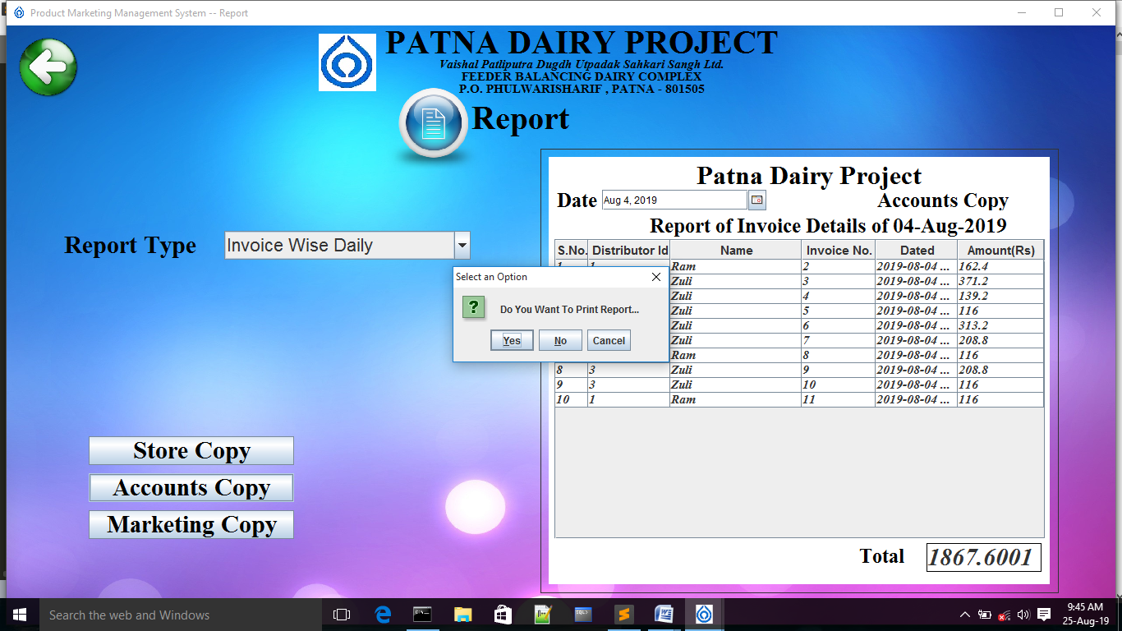

import javax.swing.*;

import javax.swing.event.*;

import javax.swing.table.*;

import java.awt.*;

import java.awt.event.*;

import com.toedter.calendar.*;

import java.text.*;

import java.io.*;

import java.sql.*;

import java.util.*;

import java.awt.print.PageFormat;

import java.awt.print.Printable;

import java.awt.print.PrinterException;

import java.awt.print.PrinterJob;

public class Report extends JFrame implements ActionListener

{

Connection con;

PreparedStatement pst , pst1;

ResultSet rst , rst1;

File f;

{

try

{

Class.forName("oracle.jdbc.driver.OracleDriver");//ClassNotFoundException

con=DriverManager.getConnection("jdbc:oracle:thin:@localhost:1521:XE","sudha","sudha123");//SQLException

}

catch(SQLException e)

{

System.out.println(e);

}

catch(ClassNotFoundException e)

{}

}

String opt;

int opt1;

int w , h ;

Toolkit toolkit = Toolkit.getDefaultToolkit();

Dimension dimension = toolkit.getScreenSize();

{

w = (int)dimension.getWidth();

h = (int)dimension.getHeight();

}

JPanel panel = new JPanel()

{

public void paintComponent(Graphics g)

{

super.paintComponent(g);

g.drawImage(new ImageIcon("Background-Wallpaper-Images-Pics.jpg").getImage(), 0 , 0 , w , h , null);

g.drawRect(650 , 150 , 630 , 540);

g.setColor(Color.BLACK);

}

};

JLabel lbl1 = new JLabel("PATNA DAIRY PROJECT");

JLabel lbl2 = new JLabel("Vaishal Patliputra Dugdh Utpadak Sahkari Sangh Ltd.");

JLabel lbl3 = new JLabel("FEEDER BALANCING DAIRY COMPLEX");

JLabel lbl4 = new JLabel("P.O. PHULWARISHARIF , PATNA - 801505");

JButton report = new JButton()

{

public void paintComponent(Graphics g)

{

super.paintComponent(g);

g.drawImage(new ImageIcon("report3.png").getImage(),0 , 0 ,120,120 , null);

}

};

JLabel report1 = new JLabel("Report");

JLabel lbl5 = new JLabel("Report Type");

JComboBox cmb1 = new JComboBox();

JButton scopy = new JButton("Store Copy");

JButton acopy = new JButton("Accounts Copy");

JButton mcopy = new JButton("Marketing Copy");

JLabel total = new JLabel("Total");

JLabel ltotal = new JLabel();

JLabel total1 = new JLabel("Total");

JLabel ltotal1 = new JLabel();

JLabel total2 = new JLabel("Total");

JLabel ltotal2 = new JLabel();

JLabel total3 = new JLabel("Total");

JLabel ltotal3 = new JLabel();

JButton exit = new JButton()

{

public void paintComponent(Graphics g)

{

super.paintComponent(g);

g.drawImage(new ImageIcon("back1.png").getImage(),0 , 0 ,80,80 , null);

}

};

JLabel sicon=new JLabel()

{

public void paintComponent(Graphics g)

{

super.paintComponent(g);

g.drawImage(new ImageIcon("icon.jpg").getImage(),0 , 0 ,70,70 , null);

}

};

JPanel inv = new JPanel();

JPanel inv1 = new JPanel();

JPanel inv2 = new JPanel();

JPanel inv3 = new JPanel();

JLabel lbl7 = new JLabel();

JLabel lbl8 = new JLabel();

JLabel lbl71 = new JLabel();

JLabel lbl81 = new JLabel();

JLabel lbl72 = new JLabel();

JLabel lbl82 = new JLabel();

JLabel lbl73 = new JLabel();

JLabel lbl83 = new JLabel();

JLabel hlbl = new JLabel("Patna Dairy Project");

JLabel copy_lbl = new JLabel();

JLabel hlbl1 = new JLabel("Patna Dairy Project");

JLabel copy_lbl1 = new JLabel();

JLabel hlbl2 = new JLabel("Patna Dairy Project");

JLabel copy_lbl2 = new JLabel();

JLabel hlbl3 = new JLabel("Patna Dairy Project");

JLabel copy_lbl3 = new JLabel();

JLabel pcopy = new JLabel();

JLabel pcopy1 = new JLabel();

JLabel pcopy2= new JLabel();

JLabel pcopy3 = new JLabel();

JDateChooser calendar=new JDateChooser(new java.util.Date());

JDateChooser calendar1=new JDateChooser(new java.util.Date());

String data[][];

String heading[]={"S.No.","Distributor Id","Name","Invoice No.","Dated","Amount(Rs)"};

String rows[][]=new String[0][0];

DefaultTableModel dtm=new DefaultTableModel(rows,heading);

JTable tab=new JTable(dtm);

JScrollPane jsp=new JScrollPane(tab);

String data1[][];

String heading1[]={"S.No.","Product Id","Name","Quantity","Amount(Rs)"};

String rows1[][]=new String[0][0];

DefaultTableModel dtm1=new DefaultTableModel(rows1,heading1);

JTable tab1=new JTable(dtm1);

JScrollPane jsp1=new JScrollPane(tab1);

String data3[][];

String heading3[]={"S.No.","Product Id","Name","Quantity","Amount(Rs)"};

String rows3[][]=new String[0][0];

DefaultTableModel dtm3=new DefaultTableModel(rows3,heading3);

JTable tab3=new JTable(dtm3);

JScrollPane jsp3=new JScrollPane(tab3);

String data2[][];

String heading2[]={"S.No.","Distributor Id","Name","Invoice No.","Amount(Rs)"};

String rows2[][]=new String[0][0];

DefaultTableModel dtm2=new DefaultTableModel(rows2,heading2);

JTable tab2=new JTable(dtm2);

JScrollPane jsp2=new JScrollPane(tab2);

JComboBox cmb3 = new JComboBox();

JComboBox cmb31 = new JComboBox();

public Report()

{

add(panel);panel.setLayout(null);

setBounds(0,0,w,h);

setVisible(true);

setTitle("Product Marketing Management System -- Report");

setIconImage(new ImageIcon("icon.jpg").getImage());

panel.add(lbl1);lbl1.setBounds(300 , 0 , 800 , 40);

lbl1.setHorizontalAlignment(JLabel.CENTER);

lbl1.setVerticalAlignment(JLabel.CENTER);

lbl1.setFont(new Font("Times New Roman",Font.BOLD,40));

lbl1.setForeground(Color.BLACK);

panel.add(sicon);sicon.setBounds(380 , 10 , 70 , 70);

setIconImage(new ImageIcon("icon.jpg").getImage());

panel.add(lbl2);lbl2.setBounds(200 , 40 , 1000 , 15);

lbl2.setHorizontalAlignment(JLabel.CENTER);

lbl2.setVerticalAlignment(JLabel.CENTER);

lbl2.setFont(new Font("Times New Roman",Font.ITALIC+Font.BOLD,15));

lbl2.setForeground(Color.BLACK);

panel.add(lbl3);lbl3.setBounds(200 , 55 , 1000 , 15);

lbl3.setHorizontalAlignment(JLabel.CENTER);

lbl3.setVerticalAlignment(JLabel.CENTER);

lbl3.setFont(new Font("Times New Roman",Font.BOLD,15));

lbl3.setForeground(Color.BLACK);

panel.add(lbl4);lbl4.setBounds(300 , 70 , 800 , 15);

lbl4.setHorizontalAlignment(JLabel.CENTER);

lbl4.setVerticalAlignment(JLabel.CENTER);

lbl4.setFont(new Font("Times New Roman",Font.BOLD,15));

lbl4.setForeground(Color.BLACK);

panel.add(report1);report1.setBounds(500 , 90 , 250 , 45);

report1.setHorizontalAlignment(JLabel.CENTER);

report1.setVerticalAlignment(JLabel.CENTER);

report1.setFont(new Font("Times New Roman",Font.BOLD,40));

report1.setForeground(Color.BLACK);

panel.add(report);report.setBounds(460,60,120,120);

report.setOpaque(false);

report.setContentAreaFilled(false);

report.setBorderPainted(false);

panel.add(lbl5);lbl5.setBounds(70 , 250 , 220 , 35);

lbl5.setForeground(Color.BLACK);

lbl5.setFont(new Font("Times New Roman",Font.BOLD,30));

cmb1.setBounds(265,250,300,35); panel.add(cmb1);

cmb1.setFont(new Font( "Arial",Font.PLAIN ,22));

cmb1.addItem("Invoice Wise Daily");cmb1.addItem("Product Wise Daily");

cmb1.addItem("Product Wise Monthly");cmb1.addItem("Distributor Wise Monthly");

panel.add(scopy);scopy.setBounds(100 , 500 , 250 , 35);

scopy.setForeground(Color.BLACK);

scopy.setFont(new Font("Times New Roman",Font.BOLD,30));

scopy.setEnabled(false);

panel.add(acopy);acopy.setBounds(100 , 545 , 250 , 35);

acopy.setForeground(Color.BLACK);

acopy.setFont(new Font("Times New Roman",Font.BOLD,30));

acopy.setEnabled(false);

panel.add(mcopy);mcopy.setBounds(100 , 590 , 250 , 35);

mcopy.setForeground(Color.BLACK);

mcopy.setFont(new Font("Times New Roman",Font.BOLD,30));

mcopy.setEnabled(false);

panel.add(exit);exit.setBounds(10, 10 , 80 , 80);

exit.setContentAreaFilled(false);

exit.setBorderPainted(false);

cmb1.addActionListener(this);

report.addActionListener(this);

scopy.addActionListener(this);

acopy.addActionListener(this);

mcopy.addActionListener(this);

exit.addActionListener(this);

}

public void actionPerformed(ActionEvent evt)

{

if(evt.getSource()==cmb1)

{

String str1 = cmb1.getSelectedItem().toString();

if(str1.equals("Invoice Wise Daily"))

{

invoice_report();

}

if(str1.equals("Product Wise Daily"))

{

product_report();

}

if(str1.equals("Product Wise Monthly"))

{

product_report_monthly();

}

if(str1.equals("Distributor Wise Monthly"))

{

distributor_report_monthly();

}

}

if(evt.getSource()==report)

{

int sno=1;

float stotal = 0.0f;

String str1 = cmb1.getSelectedItem().toString();

if(str1.equals("Invoice Wise Daily"))

{

dtm.setRowCount(0);

try

{

SimpleDateFormat sdf=new SimpleDateFormat("dd-MMM-yyyy");

String st=sdf.format(calendar.getDate());

lbl8.setText("Report of Invoice Details of "+st);

pst=con.prepareStatement("Select transaction.dist_id ,dist_name, invoice_no , invoice_date , amount_chargeable from transaction,distributor_master where distributor_master.dist_id=transaction.dist_id and invoice_date =? order by(invoice_no)");

pst.setString(1,new SimpleDateFormat("dd-MMM-yyyy").format(calendar.getDate()));

rst=pst.executeQuery();

int i=0;

while(rst.next())

{

String s[]={sno+"",rst.getString(1),rst.getString(2),rst.getString(3),rst.getString(4),rst.getString(5)};

dtm.addRow(s);

i++;

sno++;

}

int row = tab.getRowCount();

System.out.println(row);

for(int iy = 0 ; iy<row ; iy++)

{

float stot =Float.parseFloat(tab.getValueAt(iy,5).toString());

//System.out.println(s);

stotal = stotal + stot;

System.out.println(iy);

}

ltotal.setText(String.valueOf(stotal));

JOptionPane.showMessageDialog(this,"Report Generated...","Confirm Message",JOptionPane.INFORMATION_MESSAGE);

scopy.setEnabled(true);

acopy.setEnabled(true);

mcopy.setEnabled(true);

}

catch(Exception e){JOptionPane.showMessageDialog(this,"Report Not Generated...","Error Message",JOptionPane.ERROR_MESSAGE);}

}

else if(str1.equals("Product Wise Daily"))

{

dtm1.setRowCount(0);

try

{

SimpleDateFormat sdf=new SimpleDateFormat("dd-MMM-yyyy");

String st1=sdf.format(calendar1.getDate());

lbl81.setText("Report of Product Supply on "+st1);

pst=con.prepareStatement("Select prod_id , prod_name , quantity , amount , transaction.invoice_no from transaction , invoice where invoice.invoice_no = transaction.invoice_no and invoice_date = ? order by(invoice_no)");

pst.setString(1,new SimpleDateFormat("dd-MMM-yyyy").format(calendar1.getDate()));

rst=pst.executeQuery();

int i=0;

while(rst.next())

{

String s[]={sno+"",rst.getString(1),rst.getString(2),rst.getString(3),rst.getString(4)};

String y = rst.getString(5);

dtm1.addRow(s);

i++;

sno++;

}

int row = tab.getRowCount();

System.out.println(row);

for(int iy = 0 ; iy<row ; iy++)

{

float stot =Float.parseFloat(tab1.getValueAt(iy,4).toString());

//System.out.println(s);

stotal = stotal + stot;

System.out.println(iy);

}

ltotal1.setText(String.valueOf(stotal));

JOptionPane.showMessageDialog(this,"Report Generated...","Confirm Message",JOptionPane.INFORMATION_MESSAGE);

scopy.setEnabled(true);

acopy.setEnabled(true);

mcopy.setEnabled(true);

}

catch(Exception e){JOptionPane.showMessageDialog(this,"Report Not Generated...","Error Message",JOptionPane.ERROR_MESSAGE);}

}

else if(str1.equals("Product Wise Monthly"))

{

dtm3.setRowCount(0);

try

{

String mon = cmb3.getSelectedItem().toString();

System.out.println(mon.toLowerCase().substring(0,3));

lbl82.setText("Report of Product Supply in "+mon);

pst=con.prepareStatement(" select invoice_date,invoice.invoice_no,prod_id,prod_name,Quantity,amount from transaction,invoice where transaction.invoice_no=invoice.invoice_no and to_char(invoice_date,'mon')=? order by(invoice_no)");

pst.setString(1,mon.toLowerCase().substring(0,3));

rst=pst.executeQuery();

int i=0;

while(rst.next())

{

String s[]={sno+"",rst.getString(3),rst.getString(4),rst.getString(5),rst.getString(6)};

dtm3.addRow(s);

i++;

sno++;

}

int row = tab3.getRowCount();

//System.out.println(row);

for(int iy = 0 ; iy<row ; iy++)

{

float stot =Float.parseFloat(tab3.getValueAt(iy,4).toString());

//System.out.println(s);

stotal = stotal + stot;

//System.out.println(iy);

}

ltotal2.setText(String.valueOf(stotal));

JOptionPane.showMessageDialog(this,"Report Generated...","Confirm Message",JOptionPane.INFORMATION_MESSAGE);

scopy.setEnabled(true);

acopy.setEnabled(true);

mcopy.setEnabled(true);

}

catch(Exception e){JOptionPane.showMessageDialog(this,"Report Not Generated...","Error Message",JOptionPane.ERROR_MESSAGE);}

}

if(str1.equals("Distributor Wise Monthly"))

{

dtm2.setRowCount(0);

try

{

String mon1 = cmb31.getSelectedItem().toString();

lbl83.setText("Report of Distributor Details in "+mon1);

pst=con.prepareStatement("Select transaction.dist_id ,dist_name, invoice_no , amount_chargeable from transaction,distributor_master where distributor_master.dist_id=transaction.dist_id and to_char(invoice_date , 'mon')=? order by(invoice_no)");

pst.setString(1,mon1.toLowerCase().substring(0,3));

rst=pst.executeQuery();

int i=0;

while(rst.next())

{

String s[]={sno+"",rst.getString(1),rst.getString(2),rst.getString(3),rst.getString(4)};

dtm2.addRow(s);

i++;

sno++;

}

int row = tab2.getRowCount();

for(int iy = 0 ; iy<row ; iy++)

{

float stot =Float.parseFloat(tab2.getValueAt(iy,4).toString());

stotal = stotal + stot;

}

ltotal3.setText(String.valueOf(stotal));

JOptionPane.showMessageDialog(this,"Report Generated...","Confirm Message",JOptionPane.INFORMATION_MESSAGE);

scopy.setEnabled(true);

acopy.setEnabled(true);

mcopy.setEnabled(true);

}

catch(Exception e){JOptionPane.showMessageDialog(this,"Report Not Generated...","Error Message",JOptionPane.ERROR_MESSAGE);}

}

}

if(evt.getSource() == scopy)

{

String str1 = cmb1.getSelectedItem().toString();

//String str2 = cmb2.getSelectedItem().toString();

if(str1.equals("Invoice Wise Daily"))

{

pcopy.setText("Store Copy");

} //PANEL NAME WHICH HAVE TO PRINT

if(str1.equals("Product Wise Daily"))

{

pcopy1.setText("Store Copy");

}

if(str1.equals("Product Wise Monthly"))

{

pcopy2.setText("Store Copy");

}

if(str1.equals("Distributor Wise Monthly"))

{

pcopy3.setText("Store Copy ");

}

int opt= JOptionPane.showConfirmDialog(this,"Do You Want To Print Report...");

if(opt==JOptionPane.YES_OPTION)

{

PrinterJob pj = PrinterJob.getPrinterJob();

pj.setJobName(" Print Component ");

pj.setPrintable (new Printable()

{

public int print(Graphics pg, PageFormat pf, int pageNum)

{

if (pageNum > 0)

{

return Printable.NO_SUCH_PAGE;

}

Graphics2D g2 = (Graphics2D) pg;

g2.translate(pf.getImageableX(), pf.getImageableY());

if(str1.equals("Invoice Wise Daily"))

{

inv.paint(g2);

} //PANEL NAME WHICH HAVE TO PRINT

if(str1.equals("Product Wise Daily"))

{

inv1.paint(g2);

}

if(str1.equals("Product Wise Monthly"))

{

inv2.paint(g2);

}

if(str1.equals("Distributor Wise Monthly"))

{

inv3.paint(g2);

}

return Printable.PAGE_EXISTS;

}

});

if (pj.printDialog() == false)

return;

try

{

pj.print();

scopy.setEnabled(false);

acopy.setEnabled(false);

mcopy.setEnabled(false);

JOptionPane.showMessageDialog(this,"Report Printed...","Confirm Message",JOptionPane.INFORMATION_MESSAGE);

}

catch (PrinterException ex) {JOptionPane.showMessageDialog(this,"Report Not Printed...","Error Message",JOptionPane.ERROR_MESSAGE);}

}

else

{

JOptionPane.showMessageDialog(this,"Report Not Printed...","Error Message",JOptionPane.ERROR_MESSAGE);

}

}

if(evt.getSource() == acopy)

{

String str1 = cmb1.getSelectedItem().toString();

//String str2 = cmb2.getSelectedItem().toString();

if(str1.equals("Invoice Wise Daily"))

{

pcopy.setText("Accounts Copy");

} //PANEL NAME WHICH HAVE TO PRINT

if(str1.equals("Product Wise"))

{

pcopy1.setText("Accounts Copy Daily");

}

if(str1.equals("Product Wise Monthly"))

{

pcopy2.setText("Accounts Copy");

}

if(str1.equals("Distributor Wise Monthly"))

{

pcopy3.setText("Accounts Copy ");

}

int opt= JOptionPane.showConfirmDialog(this,"Do You Want To Print Report...");

if(opt==JOptionPane.YES_OPTION)

{

PrinterJob pj = PrinterJob.getPrinterJob();

pj.setJobName(" Print Component ");

pj.setPrintable (new Printable()

{

public int print(Graphics pg, PageFormat pf, int pageNum)

{

if (pageNum > 0)

{

return Printable.NO_SUCH_PAGE;

}

Graphics2D g2 = (Graphics2D) pg;

g2.translate(pf.getImageableX(), pf.getImageableY());

if(str1.equals("Invoice Wise Daily"))

{

inv.paint(g2);

} //PANEL NAME WHICH HAVE TO PRINT

if(str1.equals("Product Wise Daily"))

{

inv1.paint(g2);

}

if(str1.equals("Product Wise Monthly"))

{

inv2.paint(g2);

}

if(str1.equals("Distributor Wise Monthly"))

{

inv3.paint(g2);

}

return Printable.PAGE_EXISTS;

}

});

if (pj.printDialog() == false)

return;

try

{

pj.print();

scopy.setEnabled(false);

acopy.setEnabled(false);

mcopy.setEnabled(false);

JOptionPane.showMessageDialog(this,"Report Printed...","Confirm Message",JOptionPane.INFORMATION_MESSAGE);

}

catch (PrinterException ex) {JOptionPane.showMessageDialog(this,"Report Not Printed...","Error Message",JOptionPane.ERROR_MESSAGE); }

}

else

{

JOptionPane.showMessageDialog(this,"Report Not Printed...","Error Message",JOptionPane.ERROR_MESSAGE);

}

}

if(evt.getSource() == mcopy)

{

String str1 = cmb1.getSelectedItem().toString();

//String str2 = cmb2.getSelectedItem().toString();

if(str1.equals("Invoice Wise Daily"))

{

pcopy.setText("Marketing Copy");

} //PANEL NAME WHICH HAVE TO PRINT

if(str1.equals("Product Wise Daily"))

{

pcopy1.setText("Marketing Copy");

}

if(str1.equals("Product Wise Monthly"))

{

pcopy2.setText("Marketing Copy");

}

if(str1.equals("Distributor Wise Monthly"))

{

pcopy3.setText("Marketing Copy ");

}

int opt= JOptionPane.showConfirmDialog(this,"Do You Want To Print Report...");

if(opt==JOptionPane.YES_OPTION)

{

PrinterJob pj = PrinterJob.getPrinterJob();

pj.setJobName(" Print Component ");

pj.setPrintable (new Printable()

{

public int print(Graphics pg, PageFormat pf, int pageNum)

{

if (pageNum > 0)

{

return Printable.NO_SUCH_PAGE;

}

Graphics2D g2 = (Graphics2D) pg;

g2.translate(pf.getImageableX(), pf.getImageableY());

if(str1.equals("Invoice Wise Daily"))

{

inv.paint(g2);

} //PANEL NAME WHICH HAVE TO PRINT

if(str1.equals("Product Wise Daily"))

{

inv1.paint(g2);

}

if(str1.equals("Product Wise Monthly"))

{

inv2.paint(g2);

}

if(str1.equals("Distributor Wise Monthly"))

{

inv3.paint(g2);

}

return Printable.PAGE_EXISTS;

}

});

if (pj.printDialog() == false)

return;

try

{

pj.print();

scopy.setEnabled(false);

acopy.setEnabled(false);

mcopy.setEnabled(false);

JOptionPane.showMessageDialog(this,"Report Printed...","Confirm Message",JOptionPane.INFORMATION_MESSAGE);

}

catch (PrinterException ex) {JOptionPane.showMessageDialog(this,"Report Not Printed...","Error Message",JOptionPane.ERROR_MESSAGE); }

}

else

{

JOptionPane.showMessageDialog(this,"Report Not Printed...","Error Message",JOptionPane.ERROR_MESSAGE);

}

}

if(evt.getSource() == exit)

{

int opt= JOptionPane.showConfirmDialog(this,"Do You Want To Exit...");

if(opt==JOptionPane.YES_OPTION)

{

dispose();

}

}

}

void invoice_report()

{

inv.setVisible(true);

inv1.setVisible(false);

inv2.setVisible(false);

inv3.setVisible(false);

panel.add(inv);inv.setLayout(null);inv.setVisible(true);

inv.setBounds(660 , 160 , 610 , 520);

inv.setBackground(new Color(255 , 255 , 255));

inv.add(hlbl);hlbl.setBounds(180 , 5 , 300 , 35);

hlbl.setForeground(Color.BLACK);

hlbl.setFont(new Font("Times New Roman",Font.BOLD,32));

inv.add(lbl7);lbl7.setBounds(10 , 40 , 50 , 25);lbl7.setText("Date");

lbl7.setForeground(Color.BLACK);

lbl7.setFont(new Font("Times New Roman",Font.BOLD,25));

inv.add(calendar);calendar.setBounds(65 , 40 , 200 , 25);

inv.add(pcopy);pcopy.setBounds(400 , 40 , 200 , 25);

pcopy.setForeground(Color.BLACK);

pcopy.setFont(new Font("Times New Roman",Font.BOLD,25));

inv.add(lbl8);lbl8.setBounds(90 , 70 , 500 , 27);

lbl8.setFont(new Font("Times New Roman",Font.BOLD,25));

lbl8.setHorizontalAlignment(JLabel.CENTER);

lbl8.setVerticalAlignment(JLabel.CENTER);

lbl8.setForeground(Color.BLACK);

lbl8.setText("Report of Invoice Details of ");

inv.add(jsp);jsp.setBounds(7 , 100 , 598 , 365);tab.setFont(new Font("Times New Roman", Font.ITALIC+Font.BOLD,15));

JTableHeader eheader=tab.getTableHeader();tab.setBackground(Color.WHITE);

eheader.setFont(new Font("Times Roman",Font.BOLD,15));

tab.setAutoResizeMode(JTable.AUTO_RESIZE_OFF);

tab.setRowHeight(18);

javax.swing.table.TableColumn tableColumn =tab.getColumnModel().getColumn(0);

tableColumn.setPreferredWidth(40);

tableColumn =tab.getColumnModel().getColumn(1);

tableColumn.setPreferredWidth(100);

tableColumn =tab.getColumnModel().getColumn(2);

tableColumn.setPreferredWidth(160);

tableColumn =tab.getColumnModel().getColumn(3);

tableColumn.setPreferredWidth(90);

tableColumn =tab.getColumnModel().getColumn(4);

tableColumn.setPreferredWidth(100);

tableColumn =tab.getColumnModel().getColumn(5);

tableColumn.setPreferredWidth(105);

inv.add(total);total.setBounds(360 , 470 , 90 , 30);

total.setHorizontalAlignment(JLabel.CENTER);

total.setVerticalAlignment(JLabel.CENTER);

total.setFont(new Font("Times New Roman",Font.BOLD,25));

total.setForeground(Color.BLACK);

inv.add(ltotal);ltotal.setBounds(460 , 470 , 140 , 35);ltotal.setBorder(BorderFactory.createLineBorder(Color.BLACK,1));

ltotal.setFont(new Font("Times New Roman", Font.ITALIC+Font.BOLD,30));

}

void product_report()

{

inv.setVisible(false);

inv1.setVisible(true);

inv2.setVisible(false);

inv3.setVisible(false);

panel.add(inv1);inv1.setLayout(null);inv1.setVisible(true);

inv1.setBounds(660 , 160 , 610 , 520);

inv1.setBackground(new Color(255 , 255 , 255));

inv1.add(hlbl1);hlbl1.setBounds(180 , 5 , 300 , 35);

hlbl1.setForeground(Color.BLACK);

hlbl1.setFont(new Font("Times New Roman",Font.BOLD,32));

inv1.add(lbl71);lbl71.setBounds(10 , 40 , 50 , 25);lbl71.setText("Date");

lbl71.setForeground(Color.BLACK);

lbl71.setFont(new Font("Times New Roman",Font.BOLD,25));

inv1.add(calendar1);calendar1.setBounds(65 , 40 , 200 , 25);

inv1.add(pcopy1);pcopy1.setBounds(400 , 40 , 200 , 25);

pcopy1.setForeground(Color.BLACK);

pcopy1.setFont(new Font("Times New Roman",Font.BOLD,25));

inv1.add(lbl81);lbl81.setBounds(90 , 70 , 500 , 27);

lbl81.setFont(new Font("Times New Roman",Font.BOLD,25));

lbl81.setHorizontalAlignment(JLabel.CENTER);

lbl81.setVerticalAlignment(JLabel.CENTER);

lbl81.setForeground(Color.BLACK);

lbl81.setText("Report of Product Supply on ");

inv1.add(jsp1);jsp1.setBounds(7 , 100 , 598 , 365);tab1.setFont(new Font("Times New Roman", Font.ITALIC+Font.BOLD,15));

JTableHeader eheader=tab1.getTableHeader();tab1.setBackground(Color.WHITE);

eheader.setFont(new Font("Times Roman",Font.BOLD,15));

tab1.setAutoResizeMode(JTable.AUTO_RESIZE_OFF);

tab1.setRowHeight(18);

javax.swing.table.TableColumn tableColumn =tab.getColumnModel().getColumn(0);

tableColumn.setPreferredWidth(35);

tableColumn =tab1.getColumnModel().getColumn(1);

tableColumn.setPreferredWidth(110);

tableColumn =tab1.getColumnModel().getColumn(2);

tableColumn.setPreferredWidth(210);

tableColumn =tab1.getColumnModel().getColumn(3);

tableColumn.setPreferredWidth(90);

tableColumn =tab1.getColumnModel().getColumn(4);

tableColumn.setPreferredWidth(110);

inv1.add(total1);total1.setBounds(360 , 470 , 90 , 30);

total1.setHorizontalAlignment(JLabel.CENTER);

total1.setVerticalAlignment(JLabel.CENTER);

total1.setFont(new Font("Times New Roman",Font.BOLD,25));

total1.setForeground(Color.BLACK);

inv1.add(ltotal1);ltotal1.setBounds(460 , 470 , 140 , 35);ltotal1.setBorder(BorderFactory.createLineBorder(Color.BLACK,1));

ltotal1.setFont(new Font("Times New Roman", Font.ITALIC+Font.BOLD,30));

}

void product_report_monthly()

{

inv.setVisible(false);

inv1.setVisible(false);

inv2.setVisible(true);

inv3.setVisible(false);

panel.add(inv2);inv2.setLayout(null);inv2.setVisible(true);

inv2.setBounds(660 , 160 , 610 , 520);

inv2.setBackground(new Color(255 , 255 , 255));

inv2.add(hlbl2);hlbl2.setBounds(180 , 5 , 300 , 35);

hlbl2.setForeground(Color.BLACK);

hlbl2.setFont(new Font("Times New Roman",Font.BOLD,32));

inv2.add(lbl72);lbl72.setBounds(10 , 40 , 80 , 25);lbl72.setText("Month");

lbl72.setForeground(Color.BLACK);

lbl72.setFont(new Font("Times New Roman",Font.BOLD,25));

inv2.add(cmb3);cmb3.setBounds(95 , 40 , 200 , 25);

cmb3.addItem("January");

cmb3.addItem("February");

cmb3.addItem("March");

cmb3.addItem("April");

cmb3.addItem("May");

cmb3.addItem("June");

cmb3.addItem("July");

cmb3.addItem("August");

cmb3.addItem("September");

cmb3.addItem("October");

cmb3.addItem("November");

cmb3.addItem("December");

inv2.add(pcopy2);pcopy2.setBounds(400 , 40 , 200 , 25);

pcopy2.setForeground(Color.BLACK);

pcopy2.setFont(new Font("Times New Roman",Font.BOLD,25));

inv2.add(lbl82);lbl82.setBounds(90 , 70 , 500 , 27);

lbl82.setFont(new Font("Times New Roman",Font.BOLD,25));

lbl82.setHorizontalAlignment(JLabel.CENTER);

lbl82.setVerticalAlignment(JLabel.CENTER);

lbl82.setForeground(Color.BLACK);

lbl82.setText("Report of Product Supply in ");

inv2.add(jsp3);jsp3.setBounds(7 , 100 , 598 , 365);tab3.setFont(new Font("Times New Roman", Font.ITALIC+Font.BOLD,15));

JTableHeader eheader=tab3.getTableHeader();tab3.setBackground(Color.WHITE);

eheader.setFont(new Font("Times Roman",Font.BOLD,15));

tab3.setAutoResizeMode(JTable.AUTO_RESIZE_OFF);

tab3.setRowHeight(18);

javax.swing.table.TableColumn tableColumn =tab3.getColumnModel().getColumn(0);

tableColumn.setPreferredWidth(40);

tableColumn =tab3.getColumnModel().getColumn(1);

tableColumn.setPreferredWidth(110);

tableColumn =tab3.getColumnModel().getColumn(2);

tableColumn.setPreferredWidth(210);

tableColumn =tab3.getColumnModel().getColumn(3);

tableColumn.setPreferredWidth(115);

tableColumn =tab3.getColumnModel().getColumn(4);

tableColumn.setPreferredWidth(120);

inv2.add(total2);total2.setBounds(360 , 470 , 90 , 30);

total2.setHorizontalAlignment(JLabel.CENTER);

total2.setVerticalAlignment(JLabel.CENTER);

total2.setFont(new Font("Times New Roman",Font.BOLD,25));

total2.setForeground(Color.BLACK);

inv2.add(ltotal2);ltotal2.setBounds(460 , 470 , 140 , 35);ltotal2.setBorder(BorderFactory.createLineBorder(Color.BLACK,1));

ltotal2.setFont(new Font("Times New Roman", Font.ITALIC+Font.BOLD,30));

}

void distributor_report_monthly()

{

inv.setVisible(false);

inv1.setVisible(false);

inv2.setVisible(false);

inv3.setVisible(true);

panel.add(inv3);inv3.setLayout(null);inv3.setVisible(true);

inv3.setBounds(660 , 160 , 610 , 520);

inv3.setBackground(new Color(255 , 255 , 255));

inv3.add(hlbl3);hlbl3.setBounds(180 , 5 , 300 , 35);

hlbl3.setForeground(Color.BLACK);

hlbl3.setFont(new Font("Times New Roman",Font.BOLD,32));

inv3.add(lbl73);lbl73.setBounds(10 , 40 , 80 , 25);lbl73.setText("Month");

lbl73.setForeground(Color.BLACK);

lbl73.setFont(new Font("Times New Roman",Font.BOLD,25));

inv3.add(cmb31);cmb31.setBounds(95 , 40 , 200 , 25);

cmb31.addItem("January");

cmb31.addItem("February");

cmb31.addItem("March");

cmb31.addItem("April");

cmb31.addItem("May");

cmb31.addItem("June");

cmb31.addItem("July");

cmb31.addItem("August");

cmb31.addItem("September");

cmb31.addItem("October");

cmb31.addItem("November");

cmb31.addItem("December");

inv3.add(pcopy3);pcopy3.setBounds(400 , 40 , 200 , 25);

pcopy3.setForeground(Color.BLACK);

pcopy3.setFont(new Font("Times New Roman",Font.BOLD,25));

inv3.add(lbl83);lbl83.setBounds(90 , 70 , 500 , 27);

lbl83.setFont(new Font("Times New Roman",Font.BOLD,25));

lbl83.setHorizontalAlignment(JLabel.CENTER);

lbl83.setVerticalAlignment(JLabel.CENTER);

lbl83.setForeground(Color.BLACK);

lbl83.setText("Report of Distributor Details in ");

inv3.add(jsp2);jsp2.setBounds(7 , 100 , 598 , 365);tab2.setFont(new Font("Times New Roman", Font.ITALIC+Font.BOLD,15));

JTableHeader eheader=tab2.getTableHeader();tab2.setBackground(Color.WHITE);

eheader.setFont(new Font("Times Roman",Font.BOLD,15));

tab2.setAutoResizeMode(JTable.AUTO_RESIZE_OFF);

tab2.setRowHeight(18);

javax.swing.table.TableColumn tableColumn =tab2.getColumnModel().getColumn(0);

tableColumn.setPreferredWidth(40);

tableColumn =tab2.getColumnModel().getColumn(1);

tableColumn.setPreferredWidth(110);

tableColumn =tab2.getColumnModel().getColumn(2);

tableColumn.setPreferredWidth(210);

tableColumn =tab2.getColumnModel().getColumn(3);

tableColumn.setPreferredWidth(115);

tableColumn =tab2.getColumnModel().getColumn(4);

tableColumn.setPreferredWidth(120);

inv3.add(total3);total3.setBounds(360 , 470 , 90 , 30);

total3.setHorizontalAlignment(JLabel.CENTER);

total3.setVerticalAlignment(JLabel.CENTER);

total3.setFont(new Font("Times New Roman",Font.BOLD,25));

total3.setForeground(Color.BLACK);

inv3.add(ltotal3);ltotal3.setBounds(460 , 470 , 140 , 35);ltotal3.setBorder(BorderFactory.createLineBorder(Color.BLACK,1));

ltotal3.setFont(new Font("Times New Roman", Font.ITALIC+Font.BOLD,30));

}

void reset()

{

remove(inv);

}

public static void main(String[]args)

{ new Report();

}

}

FUTURE SCOPE OF OUR SOFTWARE

*The “Product marketing management system” of “PATNA DAIRY PROJECT ” is versatile and flexible system and can be easily modified to suit the requirement of any other institute in future. The system has been designed in such a way that hierarchy modification capabilities can be affected at any level. The dynamin screen of the system can also be modified easily to meet the specific requirement of any new client.*

* *Additional capabilities are inbuilt in the system.*
* *Dynamic screens according to requirement can be introduced any time.*
* *System is very flexible for future modifications.*